Preface

This Guide explains how to use the system to process export letters of credit. It assumes that you are familiar with the basic principles of trade finance relating to export letters of credit, and with web browsers.

# About Letters of Credit

Trade Innovation handles letters of credit as two main products:

* Import letters of credit
* Export letters of credit, covered in this document

Import letters of credit reflect the transaction from the perspective of the importer's bank, which is the issuing bank, and are described in the Import Letters of Credit User Guide – Trade Innovation.

Export letters of credit reflect the transaction from the perspective of other banks involved in the transaction in the exporter's country. These include the advising bank, which is the bank that notifies the exporter of the letter of credit, and the presenting bank, which is the bank at which the exporter presents the documents upon which payment depends. The exporter (or seller) is referred to as the beneficiary in this Guide, and the importer (or buyer) is referred to as the applicant.

Letters of credit can also be categorised into product types. Your bank can choose what product types, if any, to set up. They might include such types as back-to-back or confirmed credits, for example. If your bank has set up product types, you will be able to specify what product type a letter of credit belongs to when you create it, and you can use product types to filter which letters of credit you want to see.

The system also handles the special requirements of:

* Transferable letters of credit
* Back-to-back letters of credit
* The assignment of proceeds to additional parties
* Freely negotiable letters of credit
* Revolving credits
* Participated deals

Each export letter of credit can have any number of transfer letters of credit, back-to-back letters of credit and assignments associated with it. The system maintains a table of all such items associated with each export letter of credit, which you can view at various points during transaction processing.

Once created, transfer letters of credit are processed using events against the originating parent letter of credit. Back-to-back letters of credit, once created, are processed independent of their parent letter of credit in the same way as normal import letters of credit.

## Payment Terms

The system includes facilities for the handling of:

* Sight credits
* Acceptance credits, where payment is made upon a term draft whose maturity date is determined by acceptance of the draft by a bank
* Deferred credits, where the beneficiary does not need to draw a bill of exchange to receive payment - the issuing bank guarantees that payment will be made at a specified future date if terms and conditions are fulfilled
* Mixed credits, which are a combination of sight and acceptance or deferred credits. The system supports part-payment to facilitate mixed credits
* By negotiation

The system allows letters of credit to proceed with or without confirmation from the advising bank.

For letters of credit with associated transfer letters of credit, back-to-back letters of credit and assignments, the system has the necessary facilities for combined payment or reconciliation.

When making payments all relevant charges may be paid with the payment and funds to be paid or received in currencies different from that of the letter of credit.

## Financing and Discounting

The system allows acceptance and deferred payments to be discounted and paid early for export letters of credit.

If you have the financing module implemented you can also enter advances against export letters of credit. The module permits you to enter loans from within payment events for export letters of credit. Loans can have interest charged in advance or in arrears, or they can be discounted.

The financing module also allows you to create financing transactions independent of any existing trade finance transaction, for example to provide packing credits for export letters of credit. The trade finance transaction can then be associated with the financing transaction as it is created.

For a full description of the financing module's functionality see the Financing User Guide – Trade Innovation.

### Assigning Proceeds to Additional Parties

The system permits you to identify an unlimited number of additional parties to a letter of credit who are to receive proceeds from the transaction. Each such party is termed an assignee. The total amount of assignments, together with any back-to-back and transfer letters of credit, can be up to 100% of the value of the letter of credit.

### Licenses

The system includes facilities for the use of licenses with transactions of the type described in this Guide. Your bank can also make returns to the central licensing authority on a regular basis to show the utilisation of the licenses issued to customers.

One or more licenses can be linked to a transaction and a reservation made for the amount of the transaction. When a claim is received, a drawdown can be made against the license. Full validation between the transaction and license is provided to ensure that licenses do not become overdrawn.

If the amount of the transaction is increased or decreased during an amendment event, then additional reservations can be made for an increase or the balance reinstated for a decrease. Any unutilised balance on expiry or cancellation can be (optionally) reinstated on the license.

See the Licenses User Guide – Trade Innovation for details of licenses.

## Participating a Transaction

If you have the participations module implemented, you can participate a transaction using an existing participation deal, or create a new participation deal for use with that transaction.

You can participate a transaction from within the Advise or Issue event, or later from within a Maintain Liability event. At either of these stages, you can either select an existing agreed participation deal, or create a new deal.

If the amount of a transaction is changed by an Amend event, or by the transaction being paid, expired, or cancelled, a Drawdown/Revolve Commit Amt event may be created as a subsidiary event to update the commitment amount available on the participation deal. This will occur under the following circumstances:

* If the amount is increased, a drawdown will take place to reduce the amount available on the participation deal
* If the amount is decreased, including being reduced to zero when the transaction is paid, expired, or cancelled, a revolve will be used to increase the amount available on the participation deal only if the participation deal is defined as revolving

A Drawdown/Revolve Commit Amt event may be created by the following events:

* Amend
* Cancel
* Expire
* Maintain Liability
* Documents Presented
* Outstanding Presentation
* Claim Received
* Outstanding Claim
* Renew
* Reduction/Increase

If the participation deal itself is amended in such a way as to alter a participant's share, a Maintain Liability subsidiary event is automatically generated for each transaction affected by the amendment. This updates the transaction and the charges associated with it to take account of changes to the participation deal.

## Credit Risk Management

If your bank has implemented a credit risk management application, your system will perform on-line credit limit checking as necessary as part of the life-cycle of a transaction. Depending on how your system has been configured, account manager approval for a credit line utilisation may be required always, or only when overline conditions are detected.

See the Common Facilities User Guide – Trade Innovation for more information on credit risk management.

## Incorporating Legacy System Transactions into Trade Innovation

Your bank can incorporate export letter of credit transactions into the system from a legacy system using customer gateway interface service messages.

Each transaction is received as a customer gateway interface service message, which is processed in the usual way. Each such message, once successfully processed, is used to create an Advice Take-on event and associated master record in the system. The Advice Take-on event can be automatically released, and the master record given a status of 'LIV' or 'EXP', depending on its expiry date. Processing can then be carried out against the master record in the usual way, using the standard export letter of credit events.

The transaction's original unique reference is recorded against the master record generated within the system.

To allow legacy transactions to be incorporated into the workflow in this way your bank must set up the following for the Advice Take-on event:

* Postings to allow the calculation of current values of master-level liability and margin amounts at master level within the system
* Charges and default charge schedules
* Tracers and their default schedules
* Note types

The system allows you to enter legacy transactions manually, using the standard Advise event. An additional field is provided (see page 23) to allow you to enter the transaction's unique reference from the legacy system.

## Using Trade Innovation to Process Letters of Credit

The table below list the events covered in this Guide, explaining what each event allows you to do. The table lists the names given to events when the system is delivered. Your bank can change these names once the system is installed. Consequently, the names in your version of the system may be different from the ones listed here.

There are two names for each event:

* The full name, which is displayed when you choose a new event
* The short name, which is displayed in the Work in Progress pane of the Master Summary window

This Guide uses the full name of each event, as delivered with the system.

In addition to the events listed in the table, you can also use the functionality described in the Common Facilities User Guide – Trade Innovation when processing transactions in the system.

### Export Letters of Credit Events

| Full Name | Short Name | What it Does |
| --- | --- | --- |
| Adjust | Adjust | Allows you to make changes to any of the information held for a letter of credit (see page 117). |
| Advise | Advise | Allows you to create a letter of credit and produce a full advice for the beneficiary (see page 23). |
| Advise Take-on | Adv Takeon | An event created automatically to allow export letters of credit in a legacy system to be incorporated into the system (see page 23). |
| Amend | Amend | Allows you to make amendments to the basic details of a letter of credit (see page 109). |
| Assignment of Proceeds | Assignment | Allows you to assign proceeds to additional parties (see page 45). |
| Back to Back LC - Issue | Back/back | Allows you to create a back-to-back import letter of credit (see page 47). |
| Beneficiary Response to Amend | Amd Rspnse | Allows you to enter details of the beneficiary's response to an amendment (see page 113). |
| Beneficiary Response to Cancel | Can Rspnse | Allows you to enter details of the beneficiary's response to a cancellation (see page 123). |
| Cancel | Cancel | Allows you to cancel a letter of credit (see page 122). |
| Discount Payment | Discount | Allows you to discount accepted and deferred payments (see page 79). |
| Documents Presented | Docs Pres | Allows you to record details of documents presented and to make claims against the issuing bank when the beneficiary or another bank presents documents for payment (see page 55). The event also allows payments to be made against any transfer letters of credit, back-to-back letters of credit or assignments of proceeds associated with the export letter of credit. |
| Finance | Finance | Available only if your system has the financing module implemented. Allows you to create an independent financing transaction.  See the Financing User Guide – Trade Innovation. |
| Maintain Liability | Maint Liab | Updates a participated letter of credit to take account of changes in the participation deal. See the Participated Deals User Guide – Trade Innovation. |
| Outstanding Presentation | Outst Pres | Allows you to continue processing a previous presentation (see page 66). |
| Pre Advise | Pre Advise | Allows you to create a letter of credit using summary information provided in the form of a pre-advice from the issuing bank, and then produce a pre-advice for the beneficiary (see page 7). |
| Receive Acknowledgement | Rec Acknow | Allows you to record the acknowledgement of receipt of a letter of credit by the next advising bank (see page 44). |
| Revolve | Revolve | Automatically generated event which processes a revolving credit (see page 97). |
| Revolve Notice | Rev Notice | Automatically generated event which produces notification that a letter of credit is about to revolve (see page 96). |
| Transfer | Transfer | Allows you to create a transfer letter of credit. |
| Transfer LC – Amend | Amend Trf | Allows you to amend a transfer export letter of credit. |
| Transfer - Ben Response Amend | Amd Trf Rsp | Allows you to enter details of the beneficiary's response to an amendment to a transfer export letter of credit. |
| Transfer - Ben Response Cancel | Cancel Trf Rsp | Allows you to enter details of the beneficiary's response to cancellation of a transfer export letter of credit. |
| Transfer - Cancel | Cancel Trf | Allows you to cancel a transfer export letter of credit. |
| Transfer LC – Adjust | Adjust Trf | Allows you to adjust a transfer export letter of credit. |

For the last six menu options see the Transfer Letters of Credit User Guide – Trade Innovation.

### Freely Negotiable Letters of Credit

|  |  |  |
| --- | --- | --- |
| Full Name | Short Name | What it Does |
| Adjust | Adjust | Allows you to make changes to any of the information held for a letter of credit. |
| Amend | Amend | Allows you to make amendments to the basic details of a letter of credit. |
| Freely Negotiable LC | Free Neg | Allows you to create a freely-negotiable letter of credit and record details of documents presented (see page 84). |
| Discount Acceptance | Discount | Allows you to discount accepted and deferred payments. |
| Outstanding Presentation | Outst Pres | Allows you to continue processing a previous presentation. |

# Creating an Export Letter of Credit

This chapter explains how to use the system to initiate an export letter of credit on your system using the Pre Advise and Advise events.

For information on creating transferable letters of credit see the Transfer Letters of Credit User Guide – Trade Innovation.

## Pre-advising and Advising Export Letters of Credit

The system includes two events that allow you to create an export letter of credit. These are:

* The Pre Advise event (see page 8), which you would use to create a letter of credit using summary information provided in the form of a pre-advice from the issuing bank. This event produces a pre-advice for the beneficiary of the letter of credit
* The Advise event (see page 23), which you would use either to create a letter of credit for which no pre-advice has been received, or else to enter full details of a letter of credit that has already been created using a Pre Advise. This event produces a full advice of the letter of credit for the beneficiary

If you create a letter of credit using a Pre Advise, you must later create an Advise event in order to enter full details of the letter of credit. When you create an Advise event, the system uses any information entered for that letter of credit during a Pre Advise event to create the Advise event.

The issuing bank may require acknowledgement of receipt of the full details of the letter of credit. This is sent as a document from within the Advise event, or, in case of an advise through credit, as an acknowledgement.

### Transferable and Back-to-back Letters of Credit

Once an export letter of credit has been released, you can use it as the parent letter of credit for any number of transfer letters of credit and back-to-back letters of credit. The total value of all such letters of credit (together with any assignments - see below) must not exceed the value of the parent letter of credit. All such letters of credit must also be within the terms of the parent letter of credit – for example, the expiry date must be the same as, or earlier than, the parent.

A transfer export letter of credit in the system has its own entry in the Master Browser window, from where you can open and view it. All other processing, however, such as amendments, adjustments, cancellations and payment, take place as events against the parent master record.

Back-to-back letters of credit are also created using a released export letter of credit as the parent. As with transfer letters of credit, they must be within the terms of their parent letter of credit. From the point at which they are first created on the system, back-to-back letters of credit are processed as normal import letters of credit.

### Attaching a License

Depending on how your system has been set up and which type of letter of credit or guarantee you are using, you have the option when you issue a letter of credit or guarantee of attaching one or more licenses. The amount that is attributed to the license must be less than or equal to the license amount available, including any reservations already made against the license.

If you do attach a license to the transaction, then there will be additional validation at the time of issuance. For example:

* The product type you have selected may have been defined such that a license needs to be attached, and the system will check this as part of the validation process. Also, your system may have been set up so that specific types of licenses are required for a given type of letter of credit or guarantee
* The issue date must not be before the license issue date
* The shipment date, if entered, must be between the Valid From date and the Valid To date on the license
* The amount and currency will be validated against the license
* The principal and non-principal parties on the transaction will be validated against the license details, according to the way your system has been set up
* The goods code will also be validated against the license
* If the credit is revolving then the license amount must be sufficient to cover the maximum amount available across the revolving periods

See the Licenses User Guide – Trade Innovation for details of licenses.

### Assigning Proceeds to Additional Parties

The system permits you to assign proceeds of the letter of credit to additional parties. This can be done at any time after the release of the Advise event up to and including the time of payment.

The total amount assigned is not allowed to exceed the value of the parent letter of credit, minus any amounts allocated to transfer or back-to-back letters of credit.

## Pre-advising an Export Letter of Credit

To create a Pre Advise for an export letter of credit, in the Masters window, select the Team and Behalf of branch and use the drop-down list in the New Masters pane to select 'Export Letter of Credit - PreAdvise', then press New. The system creates a Pre Advice event either at a Log step or Input step (see page 13), depending on how the Workflow orchestration controlling the event is configured. See the *Workflow Tailoring User Guide* – Trade Innovation for details.

### The Log Step

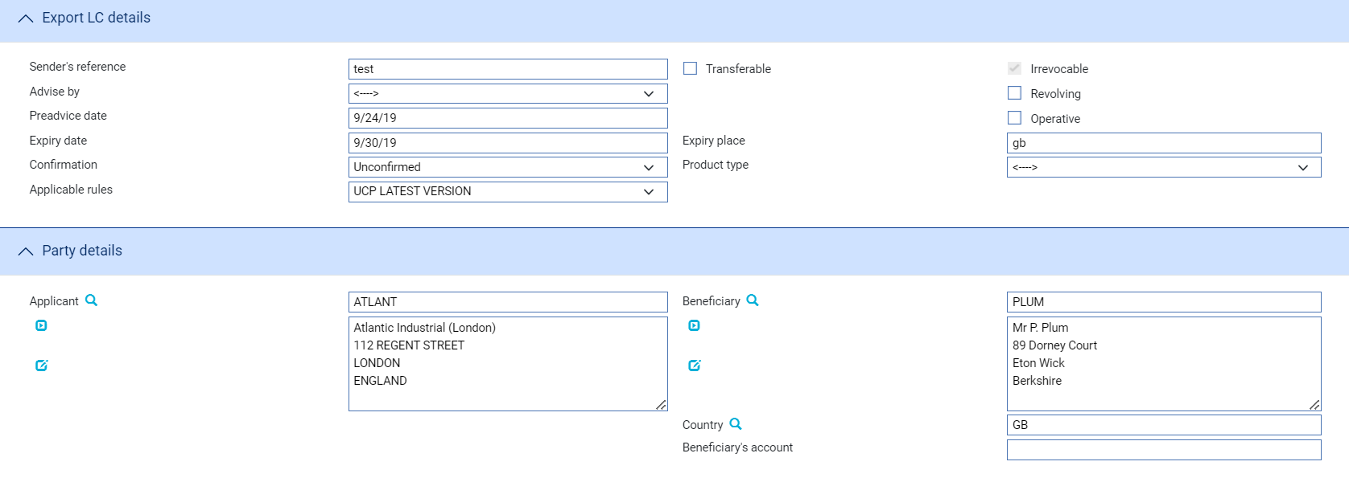 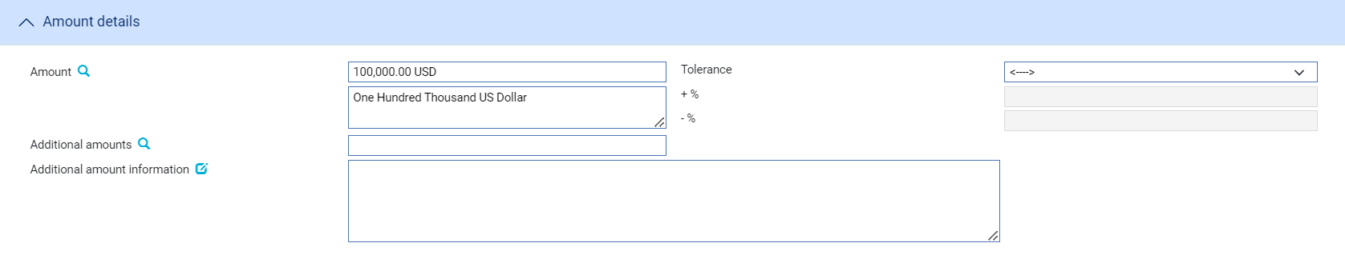  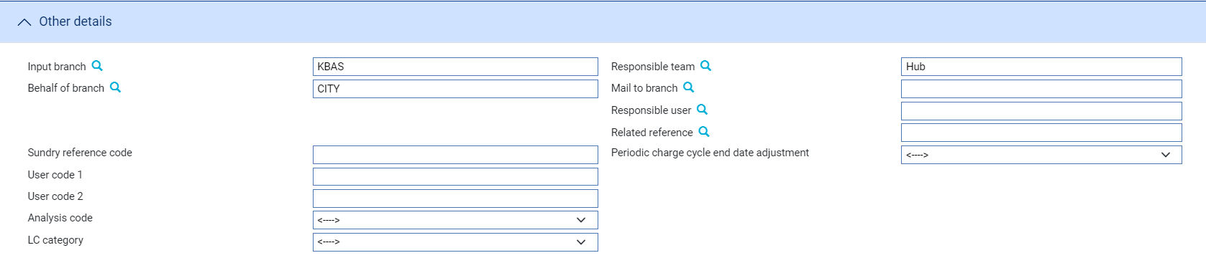

A Pre-advise log step uses the following default panes. Depending on how your system is configured, panes and fields available in log steps can be tailored for each data capture step. See the SDK - Screen Tailoring User Guide – Trade Innovation for details:

* The Export LC Details pane (see page 10)
* The Party Details Pane (see page 10)
* The Amount Details Pane (see page 10)
* The Confirmation Details Pane (see page 11)
* The Other Details Pane (see page 12)

#### The Export LC Details Pane

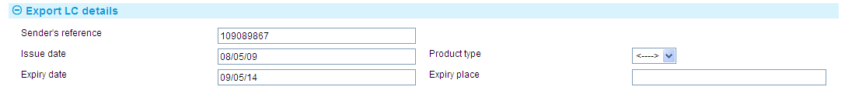

The following table explains what to enter into the fields displayed in the Export LC Details pane:

|  |  |
| --- | --- |
| Field | What to Enter |
| Sender’s Reference | The sending bank's reference. This is stored on the letter of credit's master record as the principal party's reference.  The value you enter here is compared to the Issuer's Reference for any reimbursement authorities on your database as well as against the Sender's Reference for other letters of credit, to ensure that it is unique. If the system finds a duplicate reference, it issues a warning message. |
| Issue Date | The letter of credit's issuance date. The system uses as the default either the date provided by the incoming SWIFT message or today's processing date. |
| Product Type | If your bank has set up product types for export letters of credit, select the appropriate one from the drop-down list on this field. Depending on how your system has been configured, this field may be mandatory. |
| Expiry Date | The expiry date of the letter of credit. |
| Expiry Place | The location at which the expiry date applies. |

#### The Party Details Pane

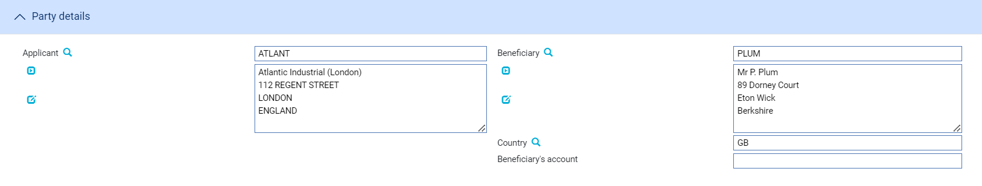 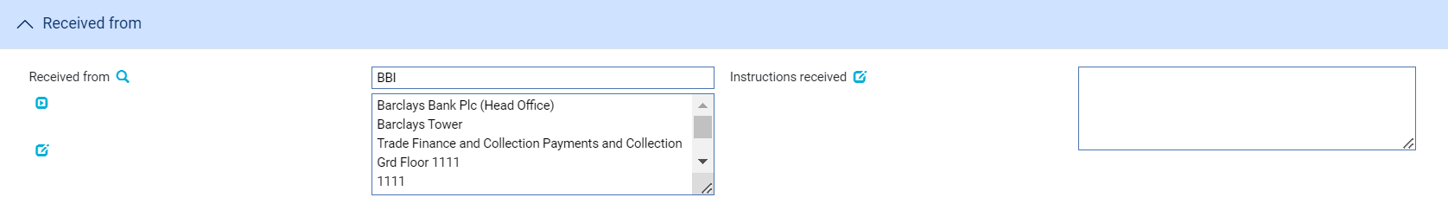

The fields in the Party Details pane allow you to identify the applicant, the beneficiary and the party from whom you received the pre-advice.

The Amount Details Pane

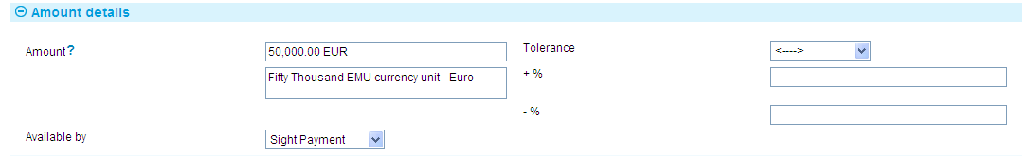

The following table explains what to enter into the fields in the Amount Details pane:

| Field | What to Enter | |
| --- | --- | --- |
| Amount | The amount and currency of the transaction. The system displays the amount and currency in the language of your system beneath these fields. You can edit this text, if necessary. | |
| Tolerance | Specify how the amount is being expressed. Select from one of the following: | |
|  | Exact | If the amount is the exact value of the letter of credit. |
|  | About | If the amount given in the Amount field is within 10% either way of the expected value of the letter of credit. |
|  | Other | If you select this option, use the -% and +% fields to specify as a percentage how much more or less than the final value of the letter of credit the amount entered is allowed to be. |
|  | Not Exceeding | If the final value of the letter of credit is expected to be no more than the amount entered, and not less than 95% of the amount entered. |
|  | Min/Max | If you select this option the system displays a + Amount and a - Amount field. Use them to specify as an amount how much more or less than the final value of the transaction the amount entered is allowed to be. |
| Available By | This field is used to set the tenor of the payment. See the Common Facilities User Guide – Trade Innovation for instructions. | |

#### The Confirmation Details Pane



In the Confirmation Requested field select one of the following values:

|  |  |
| --- | --- |
| Field | What it shows |
| Confirmed | If you have been instructed by the issuing bank to add your confirmation. |
| Unconfirmed | If you have been instructed not to add your confirmation. |
| May Add | If you have been instructed that you may add your confirmation at the beneficiary's request. |

If you have received no confirmation instructions (and the Confirmation Requested field is set as 'Unconfirmed') the Silent Confirmation field allows you as advising bank to confirm the transaction at the request of the beneficiary. Again, additional fields are present that allow you to enter the amount of the credit that is confirmed.

If a transaction receives silent confirmation in this way, it is otherwise still treated as unconfirmed.

If you select 'Confirmed' or 'May Add' additional fields are displayed.



Use them to enter the amount of the credit that is confirmed. You may enter an amount or a percentage; this is usually 100%.

If you have received no confirmation instructions (and the Confirmation Requested field is set as 'Unconfirmed') the Silent Confirmation field allows you as advising bank to confirm the transaction at the request of the beneficiary. Again, additional fields are present that allow you to enter the amount of the credit that is confirmed.

If a transaction receives silent confirmation in this way, it is otherwise still treated as unconfirmed.

#### The Other Details Pane

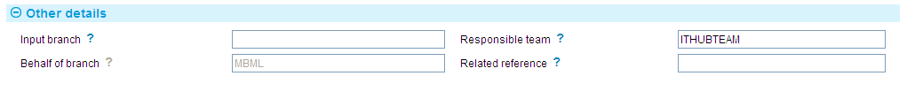

The following table explains what to enter into the fields in the Other Details pane:

|  |  |
| --- | --- |
| Field | What to Enter |
| Input Branch | The input branch for the transaction. The input branch is set from either :   * the accounting branch from the user’s team, or * the transaction branch for user if the user has a default transaction branch or is locked to a specific branch, or * a branch associated with the user where the user can enter transactions for several branches for a team |
| Responsible Team | The team that has overall responsibility for the master e.g. as the contact to resolve any queries or issues regarding the master and associated events. The system defaults the responsible team when creating the transaction as follows:   * Manual – set from team creating the transaction * Gateway – set from the team specified on the incoming message (if present and valid) otherwise to the team to which the transaction is assigned through workflow allocation based on the behalf of branch * SWIFT – set to the team to which the transaction is assigned through workflow allocation based on the behalf of branch   It can be changed, if required, to either the team associated with the primary customer, default team for the product or the user’s current team. |
| Behalf Of Branch | The behalf of branch for the transaction as entered by the user or set from the incoming SWIFT or gateway message. The behalf of branch determines the parameter sets that are to be used to generate charges, documents, postings, etc. during transaction processing. The branch can be changed to any other branch within the same main banking entity that shares the same parameter sets. |
| Related Reference | You can specify any other transaction to which this letter of credit is related. This may already have been done when the master record was created. You can use the browser to select from possible references to include. |

### Entering Full Details of the Pre-advice

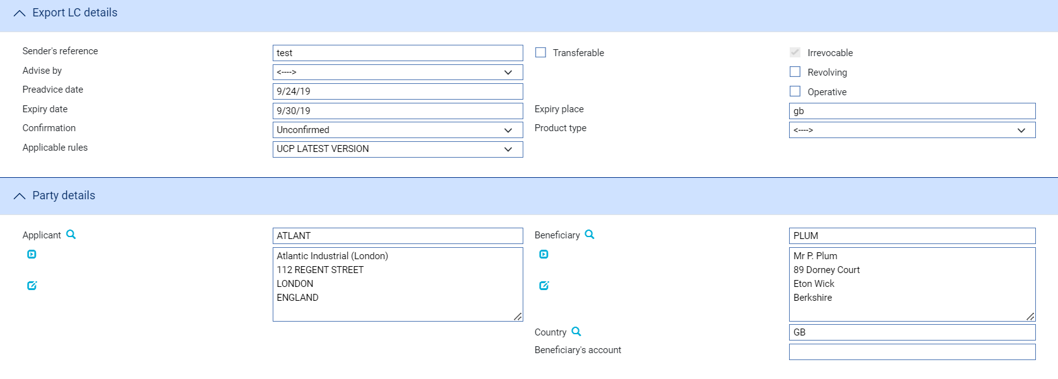 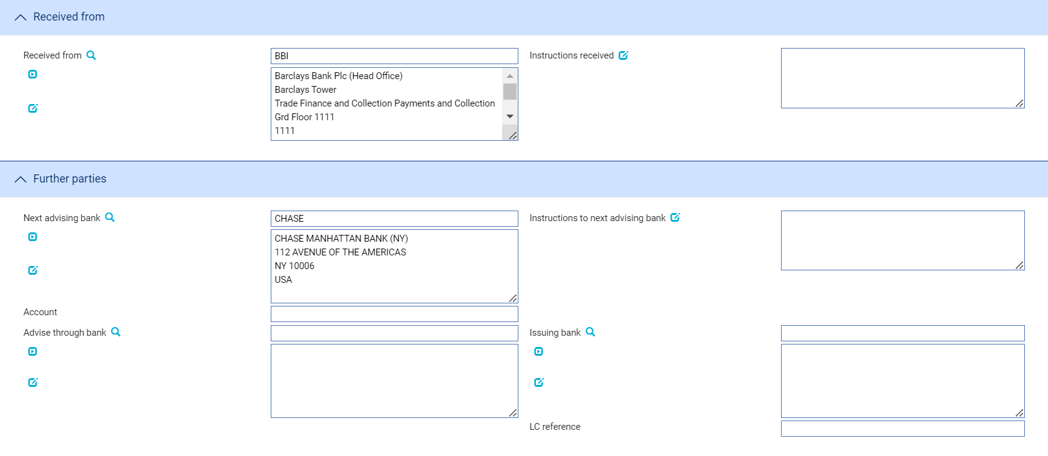 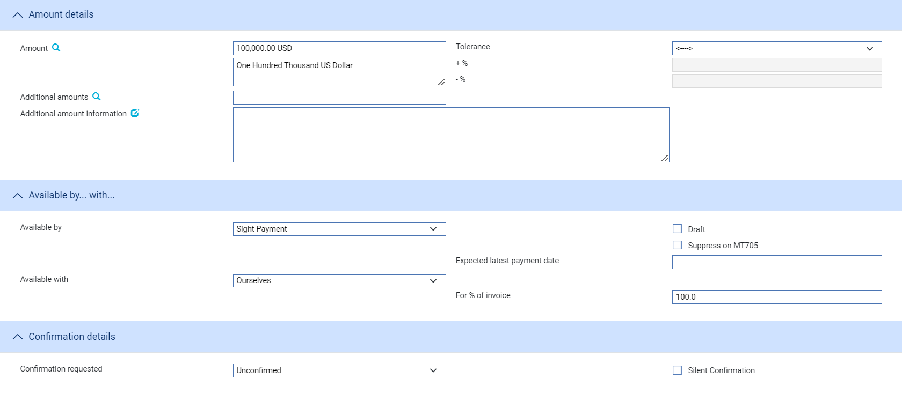 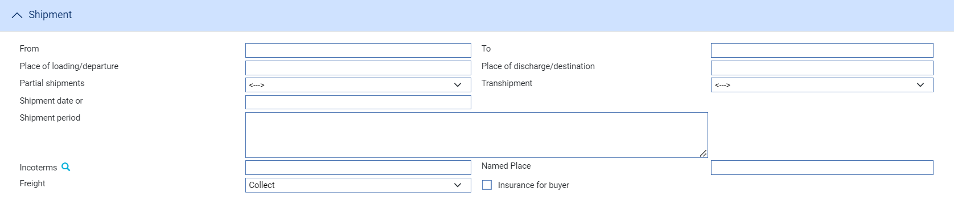 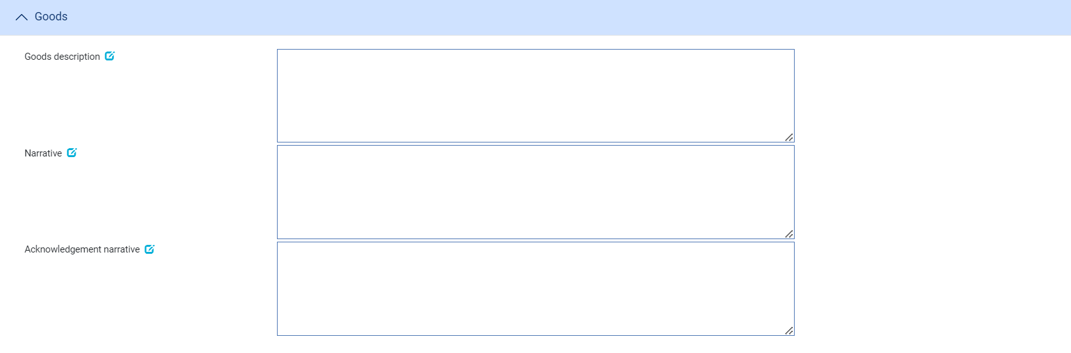 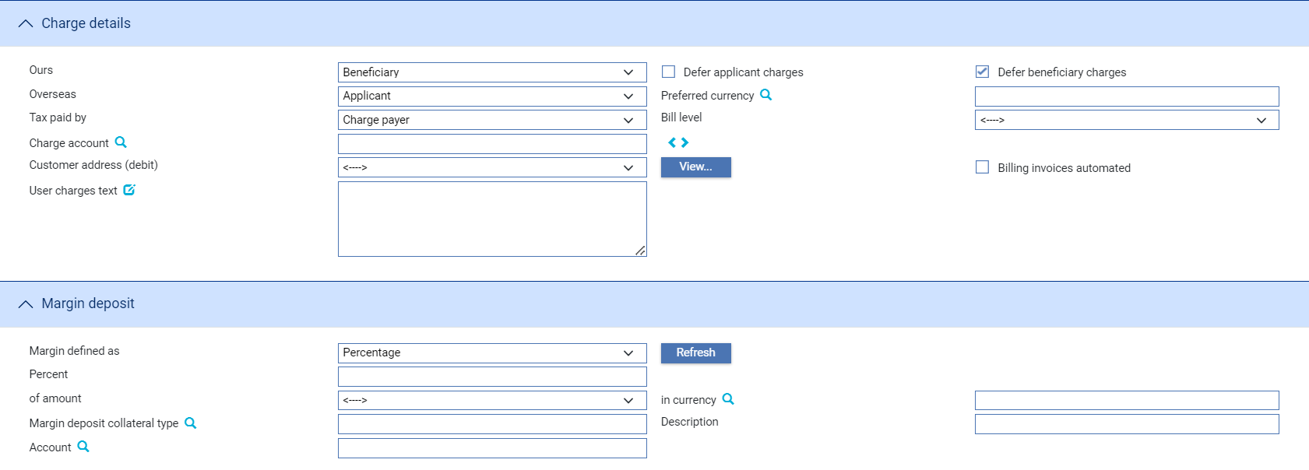

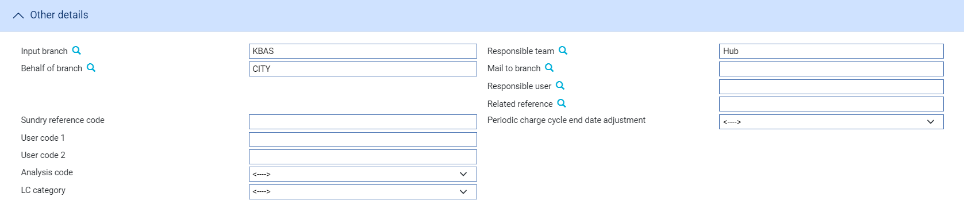

An Input step uses the following panes:

* The Export LC Details Pane (see page 15)
* The Party Details Pane (see page 16)
* The Received From Pane (see page 17)
* The Further Parties Pane (see page 17)
* The Amount Details Pane (see page 18)
* The Available By/With Pane (see page 18)
* The Confirmation Details Pane (see page 19)
* The Shipment Pane (see page 20)
* The Goods Pane (see page 21)
* The Additional Conditions pane (see page 21)
* The Charge Details Pane (see page 21)
* The Margin Deposits Pane (see the Common Facilities User Guide – Trade Innovation)
* The Other Details Pane (see page 22)

#### The Export LC Details Pane

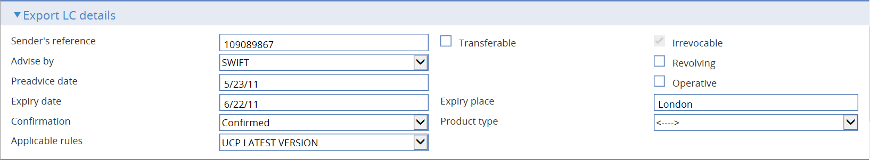

The following table explains what to enter into the fields in the Export LC Details pane:

|  | Field | What to Enter | |
| --- | --- | --- | --- |
|  | Sender's Reference | The sending bank's reference. This is stored on the letter of credit's master record as the principal party's reference.  The value you enter here is compared to the Issuer's Reference for any reimbursement authorities on your database as well as against the Sender's Reference for other letters of credit, to ensure that it is unique. If the system finds a duplicate reference, it issues a warning message. | |
|  | Transferable | Check this field if the letter of credit is transferable. By default the letter of credit is non-transferable. You must check this field if you are to be able to create transfer letters of credit using this letter of credit as the parent. | |
|  | Revocable | Check this field if the letter of credit is revocable.   1. **Revocable** flag is protected and set to Irrevocable when system option SWIFTVersion is set to 2018.   Set Zone system option ‘AllowRevocableLCs’ to make the flag editable and enable user to issue revocable letter of credit with even if SWIFT 2018 is enabled. | |
|  | Revolving | Check this box if the letter of credit is a revolving credit. | |
|  | Operative | Indicate whether the letter of credit is operative or not. If you leave this box unchecked, then the letter of credit will remain inoperative until you use a subsequent event to change this box's setting. | |
|  | Advise By | The method to be used to send the pre-advice on to the next advising bank or the beneficiary, as appropriate. | |
|  | Preadvice Date | The date the pre-advice was created on your system. The system uses today's date as the default. | |
|  | Expiry Date | The expiry date of the letter of credit. | |
|  | Expiry Place | The location at which the expiry date applies. | |
|  | Confirmation | Select from one of the following values: | |
|  |  | Confirmed | If you have been instructed by the issuing bank to add your confirmation. |
|  |  | Unconfirmed | If you have been instructed not to add your confirmation. |
|  |  | May Add | If you have been instructed that you may add your confirmation at the beneficiary's request. |
|  | Product Type | If your bank has set up product types for export letters of credit, select the appropriate one from the drop-down list on this field. Depending on how your system has been configured, this field may be mandatory. | |
|  | Applicable Rules | This allows you to select additional information to be included in the relevant SWIFT MT700 (MT710 and MT720) message generated by the event.  Select one of the following to indicate the rules applied to the issue of the documentary credit: | |
|  |  | UCP LATEST VERSION  The documentary credit is subject to the version of the ICC Uniform Customs and Practice for Documentary Credits, International Chamber of Commerce, Paris, that is in effect on the date of issue. This is used as the default. | |
|  |  | EUCP LATEST VERSION  The documentary credit is subject to the version of the Supplement of the ICC Uniform Customs and Practice for Documentary Credits for Electronic Presentations, International Chamber of Commerce, Paris, that is in effect on the date of issue. | |
|  |  | UCPURR LATEST VERSION  The documentary credit is subject to the version of the ICC Uniform Customs and Practice for Documentary Credits and the version of the Uniform Rules for Bank-to-bank Reimbursements under documentary credits, International Chamber of Commerce, Paris, that is in effect on the date of issue. | |
|  |  | EUCPURR LATEST VERSION  The documentary credit is subject to the version of the Supplement of the ICC Uniform Customs and Practice for Documentary Credits for Electronic Presentations and the version of the Uniform Rules for Bank-to-bank Reimbursements under documentary credits, International Chamber of Commerce, Paris, that is in effect on the date of issue. | |
|  |  | ISP LATEST VERSION  For standby letters of credit only. The documentary credit is subject to the version of the ICC International Standby Practices, International Chamber of Commerce, Paris, that is in effect on the date of issue. | |
|  |  | OTHR  The documentary credit is subject to other rules. Use the Other Applicable Rules field to specify those rules (up to 35 characters). | |
|  | Other Applicable Rules | Displayed only if you select OTHR in the previous field. | |

#### The Party Details Pane

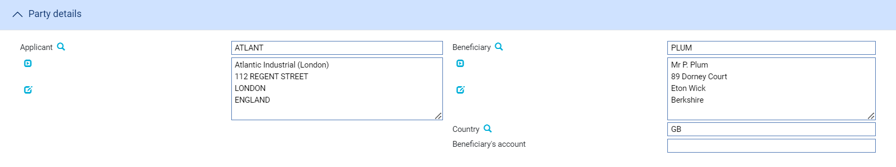

The following table explains what to enter into the fields in the Party Details pane:

|  | Field | What to Enter |
| --- | --- | --- |
|  | Applicant | The applicant. |
|  | Beneficiary | The beneficiary. |
|  | Country | The beneficiary's country. |
|  | Beneficiary's Account | If known, enter the number of the beneficiary's account with the advising bank. |

#### The Received From Pane

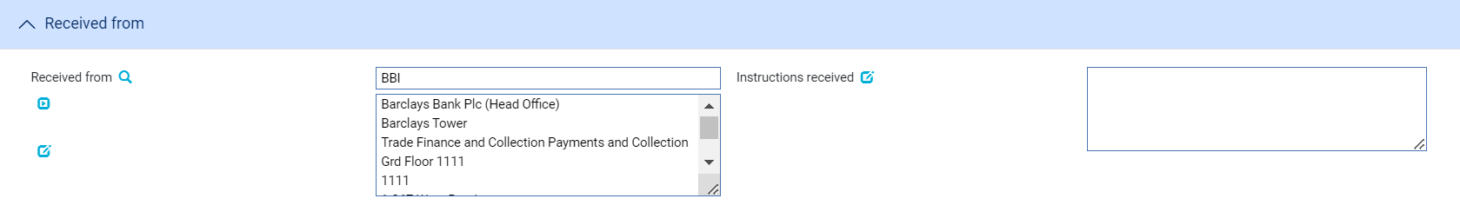

The following table explains what to enter into the fields in the Received From pane:

|  |  |  |
| --- | --- | --- |
|  | Field | What to Enter |
|  | Received From | The party from whom you received the pre-advice. |
|  | Instructions Received | Any Instructions from the bank from which the advice was received. |

#### The Further Parties Pane

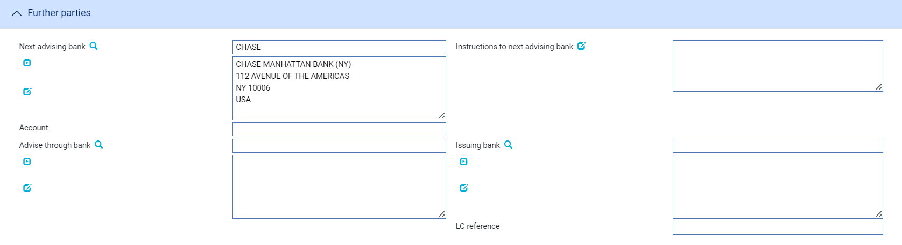

The following table explains what to enter into the fields in the Other Parties pane:

| Field | What to Enter |
| --- | --- |
| Next Advising Bank | The next advising bank. |
| Instructions to Next Advising Bank | Any instructions for the next advising bank. |
| Account | The account at the next advising bank to be used. |
| Advise Through Bank | The Advise Through bank. |
| Issuing Bank | If the sender of the pre-advice was not the issuing bank, identify the issuing bank here. |
| LC Reference | The issuing bank's reference for the letter of credit. You only need enter this if the sender was not the issuing bank. This is recorded on the letter of credit's master record as the originator's reference. |

#### The Amount Details Pane

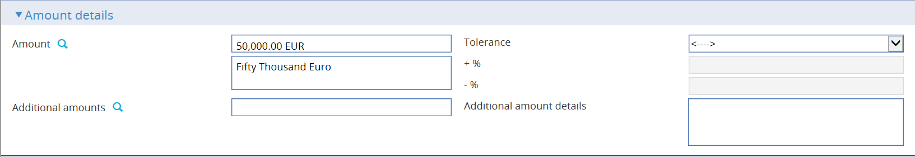

The following table explains what to enter into the fields in the Amount Details pane:

| Field | What to Enter | |
| --- | --- | --- |
| Amount | The amount and currency of the transaction. The system displays the amount and currency in the language of your system beneath these fields. You can edit this text, if necessary. | |
| Tolerance | Specify how the amount is being expressed. Select from one of the following: | |
|  | Exact | If the amount is the exact value of the letter of credit. |
|  | About | If the amount given in the Amount field is within 10% either way of the expected value of the letter of credit. |
|  | Other | If you select this option, use the -% and +% fields to specify as a percentage how much more or less than the final value of the letter of credit the amount entered is allowed to be. |
|  | Not Exceeding | If the final value of the letter of credit is expected to be no more than the amount entered, and not less than 95% of the amount entered. |
|  | Min/Max | If you select this option the system displays a + Amount and a - Amount field. Use them to specify as an amount how much more or less than the final value of the transaction the amount entered is allowed to be. |
| Additional Amounts | Any amounts payable to the beneficiary in addition to the principal amount of the transaction. These might include, for example, local freight charges.  If you enter an amount, it is added to the amount of liability under the transaction. If you use a different currency for the amount, then the amount is converted to the currency of the transaction using the current spot rate. | |
| Additional Amount Details | A text description of what any additional amounts are for. | |

#### The Available By/With Pane

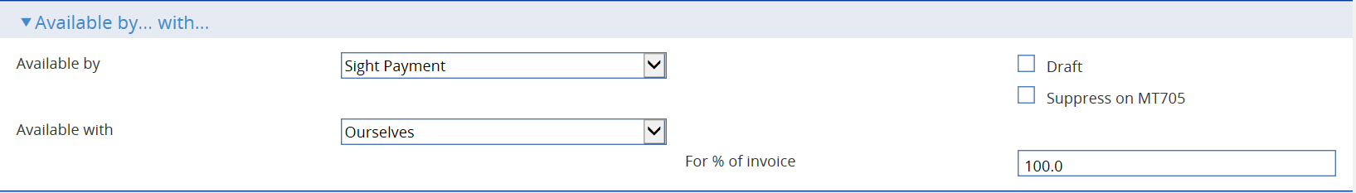

The First field is used to set the tenor of the payment. See the Common Facilities User Guide – Trade Innovation for instructions.

The following table explains what to enter into the remaining fields not covered by the Common Facilities User Guide – Trade Innovation:

| Field | What to Enter | |
| --- | --- | --- |
| Available by | This field is used to set the tenor of the payment. Refer Common Facilities User  Guide – Trade Innovation for instructions. | |
| Draft | Check the draft field if a draft is required. Refer Common Facilities User  Guide – Trade Innovation for instructions. | |
| Suppress on MT705 | Whether to omit the Available With details from the MT705 Pre-Advice. | |
| Available With | Select from one of the following to indicate which party the beneficiary should present documents for payment to:   * Ourselves * Issuing Bank * Advising Bank * Any Bank * Any Bank in (city) - the system displays a field, into which you can enter the name of the city * Any Bank in (country) - the system displays a browser which you can use to select the country * (named bank) - the system displays fields which you can use to specify the bank   additional fields may be displayed, depending on what you have selected: | |
|  | Country | If Available With is set to 'Any Bank in Country' identify the country. |
|  | City | If Available With is set to 'Any Bank in City' identify the city. |
|  | Named Bank | If Available With is set to 'Named Bank' identify the bank. |
| For % of Invoice | The percentage of the invoice value of the goods that the transaction covers. The system uses 100% as the default value. | |

#### The Confirmation Details Pane



In the Confirmation Requested field select one of the following values:

|  |  |
| --- | --- |
| Field | What it Shows |
| Confirmed | If you have been instructed by the issuing bank to add your confirmation. |
| Unconfirmed | If you have been instructed not to add your confirmation. |
| May Add | If you have been instructed that you may add your confirmation at the beneficiary's request. |

If you have received no confirmation instructions (and the Confirmation Requested field is set as 'Unconfirmed') the Silent Confirmation field allows you as advising bank to confirm the transaction at the request of the beneficiary. Again, additional fields are present that allow you to enter the amount of the credit that is confirmed.

If a transaction receives silent confirmation in this way, it is otherwise still treated as unconfirmed.

If you select 'Confirmed' or 'May Add' additional fields are displayed.



Use them to enter the amount of the credit that is confirmed. You may enter an amount or a percentage; this is usually 100%.

#### The Shipment Pane

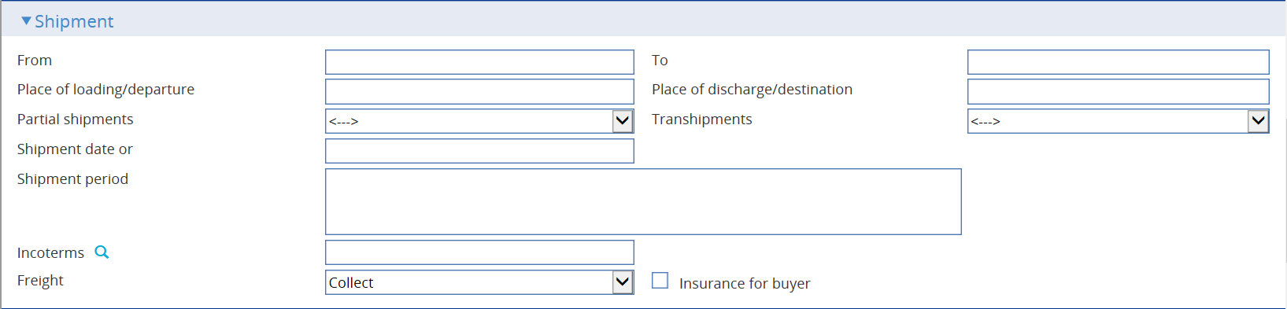

The following table explains what to enter into the fields in the Shipment pane:

| Field | What to Enter | |
| --- | --- | --- |
| From | The place of taking in charge of the goods. | |
| To | The final destination of the goods. | |
| Place of Loading/ Departure | The port or airport where the goods were loaded. | |
| Place of Discharge/ Destination | The port or airport for which the goods are destined. | |
| Partial Shipments/ Transhipments | Select from the following values: | |
|  | Blank | To leave the field blank in the associated SWIFT message |
|  | Allowed | If partial shipments/transhipments are permitted for this letter of credit. |
|  | Not Allowed | If partial shipments/transhipments are not permitted for this letter of credit. |
|  | Conditional | If selected then the user should specify conditions in the Additional conditions narrative. |
| Shipment Date | The latest shipment date allowed. | |
| Shipment Period | Specify the period of time during which goods are to be loaded or dispatched. | |
| Incoterms | Select incoterms. | |
| Freight | When you select a value in the Incoterms field, the system automatically selects the appropriate value in this field using information set up for the selected incoterms to indicate whether freight is to be pre-paid or paid on collection. You can override this value. | |
| Insurance for Buyer | When you select a value in the Incoterms field, the system automatically selects the appropriate value in this field using information set up for the selected incoterms to indicate whether the buyer is to provide insurance cover or not. The field is checked if insurance cover is to be provided by the buyer. You can override the value displayed here. | |

#### The Goods Pane

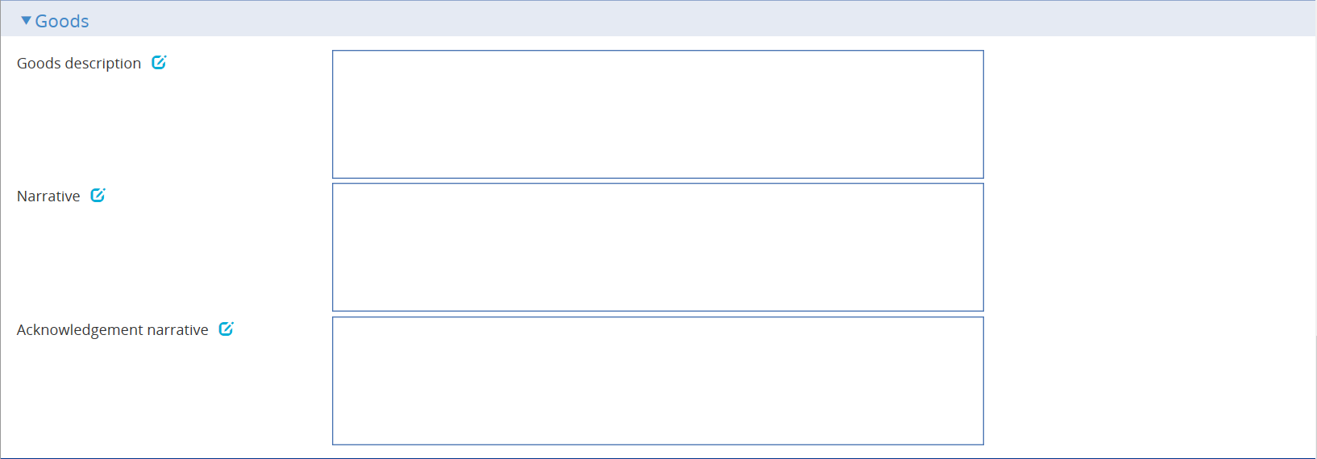

The following table explains what to enter into the fields in the Goods pane:

|  |  |
| --- | --- |
| Field | What to Enter |
| Goods Description | Enter a narrative description of the goods being delivered under the terms of the letter of credit. |
| Narrative | Any narrative that about the letter of credit |
| Acknowledgement Narrative | Additional information about acknowledgement of a received SWIFT message. |

#### The Additional Conditions Pane

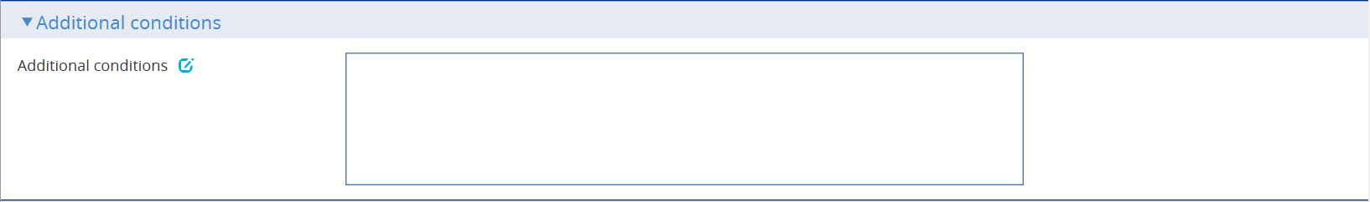 The following table explains what to enter into the fields in the Additional conditions pane:

|  |  |
| --- | --- |
| Field | What to Enter |
| Additional conditions | A description of further conditions of the documentary credit. |

#### The Charge Details Pane

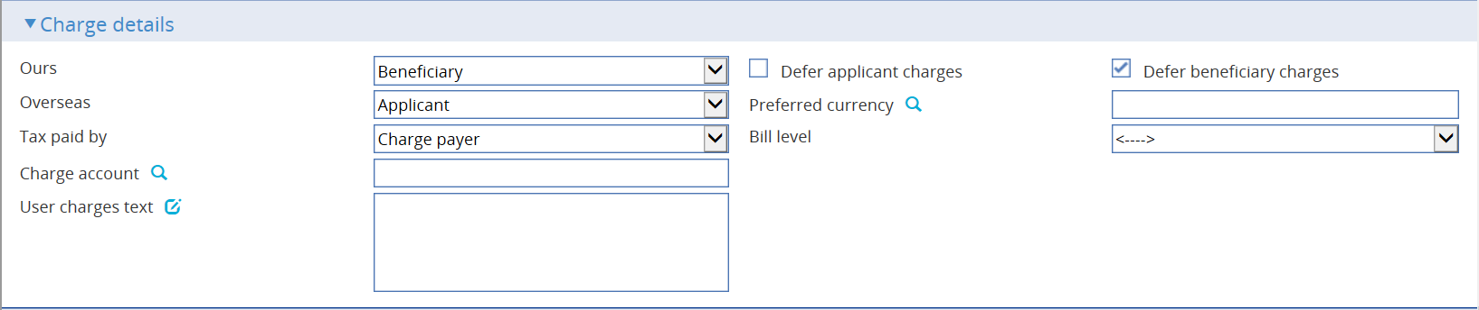

The following table explains what to enter into the fields in the Charge Details pane:

| Field | What to Enter |
| --- | --- |
| Ours | Specify which party - the beneficiary or the applicant - will pay your bank's charges. |
| Defer Applicant Charges | Indicate whether your own charges to the applicant are to be collected now or deferred until payment. Check this box if the charges are to be deferred, otherwise leave it blank. |
| Defer Beneficiary Charges | Indicate whether your own charges to the beneficiary are to be collected now or deferred until payment. Check this box if the charges are to be deferred, otherwise leave it blank. |
| Overseas | Specify which party - the beneficiary or the applicant - will pay overseas charges. |
| Preferred Currency | The currency in which your bank's own charges will be collected. Typically, you would set this to your local currency. If you leave this field blank, the system uses the currency of the letter of credit.  Where the charges are for the applicant, the setting here is overridden by the applicant's preferred currency. |
| Tax Paid By | Specify which party - your customer or the party liable for charges - will pay any tax due on the letter of credit or its charges. |
| Bill Level | Select whether charges for this license should be billed at customer level, transaction level or product level. |
| Charge Account | The number of the account used for any charges debited to the customer. Charge accounting is normally controlled by the standing settlement instructions for charges. Entering an account number here overrides the account specified in the standing settlement instructions. |
| User Charges Text | Any additional information concerning the charges. |

#### The Other Details Pane

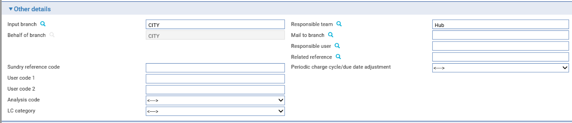

The following table explains what to enter into the fields in the Other Details pane. This pane may also include input fields defined by your bank:

|  | Field | **What to Enter** |
| --- | --- | --- |
|  | Input Branch | The input branch for the transaction. The input branch is set from either:   * the accounting branch from the user’s team, or * the transaction branch for user if the user has a default transaction branch or is locked to a specific branch, or * a branch associated with the user where the user can enter transactions for several branches for a team |
|  | Behalf Of Branch | The behalf of branch for the transaction as entered by the user or set from the incoming SWIFT or gateway message. The behalf of branch determines the parameter sets that are to be used to generate charges, documents, postings, etc. during transaction processing. The branch can be changed to any other branch within the same main banking entity that shares the same parameter sets. |
|  | Sundry Ref Code /User Code 1/ User Code 2 | You may use these fields to enter values for analysis purposes. Your bank will have devised its own system for using these fields. |
|  | Responsible Team | The team that has overall responsibility for the master e.g. as the contact to resolve any queries or issues regarding the master and associated events. The system defaults the responsible team when creating the transaction as follows:   * Manual – set from team creating the transaction * Gateway – set from the team specified on the incoming message (if present and valid) otherwise to the team to which the transaction is assigned through workflow allocation based on the behalf of branch * SWIFT – set to the team to which the transaction is assigned through workflow allocation based on the behalf of branch   It can be changed, if required, to either the team associated with the primary customer, default team for the product or the user’s current team. |
|  | Mail To Branch | The mail to branch can be set to any branch within the main banking entity of the behalf of branch. |
|  | Responsible User | A user that has responsibility for the master e.g. as the contact to resolve any queries or issues regarding the master and associated events. This can be any user assigned to the responsible team. |
|  | Related Reference | You can specify any other transaction to which this letter of credit is related. This may already have been done when the master record was created. You can use the browser to select from possible references to include. |

## Advising an Export Letter of Credit

You can create an Advise event in one of two ways:

If you have not already created the letter of credit using a Pre Advise event, in the Masters window, select the Team and Behalf of branch and use the drop-down list in the New Masters pane to select 'Export Letter of Credit - Advise', then press **New**.

If your system has been configured to allow the incorporation of legacy transactions into the system, an Original Reference field is present in the New Masters pane. This is for use when entering transactions from the legacy system manually. It allows you to enter the legacy system's unique reference for the transaction. If you enter a value here, it must be unique within the system for export letters of credit.

If you have already created a Pre Advise event for the letter of credit, in the Master Summary window select 'Advise' from the Create New Event drop-down list and press **Create**.

In either case, the system opens an Advise event at either a Log step or Input step (see page 24), depending on how the Workflow orchestration controlling the event is configured. See the *Workflow Tailoring User Guide* – Trade Innovation for details.

### Entering Full Details of the Advice

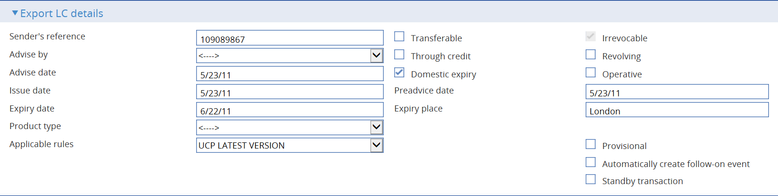 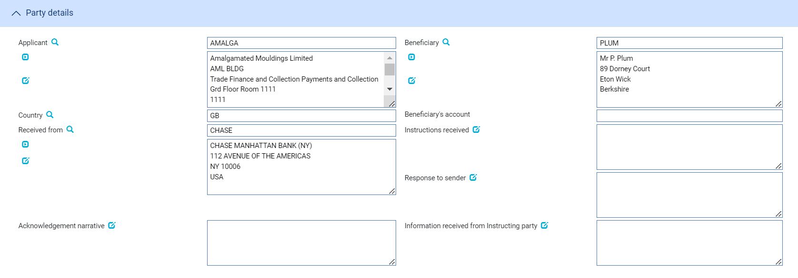

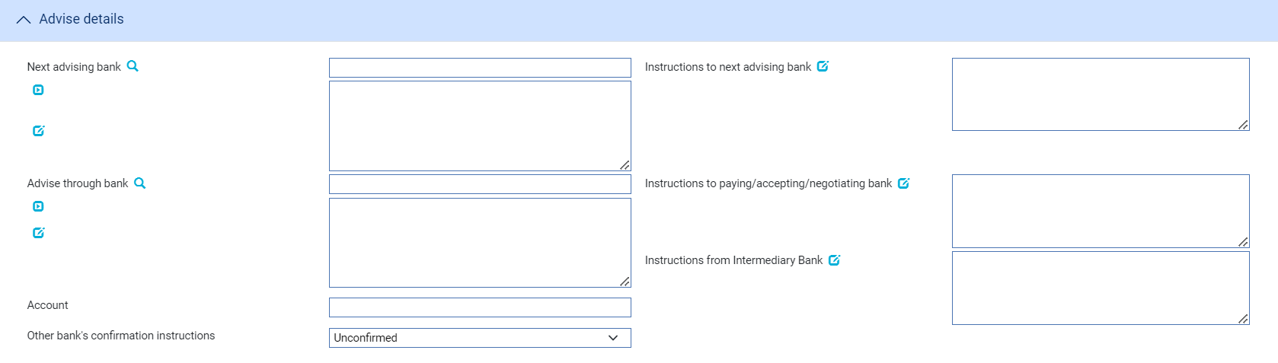

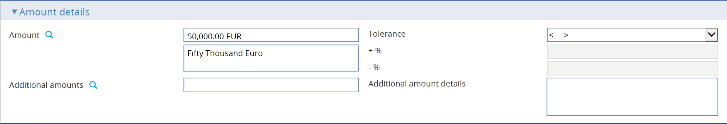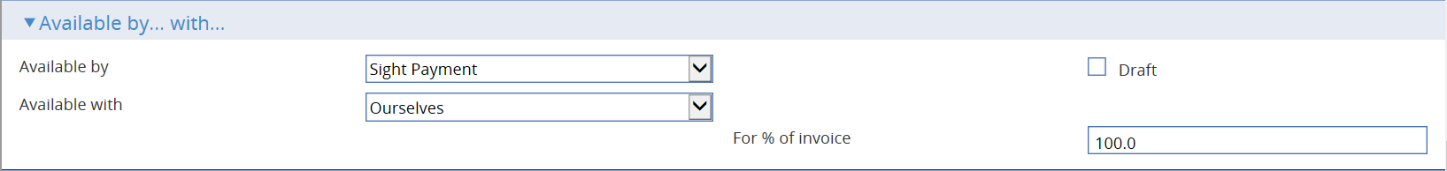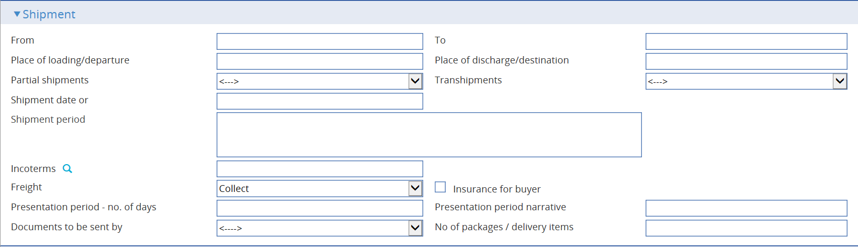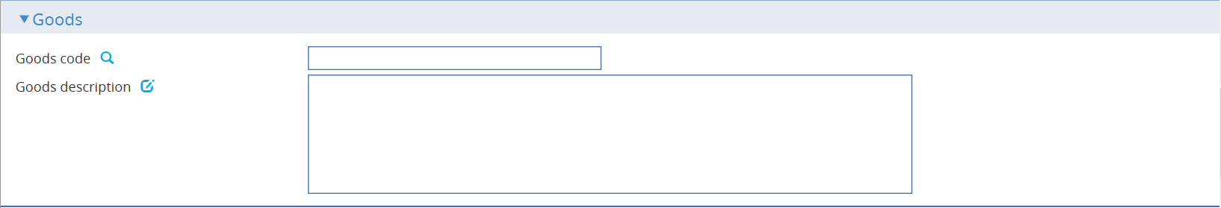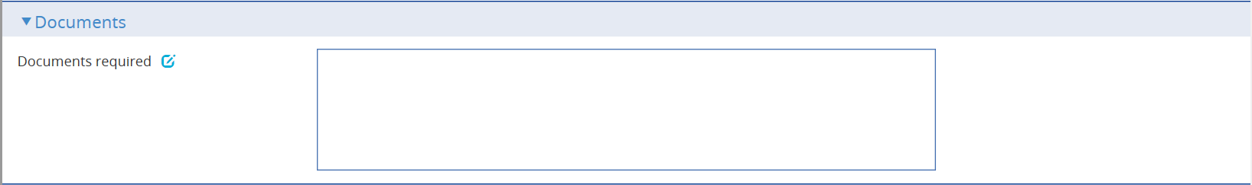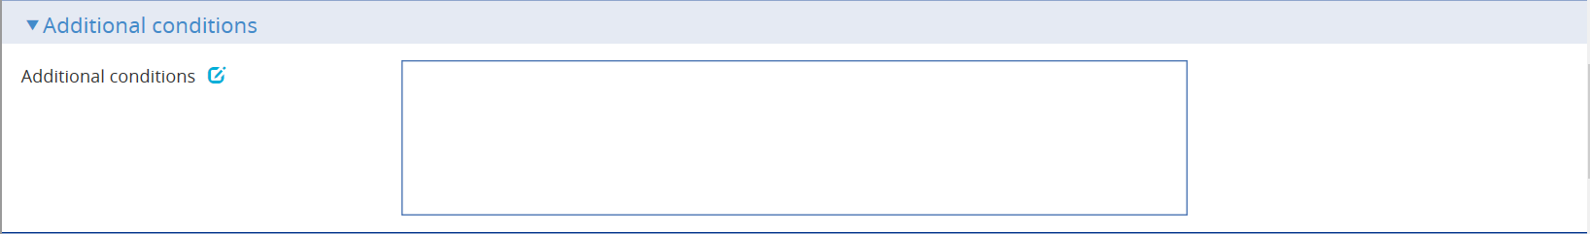

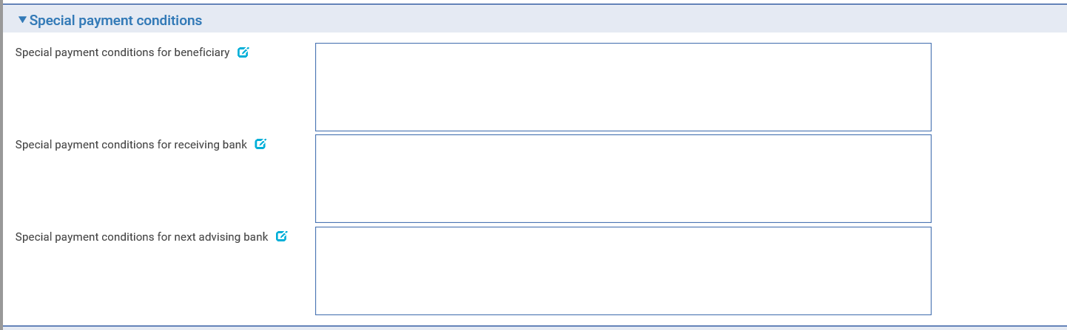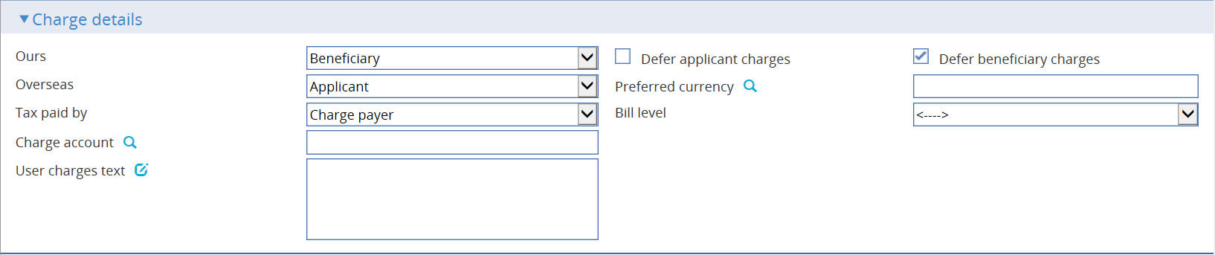

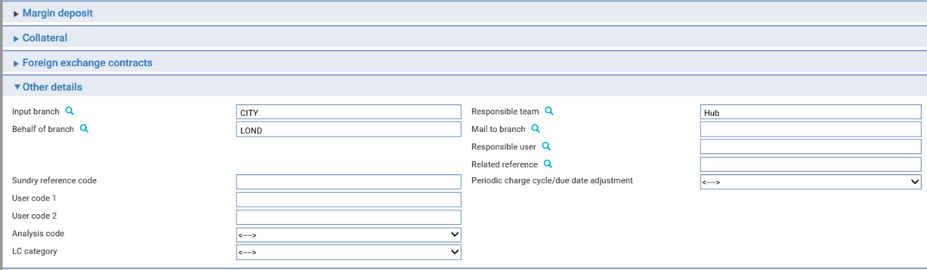 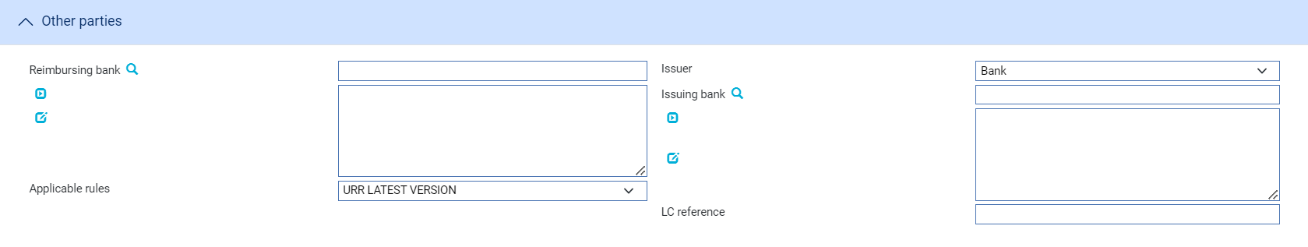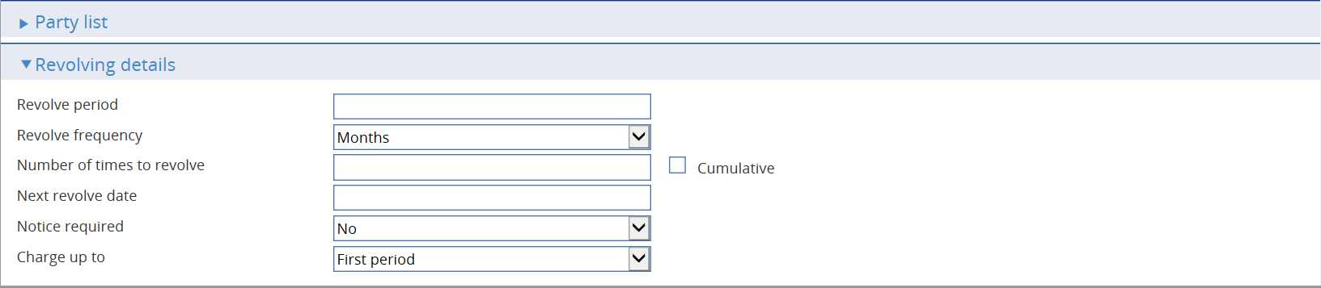

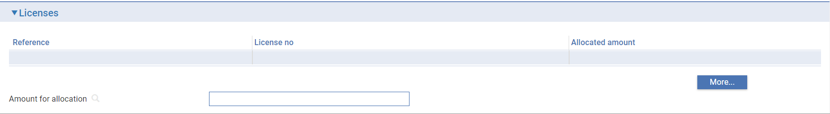

The window used during the Input step has the following panes:

* The Export LC Details Pane (see page 27)
* The Party Details Pane (see page 29)
* The Advise Details Pane (see page 29)
* The Amount Details Pane (see page 34)
* The Confirmation Details Pane (see page 31)
* The Available By/With Pane (see page 32)
* The Shipment Pane (see page 33)
* The Goods Pane (see page 34)
* The Documents Pane (see page 34)
* The Additional Conditions Pane (see page 34)
* The Special Payment Conditions Pane (see page 34)
* The Charge Details Pane (see page 35)
* The Margin Deposit Pane
* The Collateral Pane
* The Foreign Exchange Contracts Pane
* The Other Detail Pane (see page 36)
* The Other Parties Pane (see page 37)
* The Party List Pane
* The Revolving Details Pane (see page 38)
* The License Pane (see page 8)

Instructions on using the Margin Deposit pane, the Collateral pane, the FX Contracts pane and the Party List pane are given in the Common Facilities User Guide – Trade Innovation.

### The Export LC Details Pane

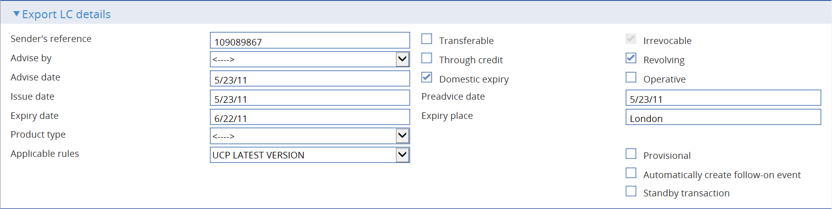

The following table explains what to enter into the fields in the Export LC Details pane:

|  | Field | What to Enter | |
| --- | --- | --- | --- |
|  | Sender's Reference | The sending bank's reference. This is stored on the letter of credit's master record as the principal party's reference.  The value you enter here is compared to the Issuer's Reference for any reimbursement authorities on your database as well as against the Sender's Reference for other letters of credit, to ensure that it is unique. If the system finds a duplicate reference, it issues a warning message. | |
|  | Transferable | Check this field if the letter of credit is transferable. You must check this field to be able to create transfer letters of credit using this letter of credit as the parent.  This field is disabled if you check the Standby Transaction field. | |
|  | Revocable | Check this field if the letter of credit is revocable.   1. **Revocable** flag is protected and set to Irrevocable when system option SWIFTVersion is set to 2018.   Set Zone system option ‘AllowRevocableLCs’ to make the flag editable and enable user to issue revocable letter of credit with even if SWIFT 2018 is enabled. | |
|  | Advise By | The method to be used to transmit the letter of credit to the next advising bank or beneficiary, as appropriate. | |
|  | Domestic Expiry | Check this box if the letter of credit expires in the bank's operating country. By default, the letter of credit expires domestically. Depending on whether the letter of credit expires locally or overseas, the system will display a different date for the expiry of the master. This date depends on product options set up by your bank. | |
|  | Revolving | Check this box if the letter of credit is a revolving credit. | |
|  | Advise Date | The date the letter of credit was created on your system. The system uses today's date as the default. | |
|  | Through Credit | Check this field if the letter of credit is being sent out with a named advise through bank as well as a next advising bank. | |
|  | Operative | Indicate whether the letter of credit is operative or not. By default the letter of credit is operative and the box is checked. If you uncheck this box, then the letter of credit will remain inoperative until you use an Amend event to make it operative. | |
|  | Issue Date | The letter of credit's issuance date. The system displays either the date provided by the incoming SWIFT message or today's processing date. | |
|  | Preadvice Date | If a pre-advice has been sent, this field displays the date of the pre-advice. | |
|  | Expiry Date | The expiry date of the letter of credit. | |
|  | Expiry Place | The location at which the expiry date applies. | |
|  | Product Type | If your bank has set up product types for export letters of credit, select the appropriate one from the drop-down list on this field. Depending on how your system has been configured, this field may be mandatory. | |
|  | Applicable Rules | Allows you to select additional information to be included in the relevant SWIFT MT700 (MT710 and MT720) message generated by the event.  Select one of the following to indicate the rules applied to the issue of the documentary credit: | |
|  |  | UCP LATEST VERSION | The documentary credit is subject to the version of the ICC Uniform Customs and Practice for Documentary Credits, International Chamber of Commerce, Paris, that is in effect on the date of issue.  This is used as the default. |
|  |  | EUCP LATEST VERSION | The documentary credit is subject to the version of the Supplement of the ICC Uniform Customs and Practice for Documentary Credits for Electronic Presentations, International Chamber of Commerce, Paris, that is in effect on the date of issue. |
|  |  | UCPURR LATEST VERSION | The documentary credit is subject to the version of the ICC Uniform Customs and Practice for Documentary Credits and the version of the Uniform Rules for Bank-to-bank Reimbursements under documentary credits, International Chamber of Commerce, Paris, that is in effect on the date of issue. |
|  |  | EUCPURR LATEST VERSION | The documentary credit is subject to the version of the Supplement of the ICC Uniform Customs and Practice for Documentary Credits for Electronic Presentations and the version of the Uniform Rules for Bank-to-bank Reimbursements under documentary credits, International Chamber of Commerce, Paris, that is in effect on the date of issue. |
|  |  | ISP LATEST VERSION | For standby letters of credit only. The documentary credit is subject to the version of the ICC International Standby Practices, International Chamber of Commerce, Paris, that is in effect on the date of issue. |
|  |  | OTHR | The documentary credit is subject to other rules. Use the Other Applicable Rules field to specify those rules (up to 35 characters). |
|  | Other Applicable Rules | Displayed only if you select OTHR in the previous field. | |
|  | Standby Transaction | Displayed only if your bank has set the StandbysWithinLCsOrGuarantees system option on, thereby allowing you to process standby letters of credit using normal letters of credit functionality.  Check this field if the transaction is a standby letter of credit rather than a normal letter of credit. | |

### The Party Details Pane

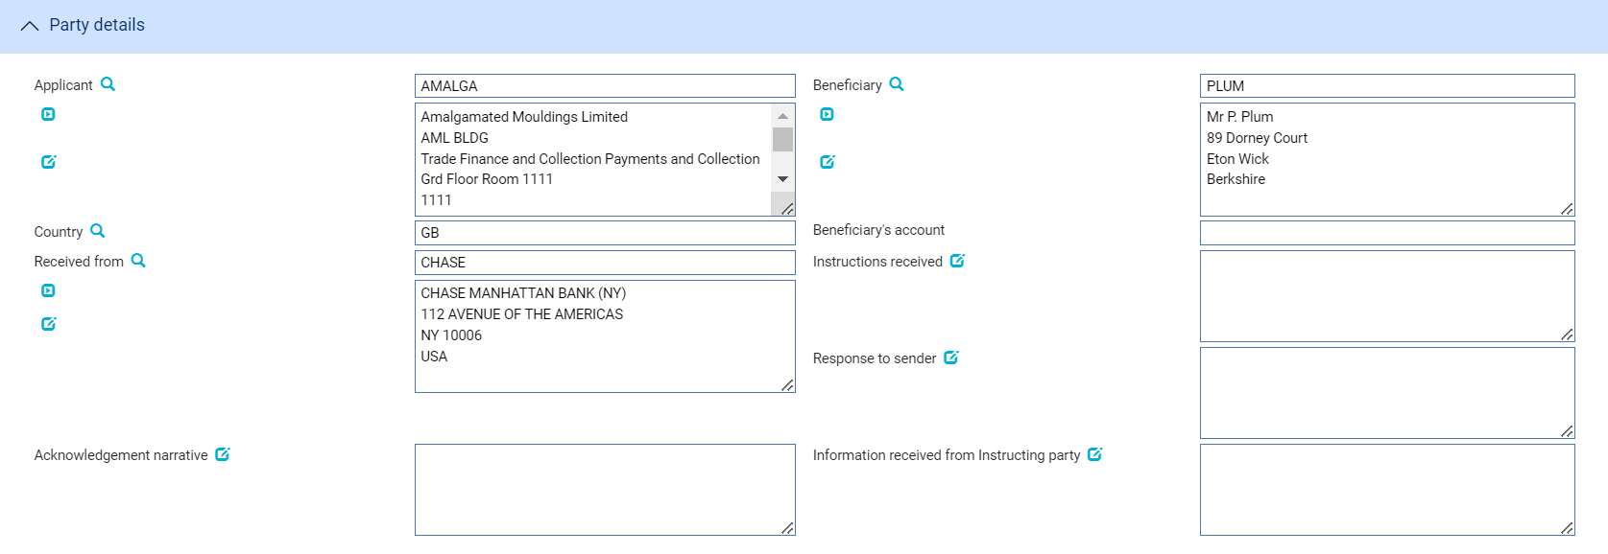

The following table explains what to enter into the fields in the Party Details pane:

|  |  |  |
| --- | --- | --- |
|  | Field | What to Enter |
|  | Applicant | The applicant. |
|  | Beneficiary | The beneficiary. |
|  | Country | The applicant’s country |
|  | Beneficiary's Account | Enter the number of the beneficiary's account with the advising bank, if you know it. |
|  | Received From | The party from whom you received the pre-advice. |
|  | Instructions Received | Any instructions from the bank from which the advice was received. |
|  | Response to Sender | Any information concerning the letter of credit for the party from whom you received it. |
|  | Acknowledgement Narrative | Any information about acknowledgement of a received SWIFT message. |
|  | Information received from Instructing party | Any information or instructions from the instructing party. |

### The Advise Details Pane

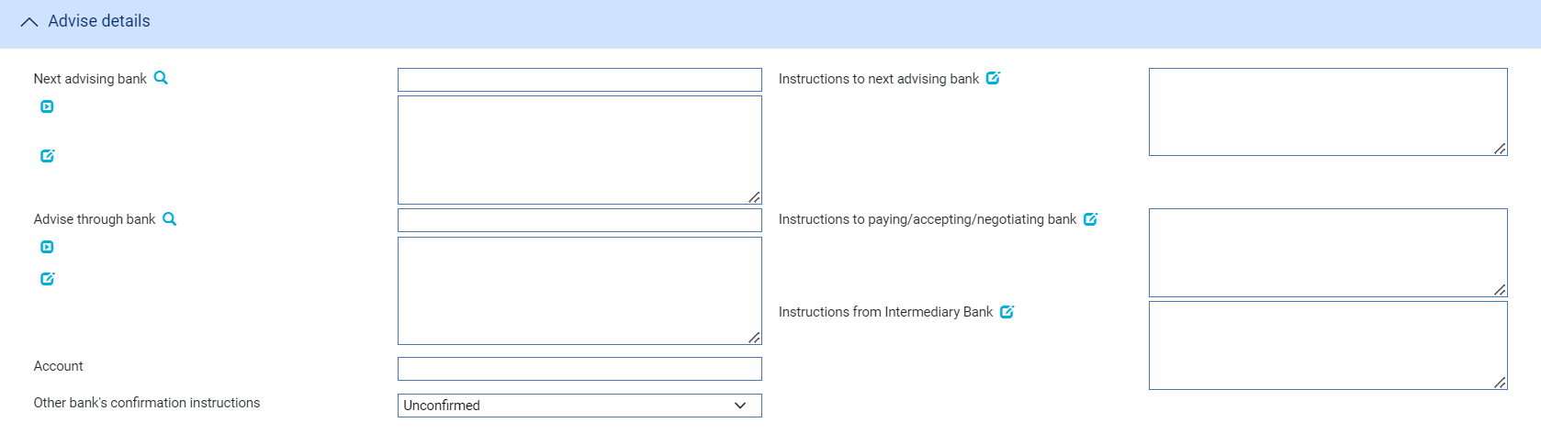

The following table explains what to enter into the fields in the Advise Details pane:

| Field | What to Enter | | |
| --- | --- | --- | --- |
| Next Advising Bank | The next advising bank to which the letter of credit advice is to be sent. | | |
| Instructions to Next Advising Bank | If the advice is being passed on to a next advising bank, enter any instructions for that bank into this field. | | |
| Advise Through Bank | The advise through bank, if relevant. | | |
| Account | The account to be used at the Advise Through bank, if relevant. | | |
| Instructions to Paying Bank | Any instructions for the paying bank. | | |
| Instructions from Intermediary Bank | Represents instructions to the intermediary bank | | |
| Other bank’s confirmation instructions | Select one from the following options: | | |
|  | Confirmed | | If you want the requested confirmation party to confirm the letter of credit. |
|  | Unconfirmed | | If you do not want the requested confirmation party to confirm the letter of credit. This is the default value. |
|  | May Add | | If you have no preference whether the requested confirmation party confirms the letter of credit or not. |
| Confirmed By | Select one from the following options: | | |
|  | Blank | The default value for this field. | |
|  | Ourselves | If you are requested to add confirmation or may add confirmation. | |
|  | Advise Through Bank | If the advise through bank is requested to add its confirmation or may add its confirmation. | |
|  | Received from bank | If the sender of the credit is requested to add its confirmation or may add its confirmation. | |
|  | OTHER | If other bank is requested to add its confirmation or may add its confirmation. | |
|  | This field is displayed and mandatory when Other Bank’s Confirmation is set to CONFIRMED or MAY ADD. | | |
| Requested Confirmation Party | The name and address of the bank which is requested to add its confirmation or may add its confirmation.  This field is displayed and mandatory when Confirmed By is set to Other. | | |
| Confirmation charges payable by | Select from one of the following options: | | |
|  | Blank | The default value for this field. | |
|  | Applicant | If you want the applicant to be responsible for payment of confirmation charges | |
|  | Beneficiary | If you want the beneficiary to be responsible for payment of confirmation charges | |
|  | This field is displayed and mandatory when confirmation is set to CONFIRMED or MAY ADD. | | |

### The Amount Details Pane

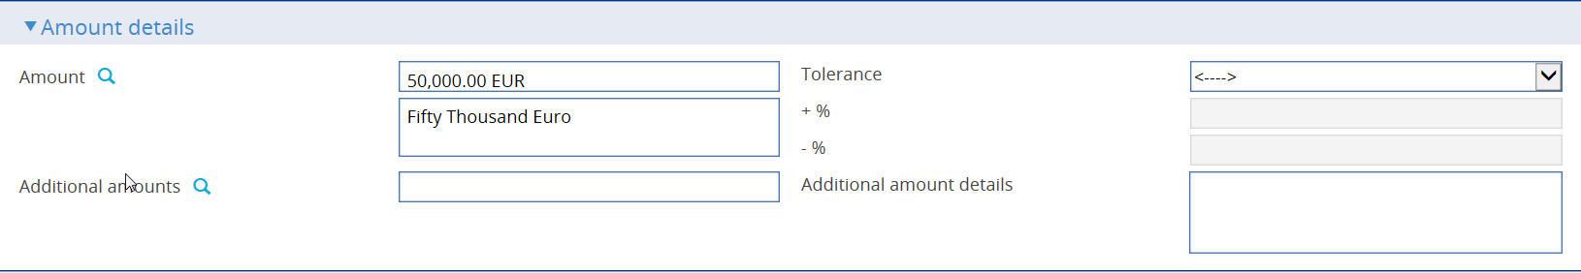

The following table explains what to enter into the fields in the Amount Details pane:

|  |  |  |
| --- | --- | --- |
| Field | What to Enter | |
| Amount | The amount and currency of the transaction. The system displays the amount and currency in the language of your system beneath these fields. You can edit this text, if necessary. | |
| Tolerance | Specify how the amount is being expressed. Select from one of the following: | |
|  | Exact | If the amount is the exact value of the letter of credit. |
|  | About | If the amount given in the Amount field is within 10% either way of the expected value of the letter of credit. |
|  | Other | If you select this option, use the -% and +% fields to specify as a percentage how much more or less than the final value of the letter of credit the amount entered is allowed to be. |
|  | Not Exceeding | If the final value of the letter of credit is expected to be no more than the amount entered, and not less than 95% of the amount entered. |
|  | Min/Max | If you select this option the system displays a + Amount and a - Amount field. Use them to specify as an amount how much more or less than the final value of the transaction the amount entered is allowed to be. |
| Additional Amounts | Any amounts payable to the beneficiary in addition to the principal amount of the transaction. These might include, for example, local freight charges.  If you enter an amount, it is added to the amount of liability under the transaction. If you use a different currency for the amount, then the amount is converted to the currency of the transaction using the current spot rate. | |
| Additional Amount Details | A text description of what any additional amounts are for. | |

### The Confirmation Details Pane



In the Confirmation Requested field select one of the following values:

|  |  |
| --- | --- |
| Field | What it Shows |
| Confirmed | If you have been instructed by the issuing bank to add your confirmation. |
| Unconfirmed | If you have been instructed not to add your confirmation. |
| May Add | If you have been instructed that you may add your confirmation at the beneficiary's request. |

If you have received no confirmation instructions (and the Confirmation Requested field is set as 'Unconfirmed') the Silent Confirmation field allows you as advising bank to confirm the transaction at the request of the beneficiary. Again, additional fields are present that allow you to enter the amount of the credit that is confirmed.

If a transaction receives silent confirmation in this way, it is otherwise still treated as unconfirmed.

If you select 'Confirmed' or 'May Add' additional fields are displayed.



Use them to enter the amount of the credit that is confirmed. You may enter an amount or a percentage; this is usually 100%.

### The Available By/With Pane

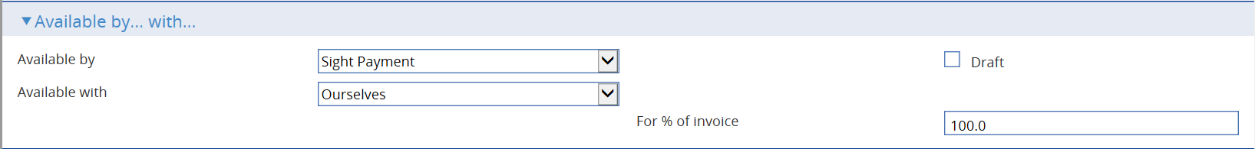

The Available By field is used to set the tenor of the payment. See the Common Facilities User Guide – Trade Innovation for instructions. The default value is Sight Payment.

The following table explains what to enter into the remaining fields not covered by the Common Facilities User Guide – Trade Innovation:

| Field | What to Enter | |
| --- | --- | --- |
| Available With | Select from one of the following to indicate which party the beneficiary should present documents for payment to:   * Ourselves * Issuing Bank * Advising Bank * Any Bank * Any Bank in (city) - the system displays a field, into which you can enter the name of the city * Any Bank in (country) - the system displays a browser which you can use to select the country * (named bank) - the system displays fields which you can use to specify the bank   additional fields may be displayed, depending on what you have selected: | |
|  | Country | If Available With is set to 'Any Bank in Country' identify the country. |
|  | City | If Available With is set to 'Any Bank in City' identify the city. |
|  | Named Bank | If Available With is set to 'Named Bank' identify the bank. |
| For % of Invoice | The percentage of the invoice value of the goods that the transaction covers. The system uses 100% as the default value. | |

### The Shipment Pane

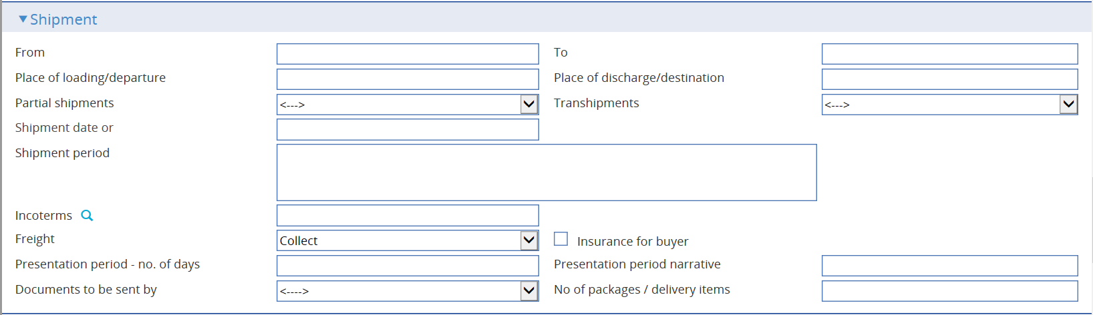

The following table explains what to enter into the fields in the Shipment pane:

| Field | What to Enter | |
| --- | --- | --- |
| From | The place of taking in charge of the goods. | |
| To | The final destination of the goods. | |
| Place of Loading/ Departure | The port or airport where the goods were loaded. | |
| Place of Discharge/ Destination | The port or airport for which the goods are destined. | |
| Partial Shipments/ Transhipments | Select from the following values: | |
|  | Blank | To leave the field blank in the associated SWIFT message. |
|  | Allowed | If partial shipments/transhipments are permitted for this letter of credit. |
|  | Not Allowed | If partial shipments/transhipments are not permitted for this letter of credit. |
|  | Conditional | If selected then the user should specify conditions in the Additional conditions narrative. |
| Shipment Date | The latest shipment date allowed. | |
| Shipment Period | Specify the period of time during which goods are to be loaded or despatched. | |
| Incoterms | Select incoterms. | |
| Freight | When you select a value in the Incoterms field, the system automatically selects the appropriate value in this field using information set up for the selected incoterms to indicate whether freight is to be pre-paid or paid on collection. You can override this value. | |
| Insurance for Buyer | When you select a value in the Incoterms field, the system automatically selects the appropriate value in this field using information set up for the selected incoterms to indicate whether the buyer is to provide insurance cover or not. The field is checked if insurance cover is to be provided by the buyer. You can override the value displayed here. | |
| Presentation Period/Presentation Period Narrative | Specify the number of calendar days after the date of shipment within which the documents must be presented for payment, acceptance or negotiation. Narrative must only be used to specify another type of date than a shipment date, for example invoice date, from which the period for presentation begins.  A default value is set automatically, calculated using the latest shipping date and the expiry date, but this default can be overridden. | |
| Documents to be Sent By | The method to be used to send documents. | |
| No of Packages/Delivery Items | Specify how many mailings are to be made. | |

### The Goods Pane

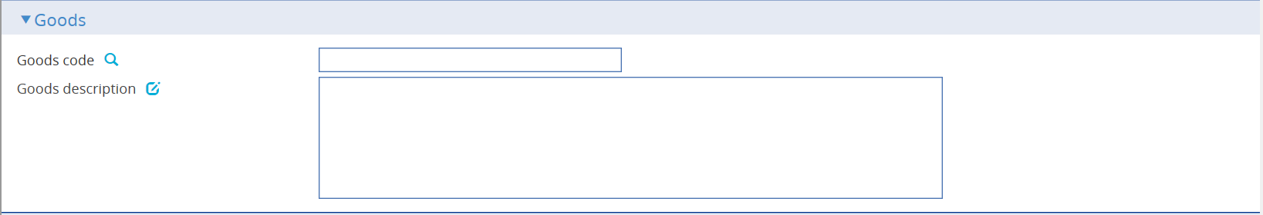

|  |  |
| --- | --- |
| Field | What to Enter |
| Goods code | Select a goods code. |
| Goods description | Enter a narrative description of the goods being delivered under the terms of the letter of credit. |

### The Documents Pane

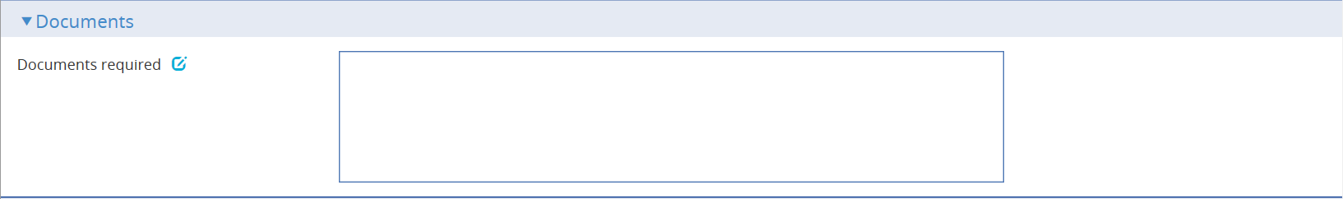

|  |  |
| --- | --- |
| Field | What to Enter |
| Documents required | Enter a narrative description of any documents required to support the transaction. |

### The Additional Conditions Pane

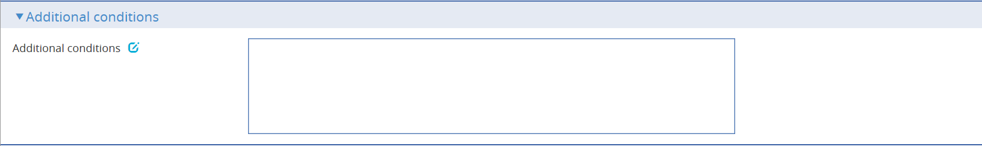

|  |  |
| --- | --- |
| Field | What to Enter |
| Additional conditions | Enter a narrative description of any additional conditions. |

### The Special Payment Conditions Pane

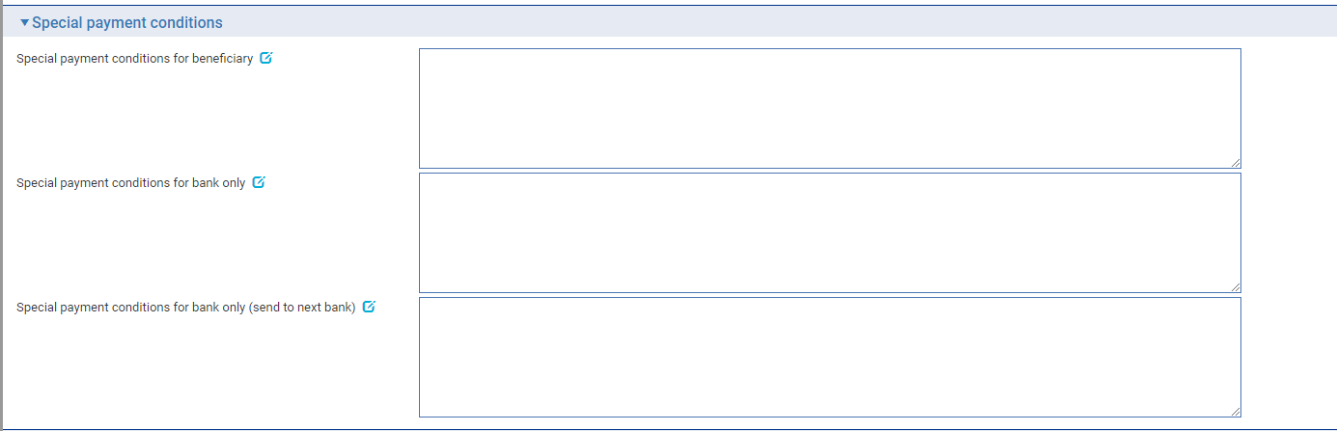

The following table explains what to enter into the fields in the Special Payment Conditions pane:

|  |  |
| --- | --- |
| Field | What to Enter |
| Special payment conditions for beneficiary | Specify special payment conditions applicable to the beneficiary of the credit. |
| Special payment conditions for bank only | Specify special payment conditions applicable to the receiving bank of the credit without disclosure to the beneficiary. |
| Special payment conditions for bank only (send to next bank) | Specify special payment conditions applicable to the next advising bank / advise through bank of the credit without disclosure to the beneficiary. |

### The Charge Details Pane

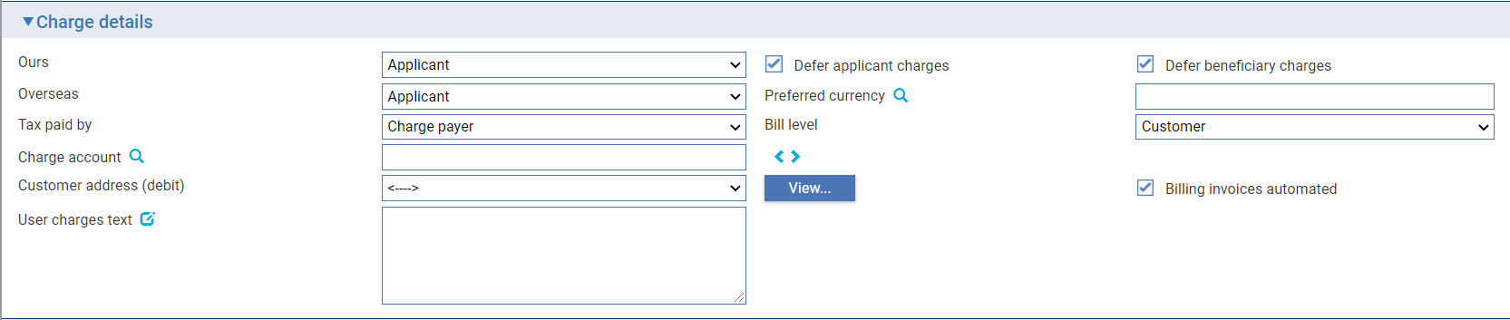

The following table explains what to enter into the fields in the Charge Details pane:

| Field | What to Enter |
| --- | --- |
| Ours | Specify which party - the beneficiary or the applicant - will pay your bank's charges. |
| Defer applicant charges | Indicate whether the applicant charges are to be collected now or deferred until payment. Check this box if the charges are to be deferred, otherwise leave it blank. |
| Defer beneficiary charges | Indicate whether the beneficiary charged are to be collected now or deferred until payment. Check this box if the charges are to be deferred, otherwise leave it blank. |
| Overseas | Specify which party - the beneficiary or the applicant - will pay overseas charges. |
| Preferred Currency | The currency in which your bank's own charges will be collected. Typically, you would set this to your local currency. If you leave this field blank, the system uses the currency of the letter of credit.  Where the charges are for the applicant, the setting here is overridden by the applicant's preferred currency. |
| Tax Paid By | Specify which party - your customer or the party liable for charges - will pay any tax due on the letter of credit or its charges. |
| Bill Level | Select whether charges for this letter of credit should be billed at customer level, transaction level or product level. The Bill level list field excludes user defined level. |
| Charge Account | The number of the account used for any charges debited to the customer. Charge accounting is normally controlled by the standing settlement instructions for charges. Entering an account number here overrides the account specified in the standing settlement instructions. |
| Customer address (debit) | The charge payer customer’s address defaults to their prime address. The customer’s alternative address can be selected using the list field.   1. This list excludes the customer’s prime and SWIFT address types. Use the adjacent View button to display the chosen address in full. |
| Billing invoices automated | This check box can be used to indicate whether the invoices for charges generated by the transaction (e.g. Billing settlement event) are automatically generated or not. |
| User Charges Text | Any additional information concerning the charges. |

### The Other Details Pane

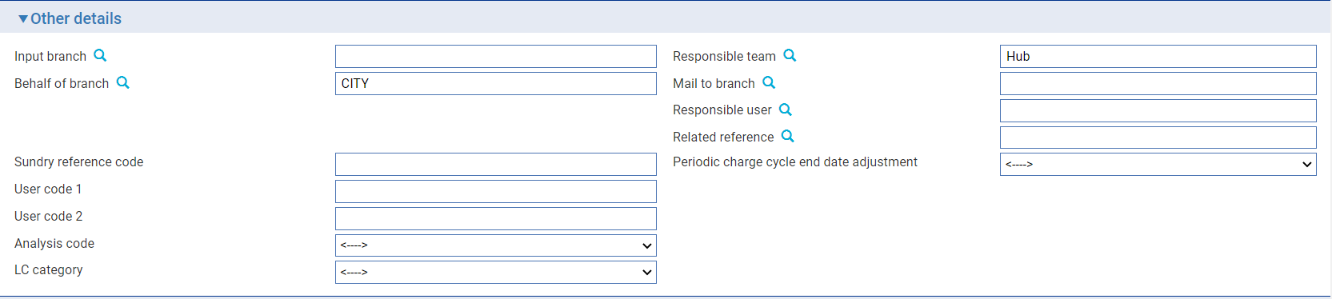

The following table explains what to enter into the fields in the Other Details pane. This pane may also include input fields defined by your bank:

|  | Field | What to Enter |
| --- | --- | --- |
|  | Input Branch | The input branch for the transaction. The input branch is set from the either:   * the accounting branch from the user’s team, or * the transaction branch for user if the user has a default transaction branch or is locked to a specific branch, or * a branch associated with the user where the user can enter transactions for several branches for a team |
|  | Behalf Of Branch | The behalf of branch for the transaction as entered by the user or set from the incoming SWIFT or gateway message. The behalf of branch determines the parameter sets that are to be used to generate charges, documents, postings, etc. during transaction processing. The branch can be changed to any other branch within the same main banking entity that shares the same parameter sets. |
|  | Sundry Ref Code /User Code 1/ User Code 2 | You may use these fields to enter values for analysis purposes. Your bank will have devised its own system for using these fields. |
|  | Responsible Team | The team that has overall responsibility for the master e.g. as the contact to resolve any queries or issues regarding the master and associated events. The system defaults the responsible team when creating the transaction as follows:   * Manual – set from team creating the transaction * Gateway – set from the team specified on the incoming message (if present and valid) otherwise to the team to which the transaction is assigned through workflow allocation based on the behalf of branch * SWIFT – set to the team to which the transaction is assigned through workflow allocation based on the behalf of branch   It can be changed, if required, to either the team associated with the primary customer, default team for the product or the user’s current team. |
|  | Analysis code/ LC category | User definable fields. These can be configured in System Tailoring | List Values/Field Mapping. |
|  | Mail To Branch | The mail to branch can be set to any branch within the main banking entity of the behalf of branch. |
|  | Responsible User | A user that has responsibility for the master e.g. as the contact to resolve any queries or issues regarding the master and associated events. This can be any user assigned to the responsible team. |
|  | Related Reference | You can specify any other transaction to which this letter of credit is related. This may already have been done when the master record was created. You can use the browser to select from possible references to include. |
|  | Periodic charge cycle end date adjustment | Provides the ability to configure the system to automatically set the date of a periodic charge cycle, where the end date falls on non-business/working day. Selection of one of the options enables the cycle date and due date to fall on the same or different dates as required. See the System Tailoring User Guide – Trade Innovation for more information. |

### The Other Parties Pane



The following table explains what to enter into the fields in the Other Parties pane:

|  | Field | What to Enter |
| --- | --- | --- |
|  | Reimbursing Bank | The bank from which reimbursement is to be requested. |
|  | Issuer | Specifies if the issuer of the credit is a bank or non-bank. |
|  | Issuing Bank | If the sender of the pre-advice was not the issuing bank, use these fields to identify the issuing bank. |
|  | Non-bank Issuer | The non-bank issuer of the credit. This field is displayed when Issuer is set to Non-bank. |
|  | Applicable Rules | This allows you to select additional information regarding the terms of the reimbursement.  Select one of the following to indicate the rules applied to the issue of the documentary credit under reimbursement instructions. |
|  |  | URR VERSION  The documentary credit is subject to the version of the ICC Uniform Rules for Bank to Bank Reimbursement, International Chamber of Commerce, Paris, that is in effect on the date of issue.  This is used as the default. |
|  |  | NOTURR  The documentary credit is not subject to the version of the ICC Uniform Rules for Bank to Bank Reimbursement, International Chamber of Commerce, Paris, that is in effect on the date of issue. |
|  | LC Reference | The issuing bank's reference for the letter of credit. You only need enter this if the sender was not the issuing bank. This is recorded on the letter of credit's master record as the originator's reference. |

### The Revolving Details Pane

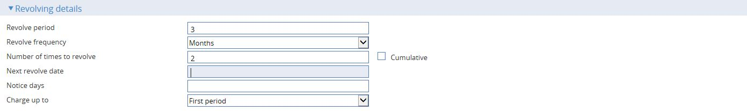

The Revolving Details pane is displayed if you check the Revolving field to indicate that the letter of credit is revolving. The following table explains what to enter into the fields in the Revolving Details pane:

| Field | What to Enter |
| --- | --- |
| Revolve Period/Revolve Frequency | Use these two fields to define the frequency at which the credit is to revolve.  For example, enter 3 into the first field, and select 'Months' in the second field if the credit is to revolve every 3 months. |
| Number of Times to Revolve | The number of times the letter of credit is to revolve.   1. When entering information into the above fields ensure that the last revolution will occur before the expiry date of the letter of credit. |
| Cumulative | Check this field if the revolution is to be cumulative; otherwise leave it blank. |
| Next Revolve Date | The date on which the first revolution is to take place. |
| Notice Days | If notification is required before the revolution takes place, enter the number of days before each revolution that the Revolve Notice event should be created. |
| Charge Up To | Indicate whether the charge period for calculating charges is to be set to be up to the expiry date, or the date of the next Revolve event. |

## The Export Letter of Credit Master Summary Window

Once you have created an export letter of credit, the system will display the basic details of that letter of credit using the Master Summary window.

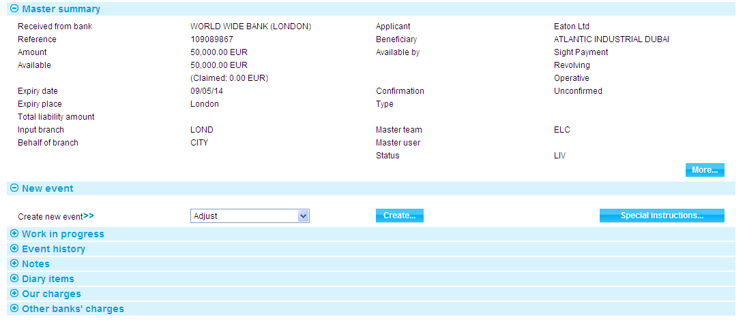

See the Common Facilities User Guide – Trade Innovation for more information on how the various panes and buttons in this window work.

If a transaction has associated transfer letters of credit, back-to-back letter of credit or assignments of proceeds, the Master Summary window displays a Splits button which you can use to list the associated transactions and view details of them.

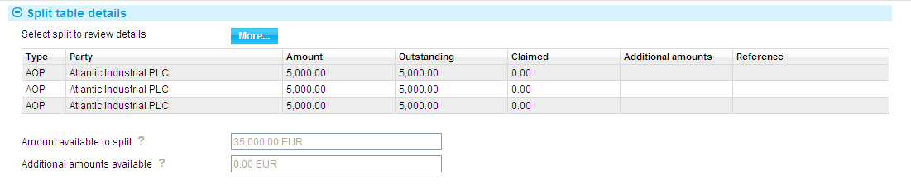

Selecting an item and pressing the More button displays additional information about the item.

The following table explains what information is shown for each item:

|  |  |
| --- | --- |
| Heading | What it Shows |
| Type | One of the following values:   * BTB for a back-to-back letter of credit * TRF for a transfer export letter of credit * AOP for an assignment of proceeds |
| Party | The name of the beneficiary or assignee. |
| Amount | The original amount due to the beneficiary. |
| Outstanding | The amount outstanding for the party. |
| Claimed | The amount in the process of being claimed. For a back-to-back letter of credit, this is the amount allocated to the back-to-back letter of credit from the parent letter of credit. |
| Reference | For transfer and back-to-back letters of credit, the letter of credit's reference. For assignments of proceeds this column is blank. |
| Amount Available to Split | The amount available for additional assignments of proceeds and back-to-back and transfer letters of credit. |
| Additional Amts Available | Any additional amounts available that can be split between back-to-back and transfer letters of credit. |

## Entering Details of an Acknowledgement

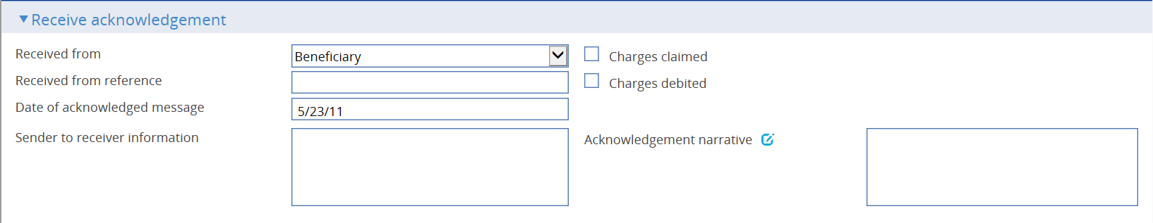

Details of an acknowledgement you have received are entered using a Receive Acknowledgement event. The event uses the same window for the Log and Input steps. Depending on how your system is configured, panes and fields available in log steps can be tailored for each data capture step. See the *SDK - Screen Tailoring User Guide* – Trade Innovation for details.

Use the Received From field to enter the role of the party from whom you have received the acknowledgement, and the Received From Reference field to enter that party's reference for the transaction. In the Sender to Receiver Information and Acknowledgement Narrative field, enter any narrative associated with the response.

If appropriate, check either the Charges Claimed box or the Charges Debited box to indicate whether the advising bank is claiming its charges or has debited its charges. You cannot check both of these boxes, but you can leave them both blank.

Use the narrative field to enter any details advised by the acknowledgment received from party.

# Assigning Proceeds to Additional Parties

The system permits you to identify an unlimited number of additional parties to a letter of credit who are to receive proceeds from the transaction. Assignee details can be entered either at the same time as payment is recorded or as a separate event - the Assignment of Proceeds event - after the release of the Issue or Advise event.

You can identify the amount to be assigned to each additional party. The total amount of assignments, together with any back-to-back and transfer letters of credit, can be up to 100% of the value of the letter of credit.

The Assignment of Proceeds event can be used to set up assignment details and subsequently to make amendments to, or delete, those details. Once entered, assignment details can be amended or deleted any time up to the disbursement of funds.

Information entered using the Assignment of Proceeds event is available during payment events. Assignment details entered as part of a payment event, or any changes to them during that event, are reviewed as part of that event's details.

1. The letter of credit's Master Summary window includes a Splits button, which allows you to display details of any assignments or transfers. Assignments are only shown in this window once the event creating them has been released.

You should ensure that all Assignment of Proceeds events are completed and released before initiating a payment event.

## Setting Up Assignee Details

To enter assignee details, in the Master Summary window select 'Assignment of Proceeds' from the Create New Event drop-down list. The system opens the event at either a Log step or Input step. Depending on how your system is configured, panes and fields available in log steps can be tailored for each data capture step. See the *SDK - Screen Tailoring User Guide* – Trade Innovation for details.

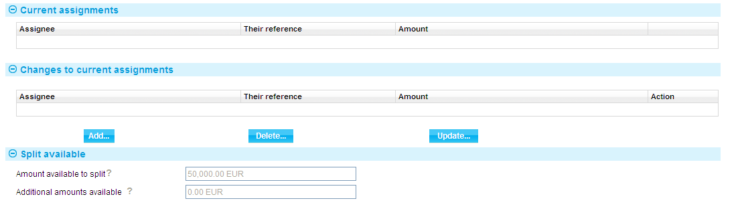

The Amount Available to Split field shows the available amount that can be assigned to other parties. The figure is updated as you add assignments. The Additional Amounts Available field shows any additional amounts available for the transaction, but these are not used for assignments.

You can use the Master Details|Settlement Instructions link to set up master-level standing settlement instructions to receive the assignment proceeds. See the Common Facilities User Guide – Trade Innovation for instructions. However, note that this button is not displayed if this window is called from within a payment event.

Press the Add button to access a window that allow you to identify parties and assign proceeds to them.

## Entering Assignment Details

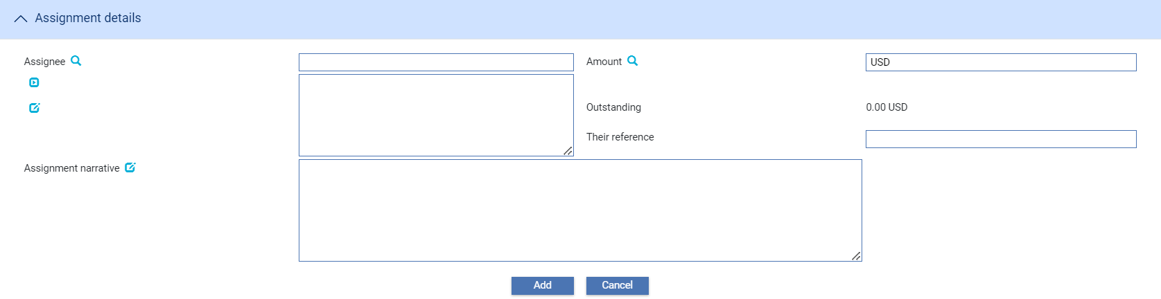

The following table explains what to enter into the fields in this window:

|  |  |  |
| --- | --- | --- |
|  | Field | What to Enter |
|  | Assignee | The assignee. |
|  | Amount | The amount to be assigned to this party, in the currency of the letter of credit. |
|  | Outstanding | Initially this field is blank. Thereafter, the system displays the amount still to be paid to this assignee. |
|  | Their Ref | The first beneficiary's reference for the assignment of proceeds. |
|  | Assignment Narrative | Any narrative text relevant to this party to be included on the notification of the assignment of proceeds. |

When you press the Add button to save assignee details the system closes the window and displays the new details in the Assignment of Proceeds window.

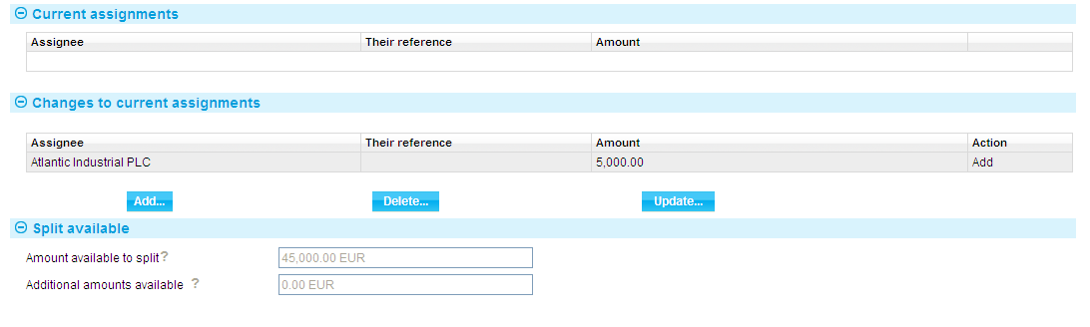

As you add assignees, they are added to the list in the Changes to Current Assignments pane. You can amend and delete assignees using the Update and Delete buttons in the usual way.

Once the initial Assignment of Proceeds event has been released, you can use further Assignment of Proceeds events to amend or delete assignee details.

When you open a subsequent Assignment of Proceeds event, the system displays details of current assignments.

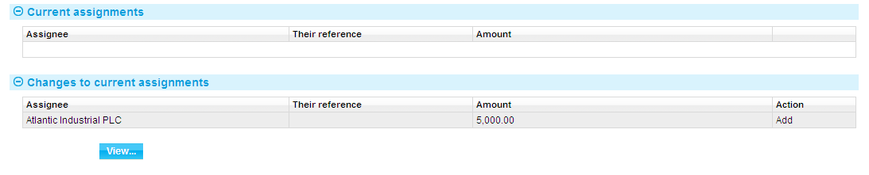

# Back-to-back Letters of Credit

The issuance of a back-to-back import letter of credit is handled in the system using a Back to Back LC - Issue event from within the parent export letter of credit. This causes a completed Back to Back LC - Issue event to be generated as part of the parent letter of credit's history, and simultaneously creates a separate import letter of credit Issue event for the back-to-back master. Once this event has been initiated, the back-to-back import letter of credit is processed independently of the export letter of credit in the normal way.

However, when processing the export letter of credit, the system takes into account the linked import letter of credit. The back-to-back import letter of credit can also be initiated via gateway message given that the parent LC reference is available and matches an export letter of credit master available.

1. For full details of the information entered for an import letter of credit see the Import Letters of Credit User Guide – Trade Innovation.

## Logging a Back-to-back Letter of Credit

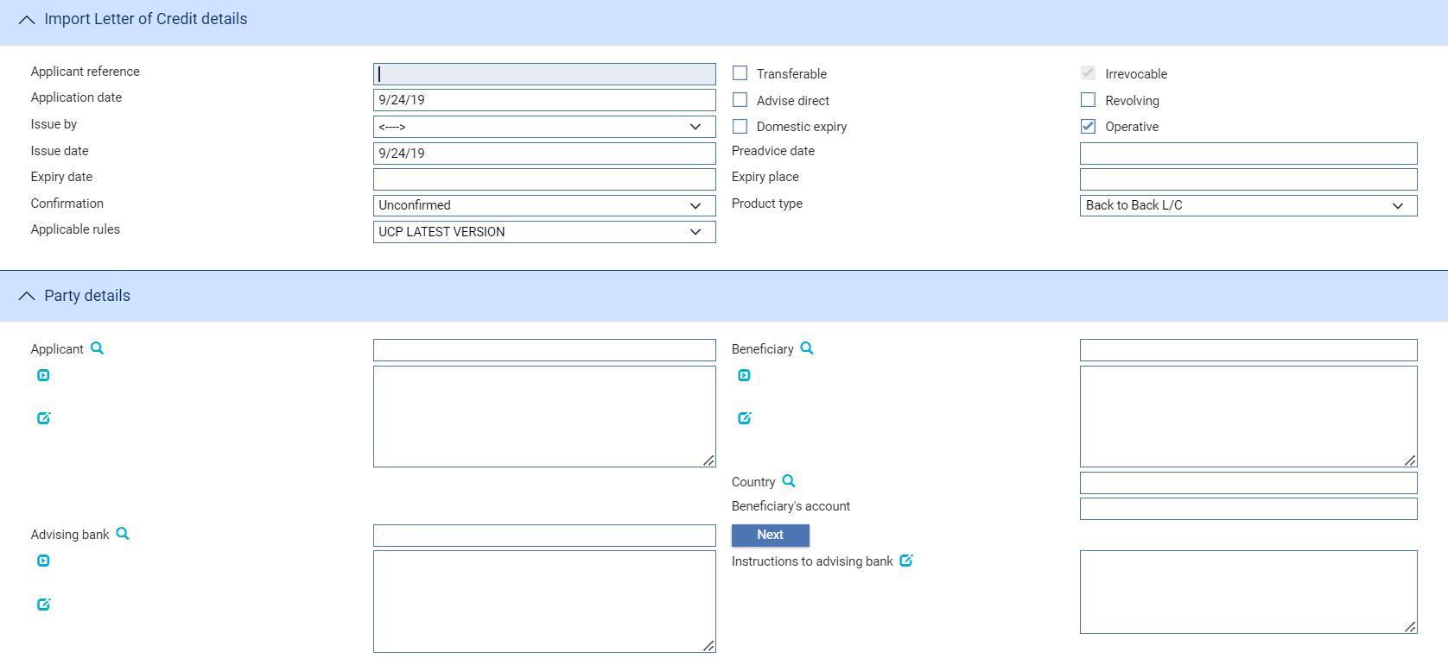 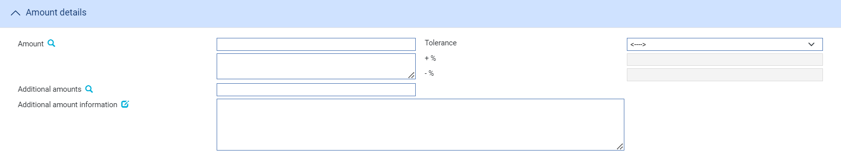 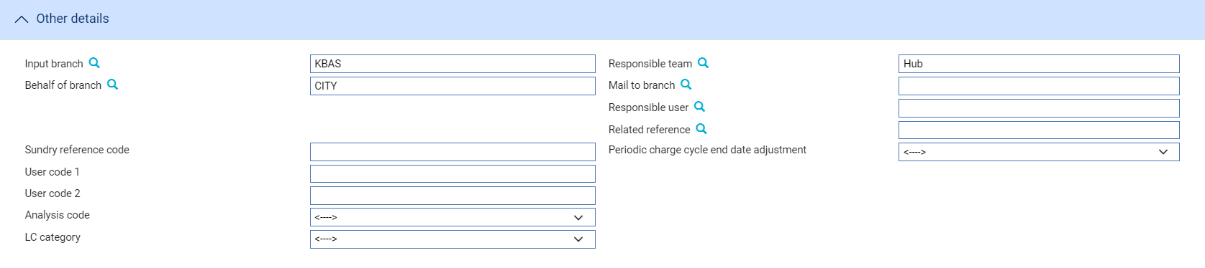

The same fields are used as during a Log step of the Pre-Advise event for an import letter of credit. Depending on how your system is configured, panes and fields available in log steps can be tailored for each data capture step. See the *SDK - Screen Tailoring User Guide* – Trade Innovation for details. The beneficiary of the parent export letter of credit is used as the default value for the applicant, and the parent export letter of credit's reference is used as the default value in the Related Reference field.

## Entering Full Details of a Back-to-back Letter of Credit

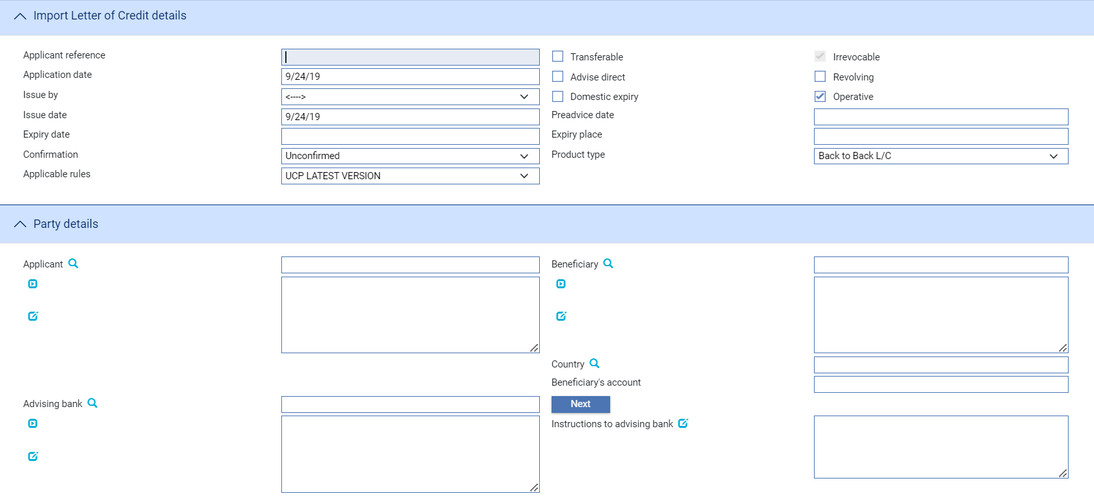

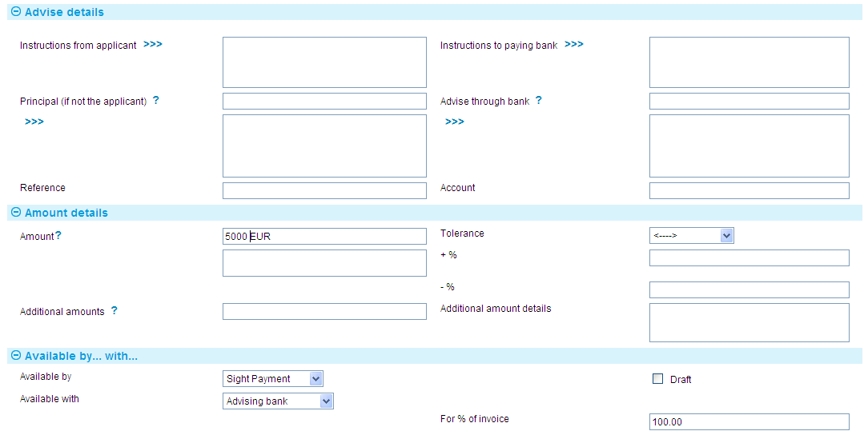

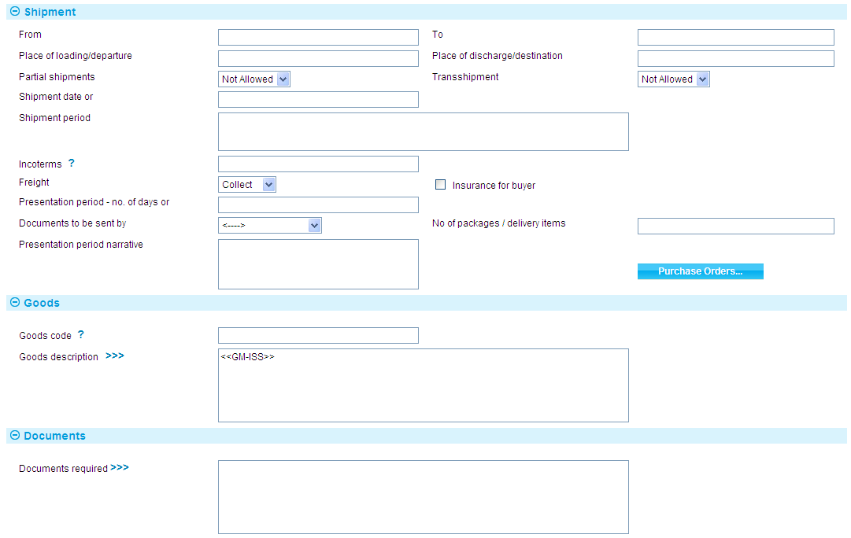

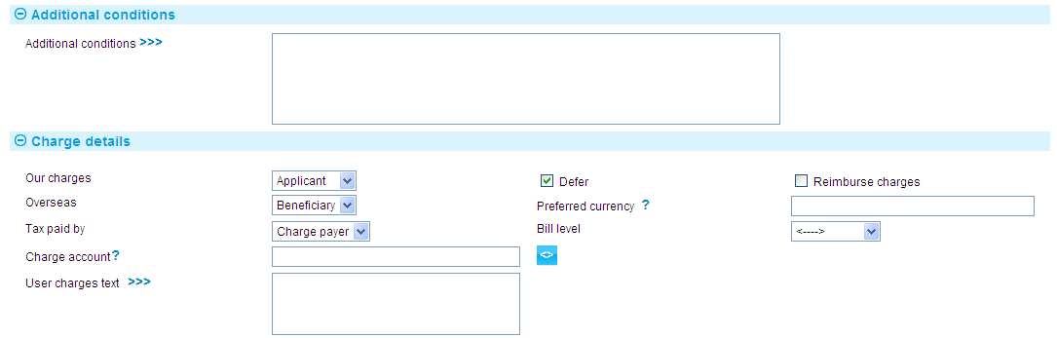 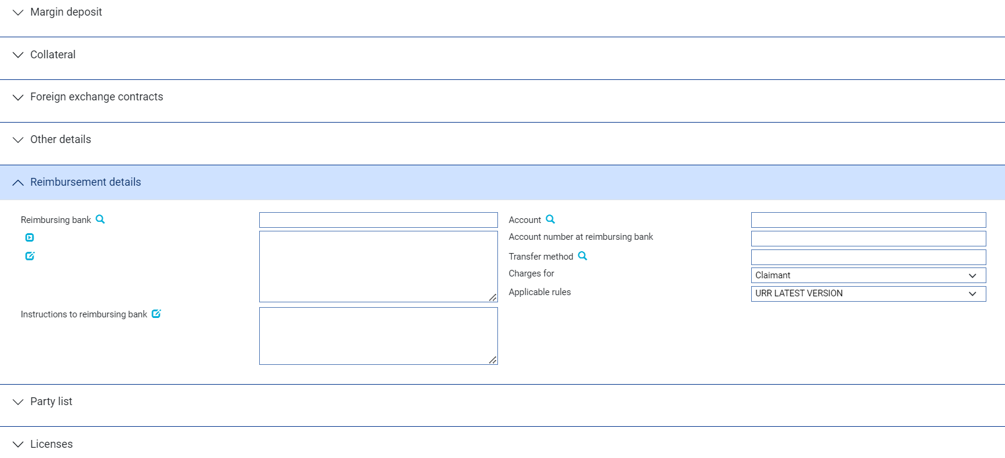

During an Input step, the same panes are used as during the Issue event's Input step for an import letter of credit. An additional pane - the Back to Back pane - displays details of the parent export letter of credit.

Note that, when creating a back-to-back import letter of credit, its expiry date must be the same day as, or earlier than, the expiry date of the parent letter of credit; and the amount must not exceed the amount of the parent letter of credit available, taking into account any transfer letters of credit, assignments of proceeds and other back-to-back import letters of credit.

## Once You Have Completed the Back-to-back Letter of Credit

Once you have completed input for either a Log step or Input step, the system creates a new master import letter of credit with its own Master summary window. The Back to Back LC - Issue event created for the export master letter of credit is now completed as an Issue event for the new import letter of credit, in the usual way.

The Master Summary window for a back-to-back import letter of credit identifies it as a back-to-back letter of credit. The window itself includes an Export LC button, which you can use to display the Master Summary window for the parent export letter of credit.

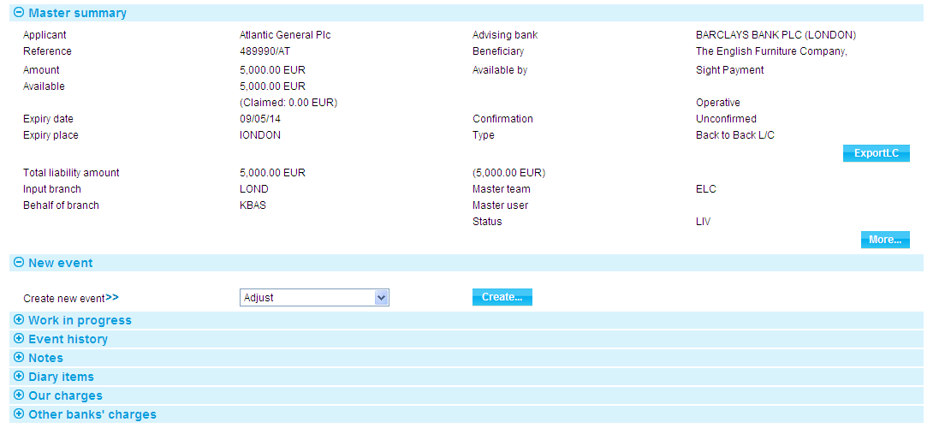

The Master Summary window for the parent letter of credit includes a Splits button. Pressing it displays details of back-to-back letters of credit set up against the parent letter of credit.

# Paying an Export Letter of Credit

This chapter explains how to use the system to record the presentation of documents and to select the required payment action for an export letter of credit, including continuing presentations that are left unpaid as a result of requesting payment. It also explains how to enter details of additional amounts, margin deposits and discounts against payments, and how to assign proceeds to additional parties.

For information on entering discounts against payments at a later date see Chapter 8.

For information on payment of transfer letters of credit and back-to-back letters of credit see Chapter 6.

For information on payment of transfer letters of credit see the Transfer Letters of Credit User Guide – Trade Innovation.

For information on payment actions, including additional bank defined actions and their effect on charges see the Appendix.

For information on repaying a financing loan from within a payment event see the Financing User Guide – Trade Innovation.

## Payment in Trade Innovation

The system permits the following claim types:

* Standard payment of an export letter of credit only. This allows a claim to be paid against the first beneficiary only
* Payment of a transfer export letter of credit only. This allows a transfer export letter of credit to be paid independently of its parent letter of credit
* The third involves payment of an export letter of credit and an associated transfer export letter of credit during the same event. This allows the first beneficiary's invoices to be substituted for those of the second beneficiary. The second beneficiary is then paid from the proceeds arising from the claim made to the issuing bank by the first beneficiary
* Payment involving the allocation of funds to assignments
* Payments involving the allocation of funds to back-to-back letters of credit

This chapter covers standard payments and payments involving assignments. Payment involving transfer letters of credit is covered in the Transfer Letters of Credit User Guide – Trade Innovation, and payment involving back-to-back letter of credit in Chapter 6.

All types of claim are handled using the same events:

* The Documents Presented event (see page 56), which allows you to record the claim and either make payment or pend the claim whilst awaiting the result of enquiries
* The Outstanding Presentation event (see page 57), which allows you to continue a pended claim

If the letter of credit is participated, payment may result in a Drawdown/Revolve Commit Amt event being created as a subsidiary event to increase the commitment amount available on the participation deal, if the deal is revolving.

### Standard Claims

When the beneficiary or bank presents documents for payment, the Documents Presented event allows you to proceed in various ways, depending on the status of the documents presented.

If the documents are in order, you can either make the payment or request payment, then send the documents presented and details of any payment made to the issuing bank. Where there is a reimbursing bank, a claim for reimbursement can be sent to the reimbursing bank.

If there are discrepancies in the documents:

* You can advise the presenting party that this is the case, and then request missing documents or return the documents to the presenting party and request re-presentation
* You can request authority from the issuing bank to make payment. When the issuing bank replies you can proceed with the payment, refuse it, or reject it, depending on whether authority has been given or not. The Outstanding Presentation event allows you to continue a claim that has been pended in this way
* If the discrepancies are only minor, you can pay the beneficiary, with the caveat that, should the documents be refused by the issuing bank that the payment will be recoverable from the presenting party

A letter of credit may have more than one Documents Presented event, and each Documents Presented event may have a history of several Outstanding Presentation events associated with it. However, only one event can be in progress for each presentation at any one time.

The system allows documents to be presented for full or partial payment, depending on whether these are permitted under the letter of credit. Where a part payment is made, the system reduces the outstanding amount of the letter of credit by the value of the part payment; the remaining amount is then available for subsequent presentations.

### Assignments of Proceeds

During payment events the system permits you to set up new assignments for the transaction, and to access details of assignments already set up and allocate proceeds to them.

Each payment amount allocated to an assignment can be discounted as part of the payment event, if required. However, it cannot be discounted later, once the payment event has completed.

You can also repay a financing transaction from within the payment event.

### Licenses

If there is a license attached to a revolving transaction, the license amount must be sufficient to cover the maximum amount available under the transaction - that is, the transaction amount plus the maximum tolerance - multiplied by the number of revolving cycles.

See the Licenses User Guide – Trade Innovation for details of licenses.

### Financing Transactions

If your system has the financing module implemented, then while processing a payment the Finance pane will be available.

This allows you to record a financing transaction against the payment, as described in the Financing User Guide – Trade Innovation.

You can also repay a financing transaction from within the payment event.

### Finance Offers

Your bank may wish to notify customers of an offer of finance, or may need to respond to a customer’s request to finance an Export Letter of Credit. Where this is necessary, the system uses the concept of the ‘Finance offer’.

Provisional event functionality may be used by your bank to advise its customers of costs incurred in respect of finance deals.

This is done by enabling events to be flagged as ‘Provisional’ so that an offer of finance may be sent to your bank’s customer and subsequently continued in the same event, or a continuation event.

It’s possible to offer finance in the following events:

* Finance
* Documents presented
* Outstanding presentation

1. Your bank will need to configure the postings, charges and other release items produced on completion of a Finance Export LC, Finance event, Documents presented event or Outstanding presentation event, so that they are generated only if the events are not flagged as provisional; and so that, if the event is provisional, it results in the creation of an offer document for the customer. See the 33TSystem Tailoring Guide 33T40T– Trade Innovation40T for information on using the rules facility to achieve this.

### Finance Event – Finance Offer

To process an Export Letter of Credit and offer financing to your bank's customer; in the Finance event, check the ‘Finance offer required’ box in the Finance offer details pane. This sets the Provisional flag as checked.

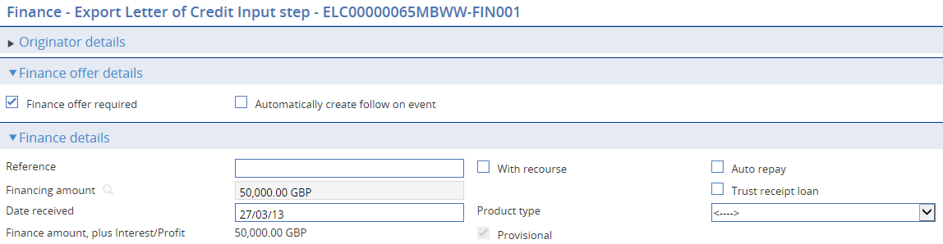

You can enter financing details in the normal manner and complete the event. Finance is now offered to your bank’s customer and the event is held in a provisional state, pending a response.

### If the Customer Accepts the Offer

If the customer accepts the offer, from the Master summary screen, initiate a Continue provisional finance event:

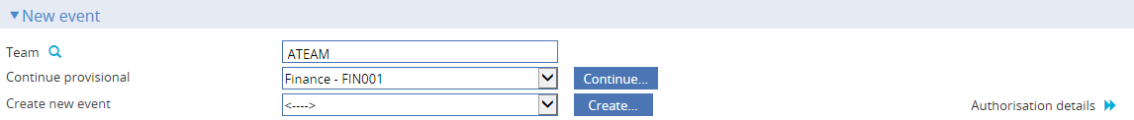

This allows you to continue processing the Finance event to conclusion. Attach the acceptance document that was received from your bank’s customer to the continue finance event, following the procedure used by your bank.

Complete the Finance event in order to complete the finance deal.

### If the Customer Wishes to Negotiate a Revised Offer

If your bank’s customer does not accept the initial offer and wishes to negotiate a revised offer, initiate a Continue Finance event and check the ‘Finance offer required’ flag. The Provisional flag will be automatically checked. This will allow you to amend the finance details as required, keeping the Provisional flag checked.

Complete the Continue Finance existing collection event. This will generate a revised offer document for the customer showing the amended offer.

This process can be repeated as many times as is necessary.

### If the Customer Rejects the Offer

If the customer rejects the offer, initiate a Continue provisional Finance event but do not check the Finance offer required flag. Manually abort the Finance event.

### Documents Presented and Outstanding Presentation events – Finance Offer

To process an Export Letter of Credit and offer financing to your bank's customer; in the Documents presented event, set the Payment option from the dropdown to ‘Finance offer’ in the Payment action pane.



You can enter financing details in the normal manner, via the subsidiary finance event and complete the Documents Presented event. Finance is now offered to your bank’s customer and the event is held in a provisional state, pending a response.

### If the Customer Accepts the Offer

If the customer accepts the offer, from the Master summary screen, initiate an Outstanding Presentation event.

The Payment action defaults to ‘Finance offer’ but you can reset this as appropriate. This allows you to continue processing the presentation and related finance deal to conclusion. Attach the acceptance document that was received from your bank’s customer to the Documents presented event, following the procedure used by your bank.

### If the Customer Wishes to Negotiate a Revised Offer

If your bank’s customer does not accept the initial offer and wishes to negotiate a revised offer, initiate an Outstanding Presentation event, leave the Payment action as ‘Finance offer’ and update the related finance event as required. Completing the Outstanding Presentation event will generate a revised offer document for the customer showing the amended offer.

This process can be repeated as many times as is necessary.

### If the Customer Rejects the Offer

If the customer rejects the offer, initiate an Outstanding Presentation event and delete the part payment financing. The Outstanding Presentation event may then be completed without financing.

## Payment at Maturity

For claims whose payment action was ‘Pay at Maturity’ or ‘Accept’ the system creates an outstanding payment event in the diary to handle the payment at the time of maturity. When the maturity date is reached the system processes the event during overnight processing. The event may require input or review and/or authorisation, in which case the system places the event in the Work in Progress pane for you to complete.

When you open an outstanding payment event for a maturity payment the system displays the relevant maturity response type.

## Document Presentation

To record the presentation of documents for an export letter of credit, in the Master Summary window select 'Documents Presented' from the Create New Event drop-down list. The system opens the event at either a Log step or Input step (see page 57). Depending on how your system is configured, panes and fields available in log steps can be tailored for each data capture step. See the *SDK - Screen Tailoring User Guide* – Trade Innovationfor details.

### Logging the Presentation

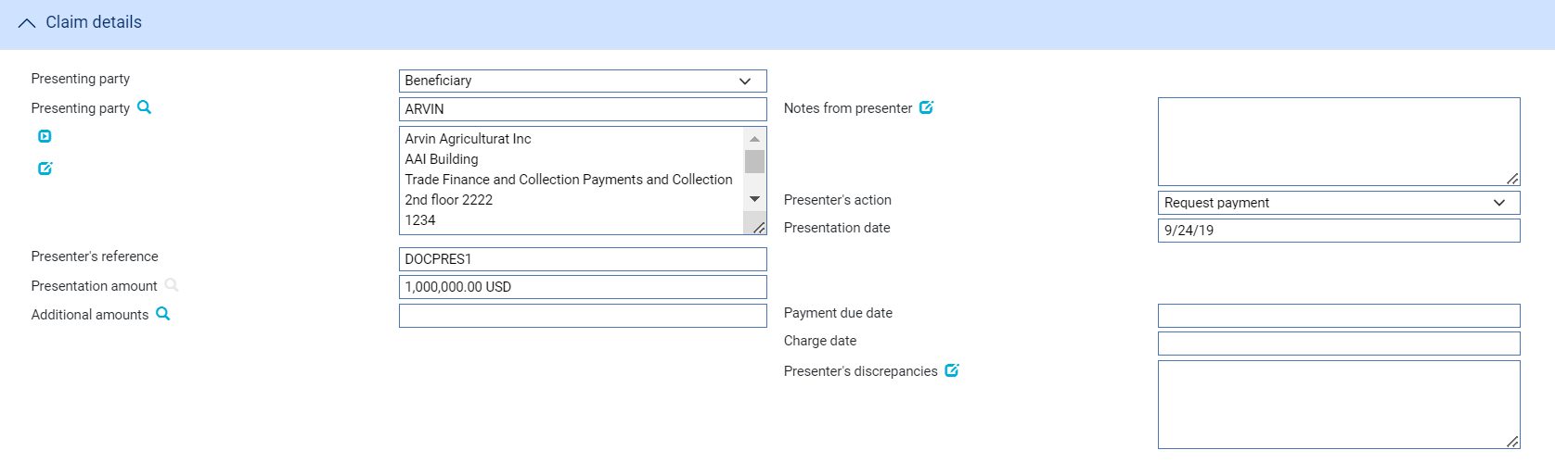 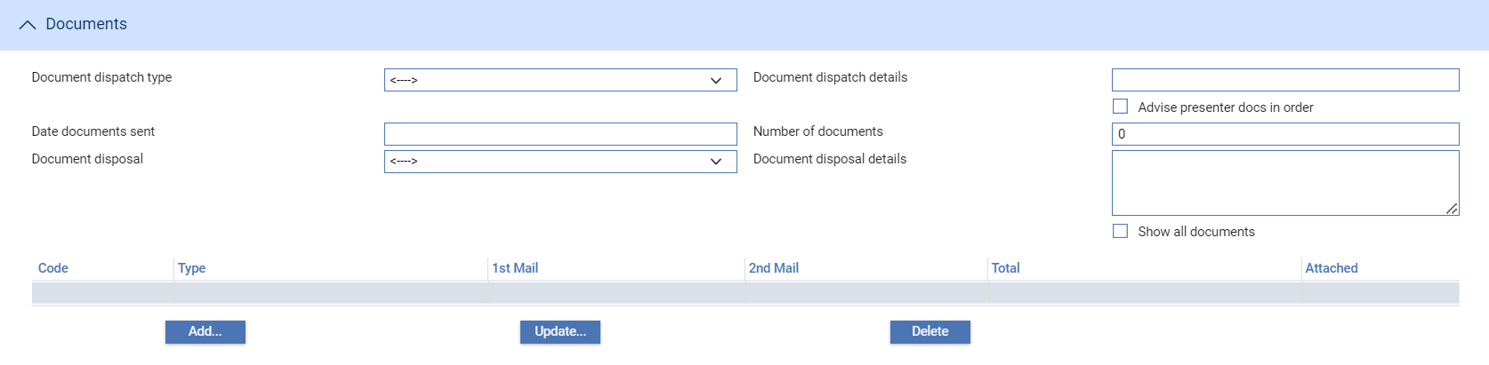

The following table explains what to enter into each of the fields in the Log window. For instructions on using the fields in the Document Details pane to identify any documents being presented see the Common Facilities User Guide – Trade Innovation:

| Field | What to Enter |
| --- | --- |
| Presenting Party Type | Select the role of the presenting party. This will default to the party the letter of credit was advised to. |
| Presenting Party | The presenting party. You can use the first field to select a party already identified in the event using their party role, in which case their details are retrieved and displayed in the remaining fields in this pane.  Alternatively, if the presenting party has not been assigned a party role within the transaction, select 'Other presenting party' in the first field, then use the remaining fields to enter their details in the usual way. If you identify a party in this way, they are assigned the role of 'Presenting party'.  The system uses the advising bank as the default, or the beneficiary, if the letter of credit was advised direct. |
| Presenter's Reference | The presenting party's reference for the presentation of documents and request for payment. |
| Select Required Claim Type | Displayed for transferable letters of credit only. Unless you wish to pay a transfer letter of credit set to ‘Standard’. For instructions on using the Documents Presented event to pay a transfer letter of credit see the Transfer Letters of Credit User Guide – Trade Innovation. |
| Presentation Amount | The amount being claimed. |
| Presentation Date | The date the documents were presented. The system uses today's date as the default. |
| Date Documents Sent | The date the documents were sent by the presenting party. |
| Number of Documents | The number of documents being presented, up to 999. In the table you can enter details for each of the documents presented to support payment. |

### Entering Full Details of the Documents Presented

 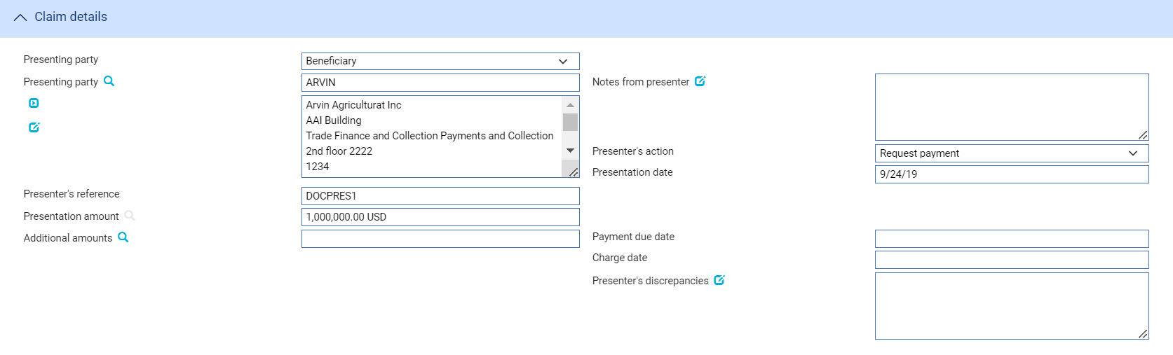

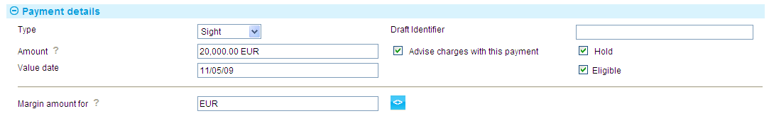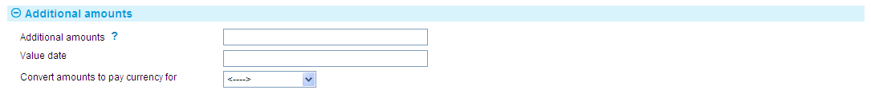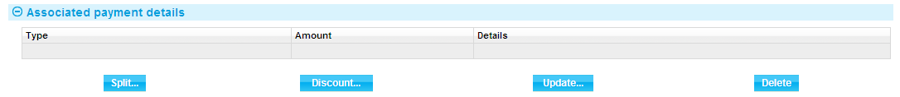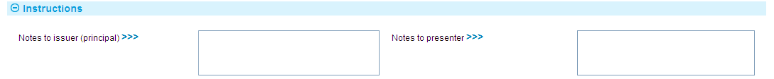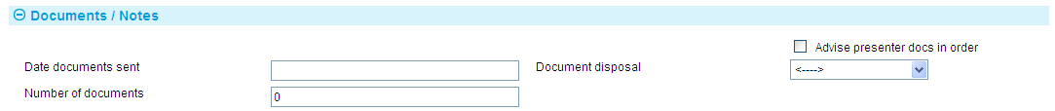 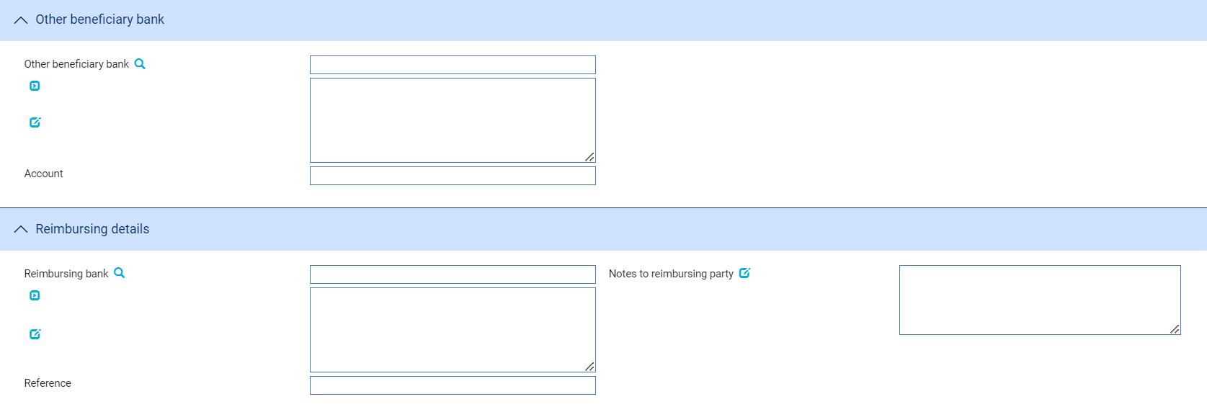

For instructions on using the Documents Presented event to pay a transfer letter of credit see the Transfer Letters of Credit User Guide – Trade Innovation.

The window used during an Input step has the following panes:

* The Claim Type Pane (see page 58)
* The Export LC Details Pane (see page 58)
* The Claim Details Pane (see page 59)
* The Payment Action Pane (see page 61)
* The Payment Details Pane (see page 62)
* The Additional Amounts Pane (see page 64)
* The Associated Payment Details Pane (see page 64)
* The Instructions Pane (see page 64)
* The Documents/Notes Pane (see page 65)
* The Other Beneficiary Bank Pane (see page 66)
* The Reimbursing Details Pane (see page 66)

For instructions on using the Export Letter of Credit Detail pane to enter details of documents see the Common Facilities User Guide – Trade Innovation.

### The Claim Type Pane



The Claim Type pane is present only for transferable letters of credit.

Unless you wish to pay a transfer letter of credit set the Claim Type field to 'Standard'. For instructions on paying transfer letters of credit see the Transfer Letters of Credit User Guide – Trade Innovation.

### The Export LC Details Pane



This provides some of the key details relevant to payment of the letter of credit – read only.

### The Claim Details Pane

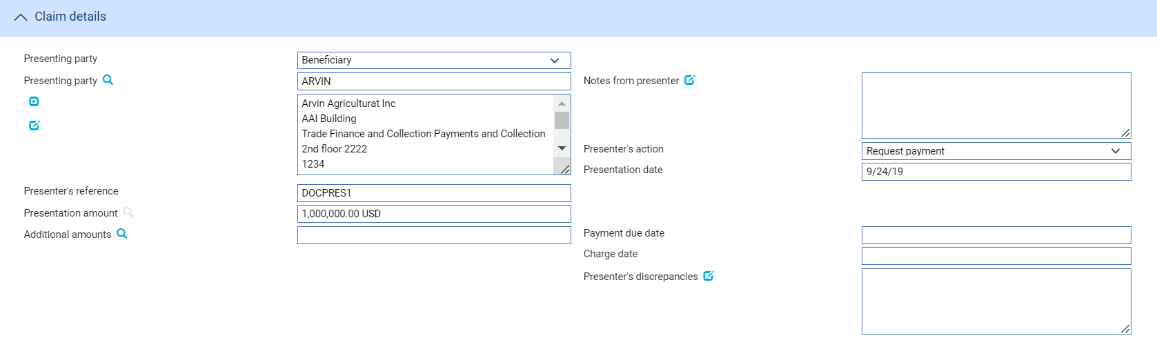

The following table explains what to enter into the Claim Details pane:

|  | Field | What to Enter |
| --- | --- | --- |
|  | Presenting Party | The presenting party. You can use the first field to select a party already identified in the event using their party role, in which case their details are retrieved and displayed in the remaining fields in this pane.  Alternatively, if the presenting party has not been assigned a party role within the transaction, select 'Other presenting party' in the first field, then use the remaining fields to enter their details in the usual way. If you identify a party in this way, they are assigned the role of 'Presenting party'.  The system uses the advising bank as the default, or the beneficiary, if the letter of credit was advised direct. |
|  | Notes from Presenter | Any notes or instructions received from the presenting party. |
|  | Presenter’s Action | Choose one of the following values from the drop-down list to indicate what action the presenter has taken with regard to the claim:   * Request Authorisation to Pay * Pay and Claim Reimbursement * Request Payment * Request Acceptance * Sender has Debited our Account * Documents Sent On Approval * Other |
|  | Presentation Date | The date of the presentation. The system uses today's date as the default. |
|  | Presenter's Reference | The presenter's reference for the letter of credit. |
|  | Presentation Amount | The system displays either the available amount of the letter of credit (less any outstanding claims) or the presentation amount, if entered during a Log step. |
|  | Presentation Currency | The currency of the presentation amount, if different from the currency of the letter of credit. |
|  | Additional Amounts | Any additional amounts being claimed. |
|  | Payment Due Date | The date payment is due, or the value date used to debit your account with the presenting bank. |
|  | Charge Date | The value date for any charges taken separately. |
|  | Presenter’s Discrepancies | Details of any discrepancies. |

Where the presenting party is a bank further details can be entered.

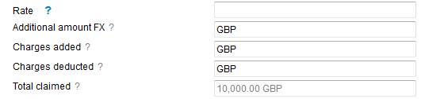

The following table explains what to enter into these additional fields:

|  |  |  |
| --- | --- | --- |
|  | Field | What to Enter |
|  | Renegotiation | Tick this box if this is a renegotiation. |
|  | Rate | If the amount in the Additional Amount field is in a currency different from that of the transaction, enter the exchange rate to be used to convert the additional amount to the currency of the letter of credit. |
|  | Additional Amount FX | The additional amounts expressed in the currency of the transaction. |
|  | Charges Added | Any charges that the sender has informed you have been added to the payment amount. For complete reconciliation check that this amount is equal to the charges due to the presenting party. |
|  | Charges Deducted | Any charges that the sender has informed you have been deducted from the payment amount. For complete reconciliation check that this amount is equal to the charges due from the presenting party. |
|  | Total Claimed | The system calculates the total amount being claimed and then displays it in this field. |

### The Payment Action Pane

See the Appendix for a list of payment actions.



The Payment Action pane allows you to process the claim by selecting a payment action and then entering details of the payment.

The actions included in the Payment Option drop-down list vary, depending on whether there was a direct presentation by the beneficiary, and on the presenter's actions, for example whether they are requesting authorisation to pay or whether instead they have paid and are requesting reimbursement.

For a single payment, details of the actual payment are entered into the Payment Details pane. If payment is mixed, to involve two or more part payments, check the Mixed Payment field. The system displays a Payments pane, which you can use to enter details of each of the part payments in turn.

Check the With Recourse box if the payment is with recourse; and the Final Payment box if the payment includes the final payment under the export letter of credit.

If your payment action is 'Reject and Claim Refund' then enter the date of the refund into the Refund Date field.

If your payment action is ‘Finance offer’, you may create a subsidiary finance event which is held in a provisional state, pending acceptance, request for revision, or rejection of the offer from your bank’s customer.

The payment action you select applies to all part payments. However, where the action is 'Pay' the individual status of a payment can be changed using the Pay Status field in the Payment Details window.

* If you enter any part payment details, the value of all part payments must not exceed the value of the letter of credit, and must reconcile with the claimed amount.
* Where the payment action for an individual part payment is 'Pay at Maturity' or 'Accept', the system creates a diary event which will cause an Outstanding Claim or Outstanding Presentation event to be generated automatically at the appropriate time to allow that part payment to be matured.
* If the payment action is 'Pay' for an acceptance or deferred payment, the system generates the postings and funds movements for the future date, and no separate future Outstanding Claim or Outstanding Presentation event takes place. The forward-dated postings are held by the system until the value date is reached, then posted during batch processing.
* If the payment action is 'Request Approval from Issuing Bank', the system displays an additional field - Reasons for Authorisation request - in the Instructions To Send pane.

1. The system is delivered with a standard set of ‘Presenter’s actions’ and ‘Payment actions’ which will typically cover the required processing for claims and documentary presentations. However, depending on your bank’s internal processes and requirements, it may be necessary to create additional Presenter’s and Payment actions that are more appropriate to your workflow.

Where this is required, your bank can use System Tailoring to define its own Parameter set based Presenter's actions and Payment actions for Export letters of credit and additionally, create Transfer presenter's actions and Response actions as required. A code and description can be entered for each of these actions together with the associated underlying payment ‘behaviour’ type, such as *General request, Pay, Reject, or Pay at maturity* which then determines the subsequent processing of the payment when the action is selected.

See the *System Tailoring User Guide* – Trade Innovation for instructions on defining additional payment actions.

### The Payment Details Pane



The Payment Details pane allows you to enter details of the payment you are making.

For mixed payment, check the Mixed Payment field in the Payment Action pane. A new pane - the Payments pane - is displayed in place of the Payment Details pane.

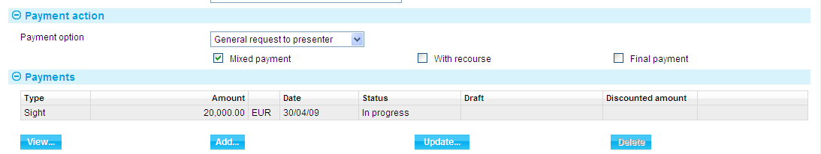

Select the payment listed in this window and press the Update button. In the window that appears, define the first part payment.

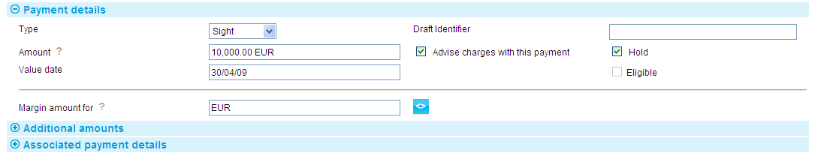

The fields are the same as those used in the Payment Details pane to define a single payment. When you close the window, the details of the part payment are listed in the Payments pane, from where you can select them and amend or delete them. Use the Add button to reopen the window to enter details of the next part payment.

Once you have entered details of a payment, or part payment, it is listed in the Payments pane.

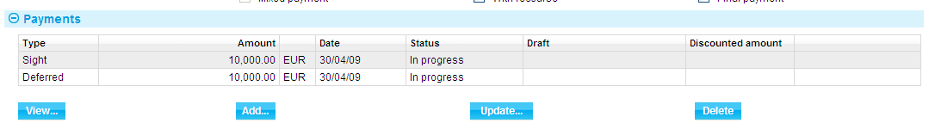

1. The system creates a first part payment for the full amount of the payment event. If you add more part payments, remember to amend the amount of this first part payment accordingly.

The following table explains what to enter to define a payment or part payment:

|  |  |
| --- | --- |
| Field | What to Enter |
| Payment Action | This field is displayed only for mixed payments, and it initially reflects the payment action selected for the claim in the main Input window. If the payment action involves refusal or leaves the claim outstanding, then you will not be able to alter the value in this field.  If the payment action involves paying the claim, then you can use this field to select a status for each individual part payment.  Select from the available options. |
| Type | Select the type of payment - Sight, Acceptance or Deferred. The fields displayed in the rest of the window vary, depending on what you enter here. |
| Amount | The amount being claimed. |
| Advise Charge with This Payment | Check this box if charges taken or claimed are to be advised with this payment. |
| Value Date | For sight payments, enter the value date of the payment.  For acceptance and deferred payment the value date of the payment is calculated using the value in the Period field.  The system issues a warning if this date does not leave enough time for any pre-debit notification required. |
| Start Date/Period/From/ After | For acceptance and deferred payments, the start date of the payment period.  Use the Period field to define the period (as, for example, 1 month or 10 days), then use the From/After field to indicate whether the period will be calculated from or after the base date. |
| Draft Identifier | If you know the draft identifier, enter it here. |
| Hold | This field is displayed for sight and acceptance payments. Check it if drafts are being held, and uncheck it if they are being returned to the claimant.  You can discount a draft only if this and the Eligible box are checked. |
| Eligible | This box must be checked for you to be able to discount a part payment. For sight and acceptance payments, the Hold box must also be checked. |

### The Additional Amounts Pane



The following table explains what to enter into the Additional Amounts pane:

|  |  |
| --- | --- |
| Field | What to Enter |
| Additional Amounts | Any additional amount. |
| Value Date | The value date of any additional amount. |
| Convert Amounts to Pay Currency For | The payment amount may need to be converted to a different currency for the paying bank and or the presenting party. If so, select the appropriate value - Presenting Party, Both Parties or Paying Bank - here. |
| Rate to Convert to Payment Currency | If the payment amount needs to be converted to a different currency select or enter the rate to be used to make the conversion. |
| Additional Amounts FX | The additional amount, expressed in the currency of the reimbursement authorisation. |
| Behalf of Branch | Where relevant, the branch that owns the foreign exchange deal. |

### The Associated Payment Details Pane



The Associated Payment Details pane allows you to apply further processing against the payment or part payments being made. As payments are defined they are listed in this pane. You can select them individually and enter details of a loan or discount or license drawdown.

### The Instructions Pane

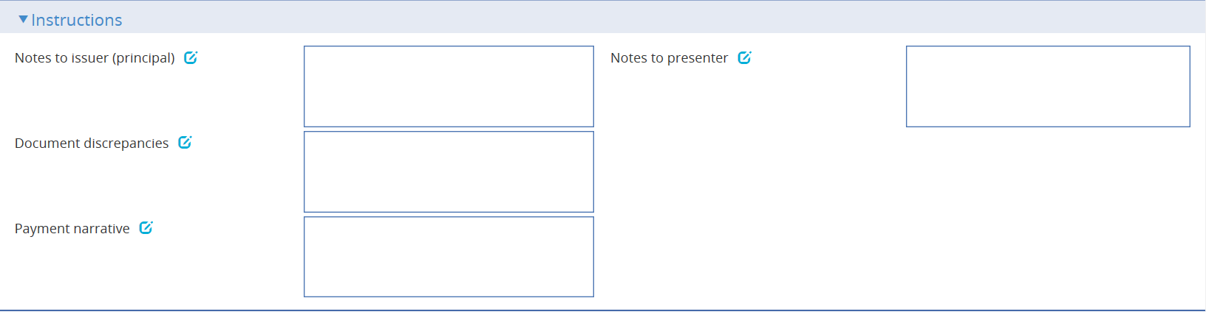

The Instructions pane allows you to enter notes for the issuer and the presenter.

Depending on the setting of the system option DiscrepancyFieldAlwaysVisible the Document Discrepancies field may be displayed here, even if the payment action would not normally require it to be populated. When the system option is switched on the field allows you to enter minor discrepancies for your bank's own audit purposes, where the payment action does not normally involve reporting discrepancies.

Payment Narrative field is displayed when payment action is set to Pay, Pay and claim reimbursement, Pay at maturity, Pay with discrepancies, Pay with financing, Accept or Approve Authorisation Request.

### The Documents/Notes Pane

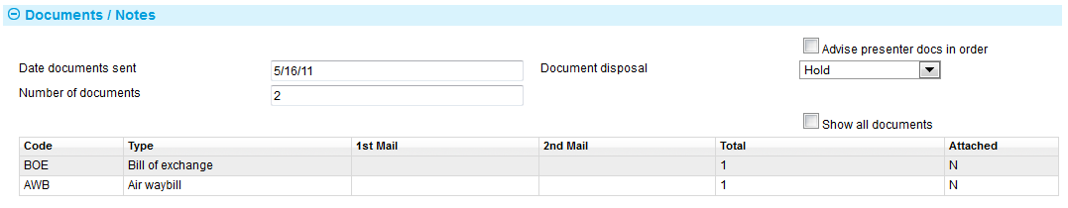

The following table explains what to enter into the fields in the Documents/Notes pane. See the Common Facilities User Guide – Trade Innovation for instructions on adding, amending, deleting and viewing details of the actual documents involved:

|  | Field | What to Enter | |
| --- | --- | --- | --- |
|  | Date Documents Sent | The date the documents were sent, as stated on the claim. | |
|  | Number of Documents | The number of documents received here. Use the Add button to identify each of the documents received in turn. | |
|  | Document Disposal | Use this dropdown to indicate the disposal action for the documents. | |
|  |  | Hold | Select this field if you intend to hold documents received whilst awaiting further instructions from presenter/issuing bank. |
|  |  | Notify | Documents held until the issuing bank receives a waiver from the applicant and agrees to accept it, or receives further instructions from the presenter prior to agreeing to accept a waiver. |
|  |  | Previous instructions | Acting in accordance with instructions previously received from the presenter. |
|  |  | Return | Select this field if documents are to be returned to the sender. |
|  | Advise Presenter Documents In Order | Check this box if the presenter is to be advised that that any documents received are in order. | |

If your bank has chosen to record an audit trail of all changes to attached documents then the Show All Documents check box allows you to see an audit trail of all changes for a document type.

### The Other Beneficiary Bank Pane

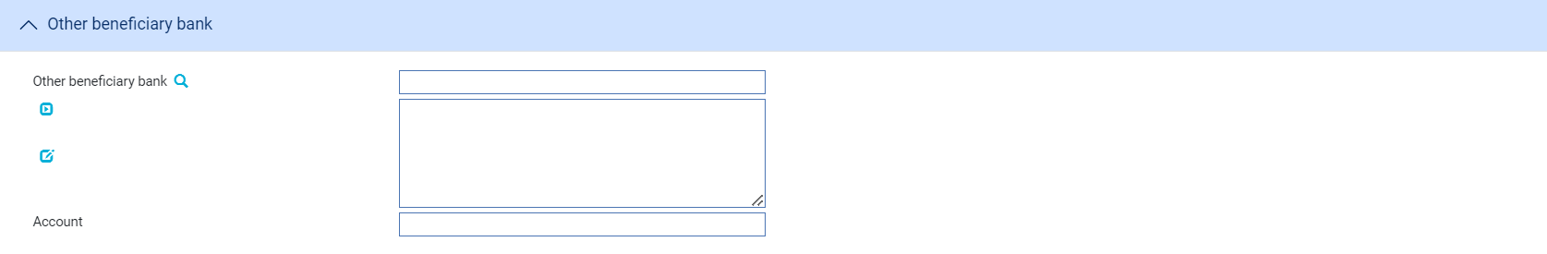

The fields in the Other Beneficiary Bank pane allow you to identify the bank you want the issuing bank to pay, if other than your own bank, and the number of the account to be credited.

### The Reimbursement Details Pane

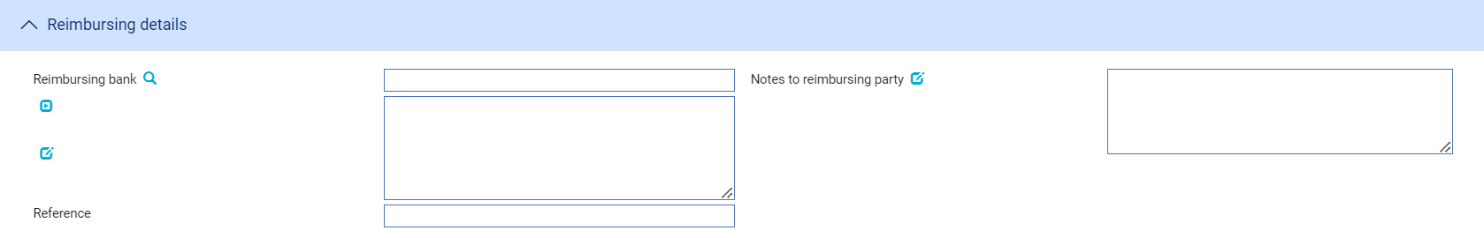

The fields in the Reimbursement Details pane allow you to identify the bank from which reimbursement is to be requested, together with any notes for the reimbursing bank and the reimbursing bank's reference for the claim or letter of credit, if known.

## Continuing a Claim

If you select a payment action during the Documents Presented event which involves postponing payment whilst awaiting a reply, for example until you have received authorisation to pay from the issuing bank, the Outstanding Presentation event allows you to continue the claim.

To continue the claim, in the Master Summary window select 'Outstanding Presentation' from the Create New Event drop-down list. The system opens the event at either a Log step (see page 67) or Input step (see page 69). Depending on how your system is configured, panes and fields available in log steps can be tailored for each data capture step. See the *SDK - Screen Tailoring User Guide* – Trade Innovationfor details.

### Selecting the Presentation to Continue

If there is only one outstanding claim, the system retrieves it and displays its details. If there is more than one outstanding claim, you must use the Select button to select the one to continue. When you press this button the system displays the Select Payment Event window.

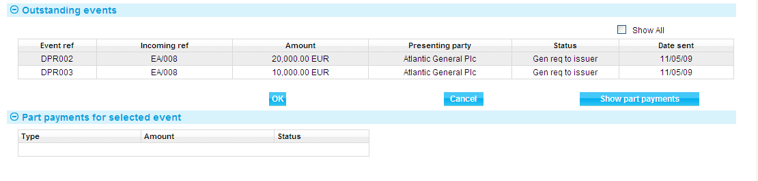

This window lists all completed Documents Presented events that have not been paid. The window does not show any claims currently in progress. If you check the Show All box, the system also includes in the list all completed Documents Presented and Outstanding Presentation events that have been paid in full or been rejected.

If you check the Show All box, the system also includes in the list all completed payment events that have been paid in full or been rejected. You can initiate an outstanding claim event against a completed claim event in order to issue general correspondence or to reject a previously-paid claim.

You can view details of the drafts associated with a claim by selecting the event and pressing the Show Part Payments button.

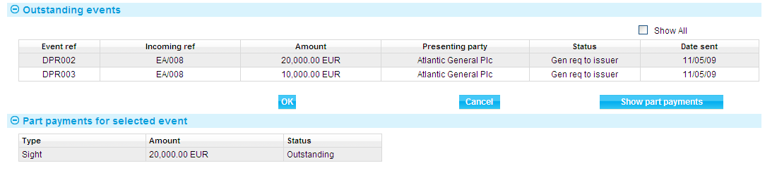

When you select an event and then press the OK button, the system closes the window and displays information taken from that event.

### Logging the Response

If there is more than one outstanding presentation from the letter of credit, the Select button allows you to select the one to continue.

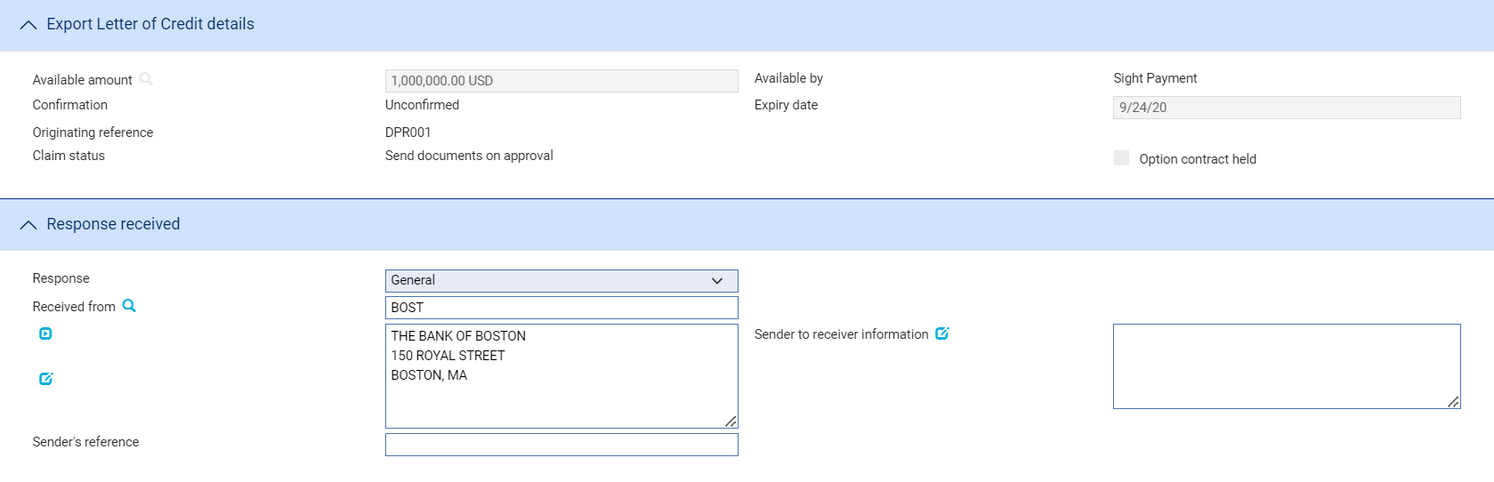

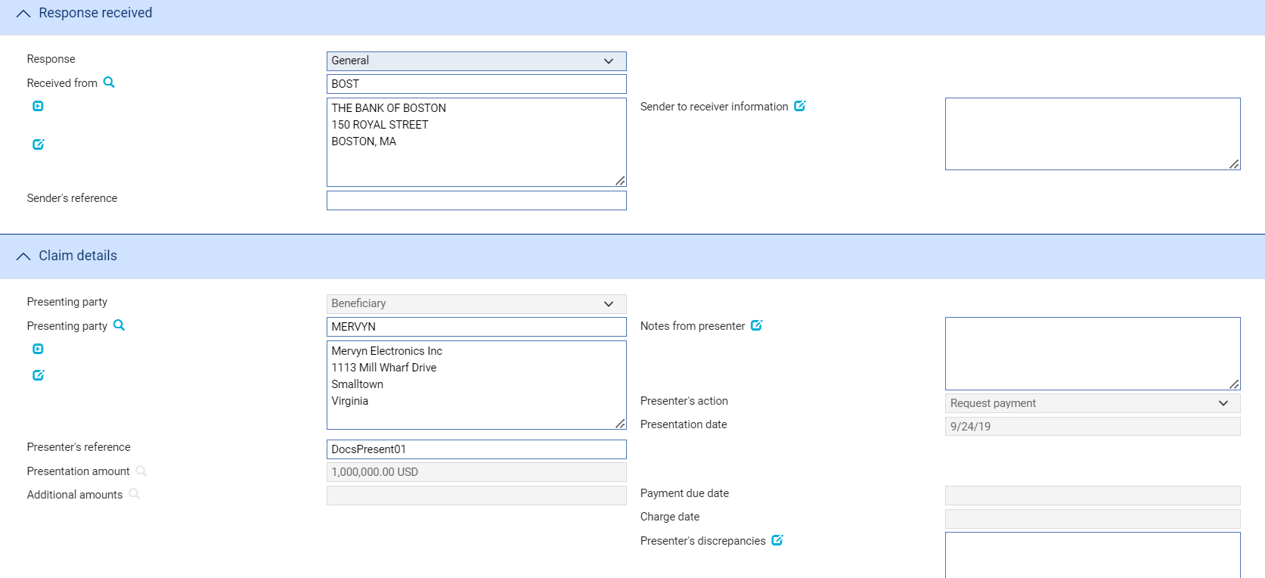

The following table explains what to enter into the fields displayed during a Log step:

| Field | What it Shows |
| --- | --- |
| Originating Reference | The reference of the event that is being continued. A read only field. |
| Response | The type of response received. You can select from the following:   * General (see page 70) * Documents Received (see page 70) * Advice of Discharge (see page 70) * Refusal (see page 71) * Authorisation to Pay (see page 72) * Advice of Payment (see page 74) * Invoices Received (see page 70) for transfer letters of credit * Maturity (see page 74) (if the event has been generated automatically from a diary action) * Reverse Payment (see page 75) |
| Received From | Details of the party from whom you received the reply. |
| Sender's Reference | The reference used by the sender for the reply. |
| Payment Advice Date | The date of the original payment advice. |
| Response Received Date | The date the reply was received by your bank. The system uses today's date as the default. |
| Presenting Party | The presenting party details. |
| Status | The status of the claim. |
| Presentation Date | The date the original request was sent. |
| Presenter's Reference | The presenter's reference for the original claim. |
| Presentation Amount | The amount of the claim in the original Documents Presented event, and the payment type. |
| Type | The payment type – Sight, Acceptance or Deferred. |

### Entering Full Details of the Response

If there is more than one outstanding presentation from the letter of credit, the Select button allows you to select the one to continue.

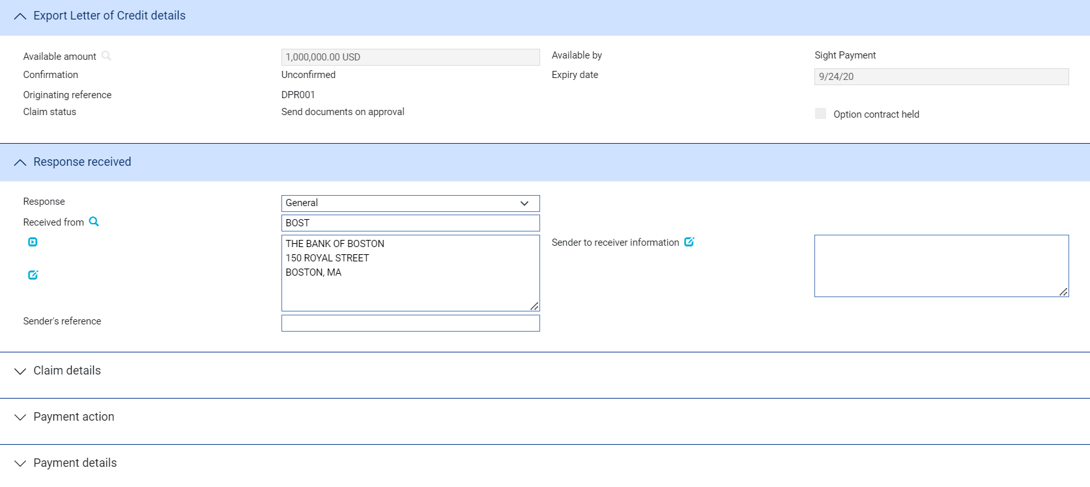 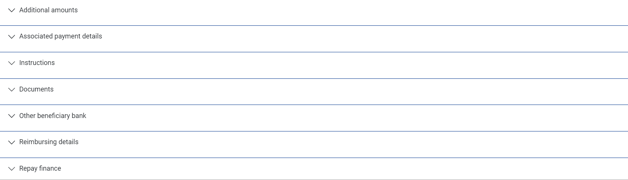

Use the Received From field to identify the party from whom you received the response, and enter their reference for the response into the Sender's Reference field.

The Response field allows you to identify the type of response received. You can select from the following values:

* General (see page 64)
* Documents Received (see page 64)
* Advice of Discharge (see page 64)
* Refusal (see page 65)
* Authorisation to Pay (see page 66)
* Advice of Payment (see page 68)
* Invoices Received (see page 64) for transfer letters of credit
* Maturity (see page 68) (if the event has been generated automatically from a diary action)
* Reverse Payment (see page 69)

The fields shown in the window vary, depending on what response type you select.

### General/Documents Received/Invoices Received

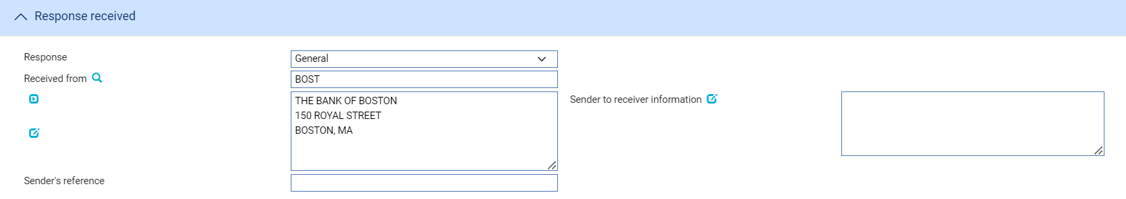

If you select a response type of 'General', 'Documents Received' or 'Invoices Received' you can use the Sender to Receiver Information field to enter any narrative from the sender. If you select 'Documents Received', you should also enter details of the documents received into the Documents/Notes pane.

### Advice of Discharge

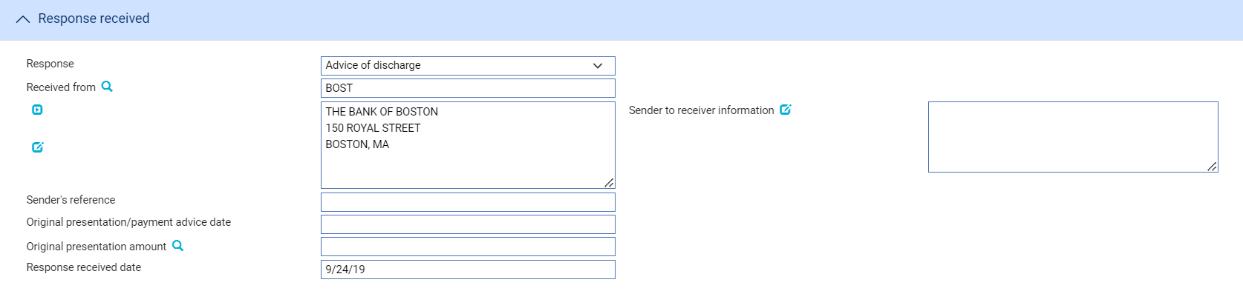

The following table explains what to enter into the fields displayed when you select a response type of 'Advice of Discharge':

|  |  |
| --- | --- |
| Field | What to Enter |
| Sender to Receiver Information | Any narrative from the sender. |
| Payment Advice Date | The date of the original payment advice. |
| Amount Originally Claimed | The amount claimed on the original payment advice. |
| Response Received Date | The date that the response was received |

### Refusal

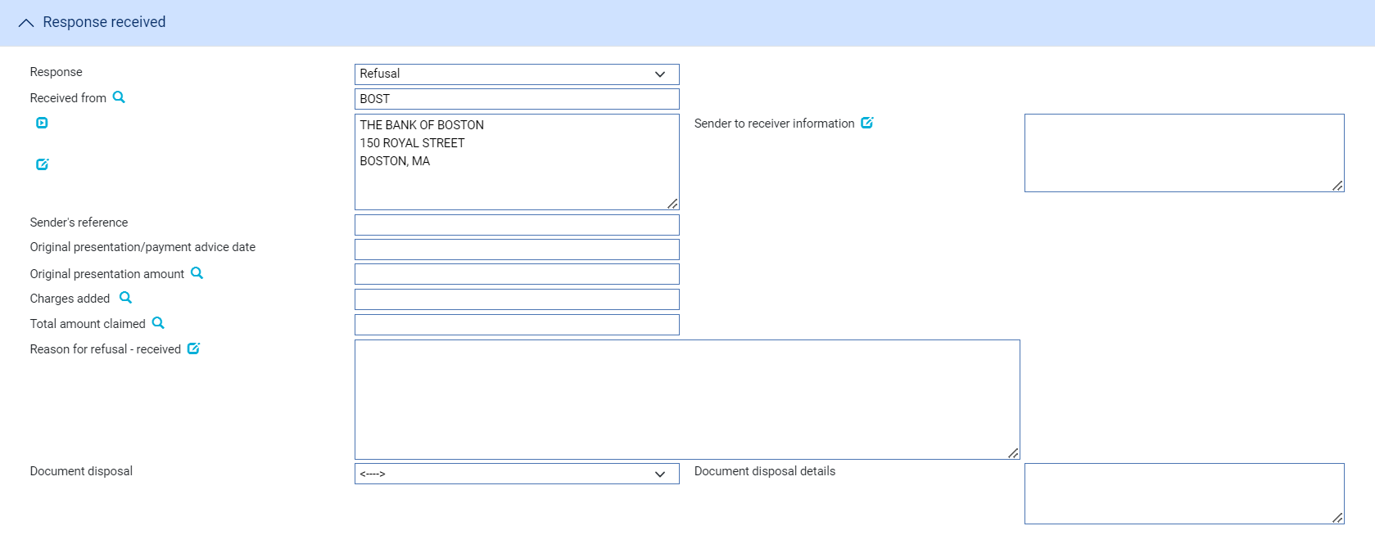

The following table explains what to enter into the fields displayed when you select a response type of 'Refusal':

| Field | What to Enter | |
| --- | --- | --- |
| Sender to Receiver Information | Any narrative from the sender. | |
| Disposal of Documents | Use this dropdown to indicate the disposal action for the documents. | |
|  | Hold | Select this field if you intend to hold documents received whilst awaiting further instructions from presenter/issuing bank. |
|  | Notify | Documents held until the issuing bank receives a waiver from the applicant and agrees to accept it, or receives further instructions from the presenter prior to agreeing to accept a waiver. |
|  | Previous instructions | Acting in accordance with instructions previously received from the presenter. |
|  | Return | Select this field if documents are to be returned to the sender. |
| Reason for Non-Payment | Specify the reason for non-payment.  Use one of the following options: | |
|  | Different claiming bank | |
|  | Duplicate claim | |
|  | Insufficient information in the claim | |
|  | Not authorised by Issuing Bank to reimburse | |
|  | Other | |
|  | Total claim exceeds maximum amount (excluding additional amounts) | |
|  | Refer to Issuing Bank for further instruction | |
|  | TT claim not allowed | |
|  | Information stated in the claim differs from the R/A | |
|  | Total claim exceeds available amount (including additional amounts) | |
| Disposal of Reimbursement Claim | Specify the action taken by the Reimbursing Bank  Use one of the following options: | |
|  | Claim has been cancelled. | |
|  | Claim is held. | |
|  | Claim has been returned. | |
| Payment Advice Date | The date of the original payment advice. | |
| Amount Originally Claimed | The amount claimed on the original payment advice. | |
| Charges Added | Any charges being claimed by the sender arising from the refusal.  These can be added using the Charges Summary window - see the Common Facilities User Guide – Trade Innovation for instructions. | |
| Total Amount Claimed | The total amount being claimed. This is the original amount claimed plus additional charges added. | |
| Discrepancy Details Received | Narrative giving the reason for the refusal. | |

### Authorisation to Pay

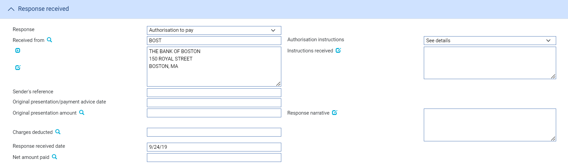

The following table explains what to enter into the fields displayed when you select 'Authorisation to Pay':

| Field | What to Enter |
| --- | --- |
| Authorisation Instructions | Use the first field to select from one of the following:   * Accept * Debit Selves * Pay and Claim Reimbursement * Receive Remittance * See Details * Negotiate |
| Instructions Received | Enter narrative describing the terms of the authorisation. |
| Payment Advice Date | The date of the original payment advice. |
| Amount Originally Claimed | The amount claimed on the original payment advice. |
| Charges Deducted | Any charges being deducted by the sender. For complete reconciliation check this amount using the Charges Summary window.  See the Common Facilities User Guide – Trade Innovation for instructions. |
| Net Amount Paid | The net amount being paid. |
| Response Narrative | Narrative from Sender. |

### Advice of Payment

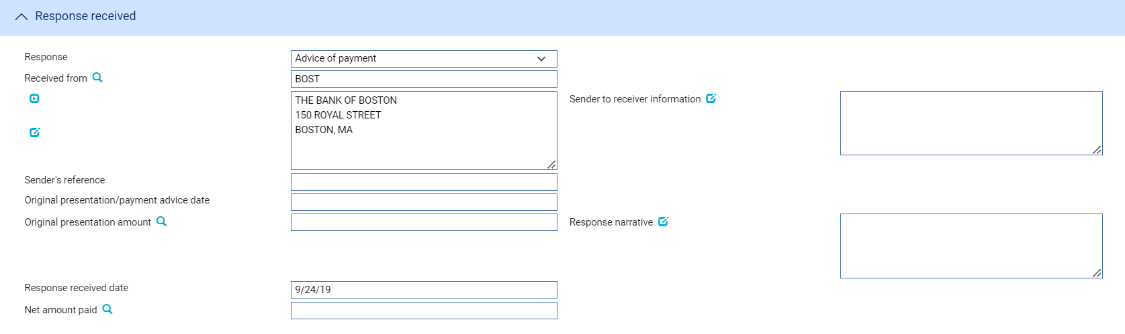

The following table explains what to enter into the fields displayed when you select 'Advice of Payment':

|  |  |
| --- | --- |
| Field | What to Enter |
| Sender to Receiver Information | Any narrative from the sender. |
| Payment Advice Date | The date of the original payment advice. |
| Amount Originally Claimed | The amount claimed on the original payment advice. |
| Response Received Date | The date on which you received the response. |
| Net Amount Paid | The net amount being paid by the sender of the message. |
| Response Narrative | Any additional narrative from the sender. |

### Adjust Maturity

The Adjust Maturity payment action enables you to change the value date of a future-dated payment that was specified during the payment event that you are continuing - referred to here as the source event. This may be necessary if, for example, the advising bank requests you to change the date of a future payment.

This action is available only if the AllowAdjustMaturity system option is set on and only in the following circumstances:

* In an Outstanding Claim event or an Outstanding Presentation event
* When the payment action selected in the event that you are continuing was 'Pay'
* The payment date is in the future

Unlike the other payment actions, this action is not available during a Claim Received or Documents Presented event.

You can change the following value dates, provided they are in the future:

* For the payment, in the Value Date field
* For any additional amounts
* For associated charges, using the Settlement Details window (see the Common Facilities User Guide – Trade Innovation)

When you change such a value date the system identifies charges in the source event that were due to be taken on a future value date that has not yet been reached, supersedes them in the source event and includes them in the current event set to 'Take'. Their value date can be changed using the Settlements window.

The system also identifies postings projected in the source event with a value date that has not yet been reached and stops the original projections being posted and generates replacement projections with the revised value date.

Any SWIFT payment messages that have not yet been released are stopped and new messages generated, as appropriate, from the current event. However, If messages from the source event have already been released:

* For funds movement messages (such as MT202), the equivalent messages in the new event are automatically suppressed
* For event document messages (such as MT756), you should set up rules to prevent the issue of such duplicate messages

Any charges or additional amounts that had no value date entered for them will be automatically assigned the new value date for the payment.

Value dates that have passed cannot be changed. For example, if the original claim included part payments and the value date for one of those has now passed, you cannot change the value date for that part payment.

You can enter explanations for or comments on the change in the Notes to Applicant and Notes for Presenter fields.

### Reverse Payment

The Reverse Payment action allows a payment to be refunded where, for example, a claim is initially paid but is subsequently found to be discrepant. The payment action is available only when a transaction is flagged as having multiple payments, with a single part payment that has already been paid.

When this payment action is selected, the part payment that has already been paid is set to ‘Paid/Reversed’.

Your bank will need to define postings to reverse the part payment. This might involve the reinstatement of any liability, if appropriate.

## Processing Associated Payment Details



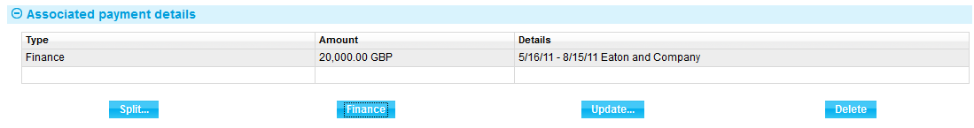

The Associated Items pane allows you to apply further processing against the payment or part payments being made. As payments are defined they are listed in this pane. You can select them individually and enter details of:

* An assignment to a third party (see page 76)
* A loan (see page 76) - select the Finance line and press **Update**
* A discount (see page 79) - press the Discount button
* A license - press the Licenses button. See the Licenses User Guide – Trade Innovation for further instructions

### Assigning Proceeds to a Third Party

Press the Split button that appears in the Associated Payment Details pane.

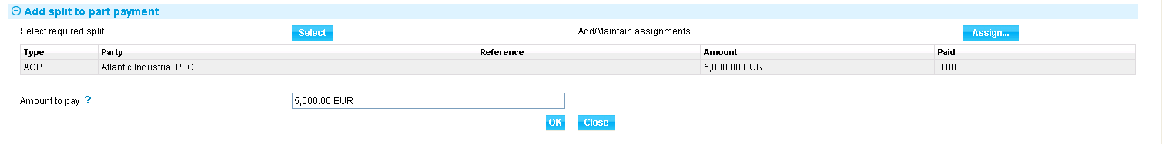

In the window that appears the system lists all assignments of proceeds (AOP), transfer letters of credit (TRF) and back-to-back letters of credit (BTB) created against the parent transaction, showing for each:

* The name of the beneficiary or assignee
* The original amount allocated
* The amount paid to date

Select the third party to whom you wish to assign proceeds and press Select.

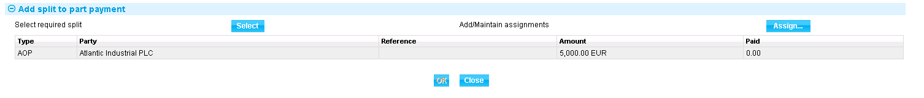

The system displays the amount to be assigned, which you can overtype. Press Assign to assign the amount to the selected third party.

### Entering Details of a Loan

1. The functionality described in this section is used to enter loans for systems where the financing module is not implemented. If your system has the financing module implemented see the Financing User Guide – Trade Innovation for information on processing loans.

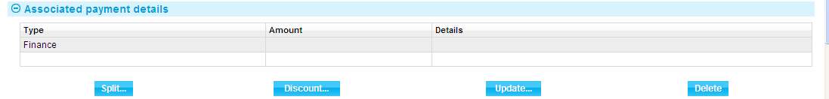

This is used to record information if the applicant to borrow funds in order to defer payment to a later date. Typically repayment is made from the applicant's own funds at a future date, for example after an onward sale of goods has been arranged. When you double click on this line or select it and press **Update**, the system displays a window which allows you to enter details of a loan being made against a payment.

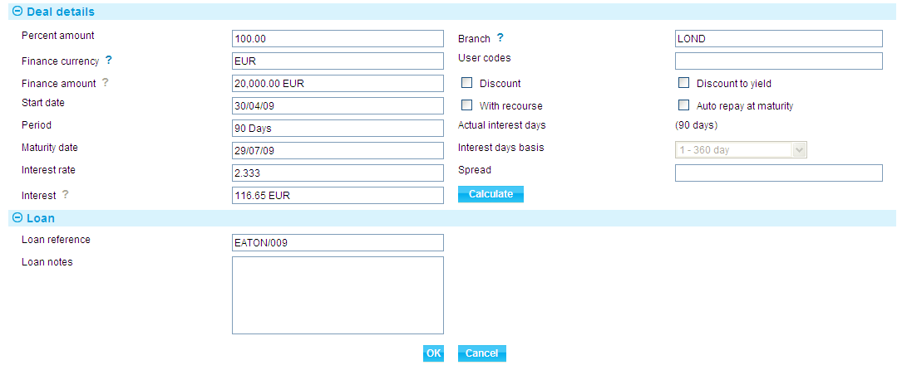

The following table explains what to enter into the field in this window to record details of any such loan.

When you have completed input and closed this window, the Finance line displays the amount and currency of the loan, its start date and maturity date, the interest rate, and the interest/discount amount.

| Field | What to Enter |
| --- | --- |
| Percent Amount | The amount of the part payment to be financed, as a percentage. |
| Discount/ Discount to Yield | Indicate when interest is to be paid. Check the Discount box if interest is to be paid at inception, or leave the box blank if interest is to be paid at maturity.  Check the Discount to Yield box if the discount to yield formula is to be used to calculate the discount instead of the standard discount formula.  If you click on either the Discount box or the Discount to Yield box the system displays extra fields. |
|  | |
|  | Once you enter a value into the Rate field the system calculates and displays the discount amount and displays it using the Discount Interest field. Alternatively, you can enter the discount amount into the Discount Interest field, and the system will calculate the interest rate and display it using the Rate field. In either case the system calculates and displays the net amount due using the Net Amount field.  Use the Discount Paid By field to define who will pay the discount interest amount on the loan. The debit party is the applicant and the credit party is the presenter. The system uses the credit party as the default. |
| Finance Currency | The currency of the loan, if different from the currency of the transaction.  If you enter a currency here that is different from the transaction currency, the system displays an Exchange Rate field for you to identify the exchange rate to be used to convert the loan amount from the transaction currency.  When you have selected an exchange rate the system calculates and displays the converted amount in the Finance Amount field. |
| With Recourse | Use this field to indicate whether or not the loan is with recourse. This field is available for Bank use. By default, the box is unchecked and the loan is without recourse. |
| Start Date | The start date of the loan. The system uses the part payment value date as the default. |
| Period/ Maturity Date | The maturity date for the loan. Either enter the maturity date; or use the Period fields to identify the number of days, weeks, months, quarters or years after its start date the loan will mature. If you select the latter option, the system calculates the maturity date and displays it in the Maturity Date field.  The Maturity Date field may be left open for loans with interest payable at maturity. This allows the maturity date to be entered as the loan is repaid. |
| Rate | The overall rate at which interest or discount is to be will be required to record details of the repayment manually.  This field can be checked only if the Maturity Date field is not blank. |
| Spread | The spread rate that has been added to the interest rate. This is used for reporting purposes only. Your bank will have devised its own system for using this field.  The values entered here will appear on the deal generated for the loan. |
| Branch | The branch that owns the loan. |
| Discount Paid By | Select which party is to pay the discount - the credit party or the debit party. |
| Discount Interest | The discount interest amount. |
| Net Amount | The amount to be advanced. The system uses the amount claimed as the default here, and converts it using information entered in the previous fields. |

### Discounting Payments

1. The functionality described in this section is available only if you do not have the financing module implemented.

For payments where you have checked both the Eligible box and the Hold box, the Discount button in the Associated Payment Details pane is enabled.

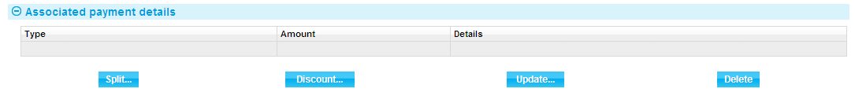

This allows you to record details of a payment to be made to the presenter before the date due under the terms of the master record.

When you press the Discount button the system opens a window for you to enter details of the discount.

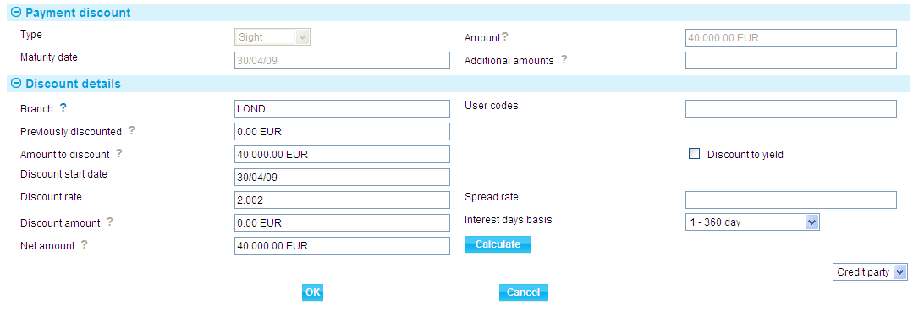

Details of the payment or part payment being discounted are displayed at the top of the window. The table below explains what to enter into the field in this window. Pressing the Calculate button updates the fields, using the values you have entered.

|  | Field | What to Enter |
| --- | --- | --- |
|  | Previously Discounted | If a discount has already been given against the transaction, the amount against which the discount was given. |
|  | Amount to Discount | The amount of the discounted payment for which the early payment is to be made. This may be up to the amount due under the part payment, including additional amounts. |
|  | Discount Date | The date the discounted payment is to be made. The system uses today's date as a default. |
|  | Spread Rate | The spread rate that has been added to the interest rate. This is used for reporting purposes only. |
|  | Days Basis | The days basis to be used to calculate the interest. A list of valid values is given in the Common Facilities User Guide – Trade Innovation. |
|  | Discount to Yield | Click once on the Discount to Yield box so that it is checked if the discount to yield formula is to be used to calculate the discount instead of the standard discount formula. |
|  | Discount Amount | The amount of the discount. If you enter the interest rate into the Discount Rate field, the system us calculates the discount amount and displays it in this field, where you can overwrite it. Alternatively, you can enter the discount value directly into this field and the rate will be automatically recalculated. |
|  | Discount Rate | The interest rate to be used to calculate the discount interest amount. Enter the overall rate at which discount is to be calculated (including the spread).  Alternatively, you can enter the discount as an amount in the Discount Amount field. |
|  | Net Amount | The total value of the early payment, taking into account any discount due. |
|  | Discount Paid By | Indicate which party is to pay the discount on the early payment. |
|  | Branch | The branch that owns the discount deal. |

# Payment and Back-to-back Letters of Credit

Once a back-to-back letter of credit is created, it proceeds to settlement independently of its parent letter of credit. However, when a claim is paid under the parent letter of credit, the system permits you to allocate funds from those received for the export letter of credit to the back-to-back letter of credit.

The allocation of those funds from the parent to the back-to-back letter of credit can then be achieved using postings set up using the system tailoring application to allocate the funds to a suspense account for the beneficiary of the back-to-back letter of credit. The claim against the back-to-back letter of credit can be paid from this suspense account for the applicant either before or after receipt of funds from the issuer of the parent letter of credit.

Where the two letters of credit are in different currencies, you can use foreign exchange deals to convert the funds to the required currency. The necessary deals can be entered in the usual way during payment events for either the parent letter of credit or the back-to-back letter of credit.

This chapter explains how to allocated funds to a back-to-back import letter of credit as part of the process of paying its parent export letter of credit. It describes only the additional processing required, and assumes that you are familiar with the Documents Presented and Outstanding Presentation events.

## Allocating Funds to a Back-to-back Letter of Credit

You can allocate funds to a back-to-back letter import letter of credit while paying an export letter of credit during a Documents Presented or an Outstanding Presentation event.

Press the Split button that appears in the Associated Payment Details pane.

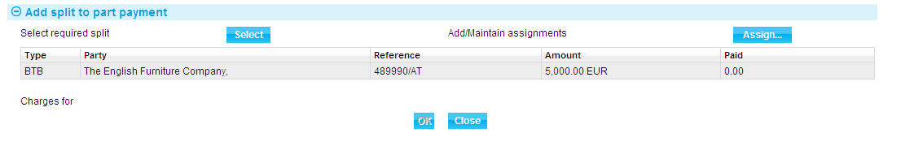

In the window that appears the system lists all assignments of proceeds (AOP) and back-to-back letters of credit (BTB) created against the parent transaction, showing for each:

* The name of the beneficiary or assignee
* The original amount allocated
* The amount paid to date

Select the third party to whom you wish to assign proceeds and press Select.

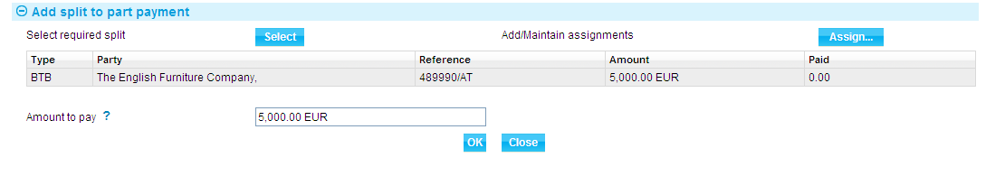

The system displays the amount to be assigned in the Amount to Pay field, where you can amend it or change the currency. Press Assign to assign the amount to the selected third party.

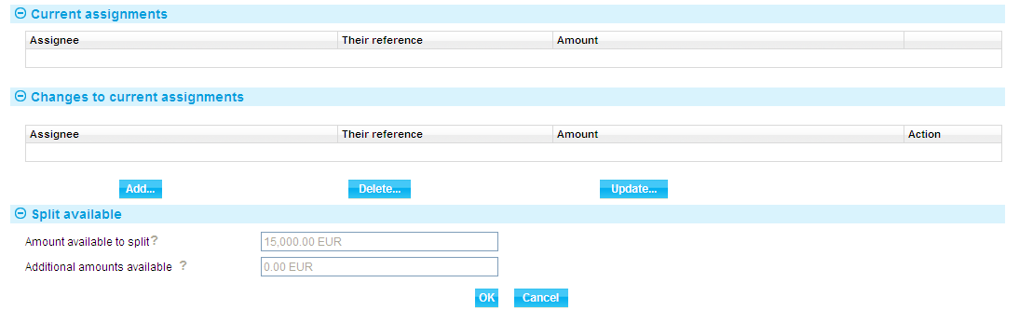

The assignment is listed. Press the OK button to repeat the process to pay any further back-to-back letters of credit.

You can amend and delete the details of payments made to back-to-back letters of credit using the Update and Delete buttons in the usual way.

If the back-to-back letter of credit is in a different currency from the parent letter of credit, the system issues a warning, so that you can enter the necessary foreign exchange deals as part of this event, as required.

## After the Payment has been Made

Once the payment event for the export letter of credit has been released, the system allocates the funds to the appropriate reconciliation account, from which the claim received for the back-to-back letter of credit will be, or has been, funded.

# Freely Negotiable Letters of Credit

Freely negotiable letters of credit are letters of credit issued as available at any bank or at any one of a number of banks, for example banks in a particular country. They permit the beneficiary to present the letter of credit, together with the required documents, for payment at any bank within the terms of the letter of credit. The system handles freely negotiable letters of credit as a type of export letter of credit. A Freely Negotiable LC event allows documents to be presented at the same time as you record the letter of credit on your system. Payment may therefore take place as part of the Freely Negotiable LC event. Alternatively, you can pend payment while you seek authorisation from other parties to the letter of credit and make payment using an Outstanding Presentation event.

Once a Freely Negotiable LC event has been completed and released, it creates a new master record for the letter of credit which can be accessed via the Master browser window. The master record can be amended or adjusted using an Amend or Adjust event; and it expires and is booked off in the usual way.

If your system has the financing module implemented you are able to make a loan against the letter of credit, as explained in the Financing User Guide – Trade Innovation.

This chapter explains how the system handles freely negotiable letters of credit. It assumes that you are familiar with the Documents Presented (see page 57) and Outstanding Presentation (see page 66) events.

## Licenses

If there is a license attached to the transaction, then a drawdown can be made. Depending on the payment action chosen, an automatic drawdown may be done for the amount of the part payment. The drawdown is only automatic if there is only one license attached. Where there are more attached, you must manually allocate the payment amount to each license for drawdown.

There will be additional validation during the presentation of the claim and the processing of the payment:

* If the latest payment date has been entered on the license, the payment value date (and the charge date) on the part payment must be within the license latest payment date
* Each drawdown amount must be within the license amount. You can use the system parameters to set up options for overdrawn, tolerance limits and multiple licenses - see the *System Tailoring User Guide* – Trade Innovation for more information about setting system parameters
* At expiry or final payment of a transaction, any unutilised portion of the reserved license amount can be made available for drawing by another transaction. A reinstatement event restores the unutilised portion of the reservation on the license
* For mixed payment claims, each claim can have more than one part payment that creates drawdowns; each part payment can itself have multiple drawdowns - one for each license

See the Licenses User Guide – Trade Innovation for details of licenses.

## Entering Details of a Freely Negotiable Letter of Credit

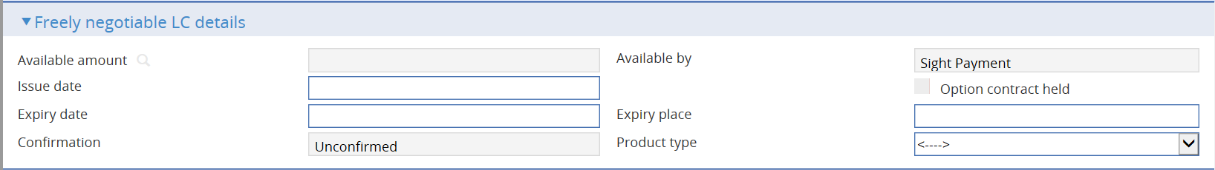 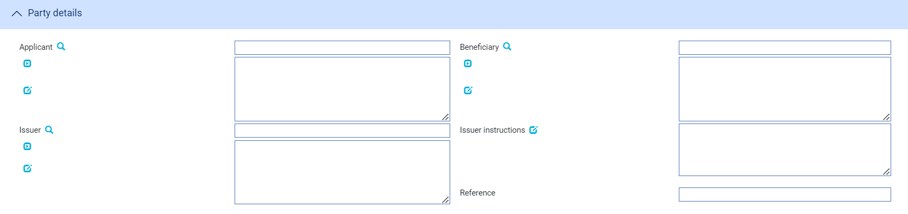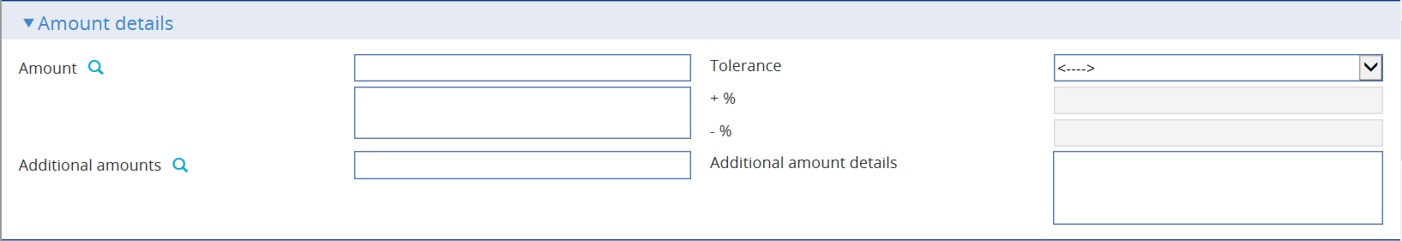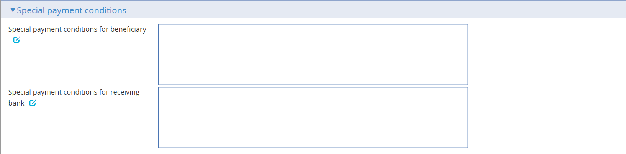 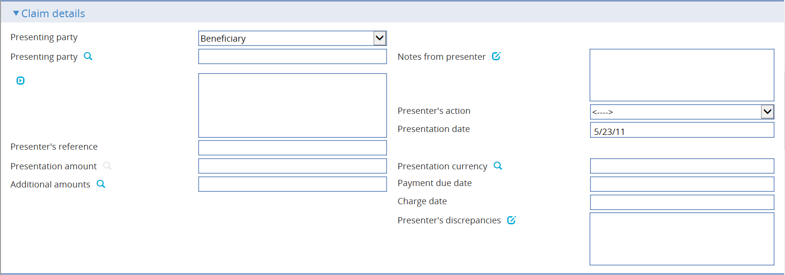 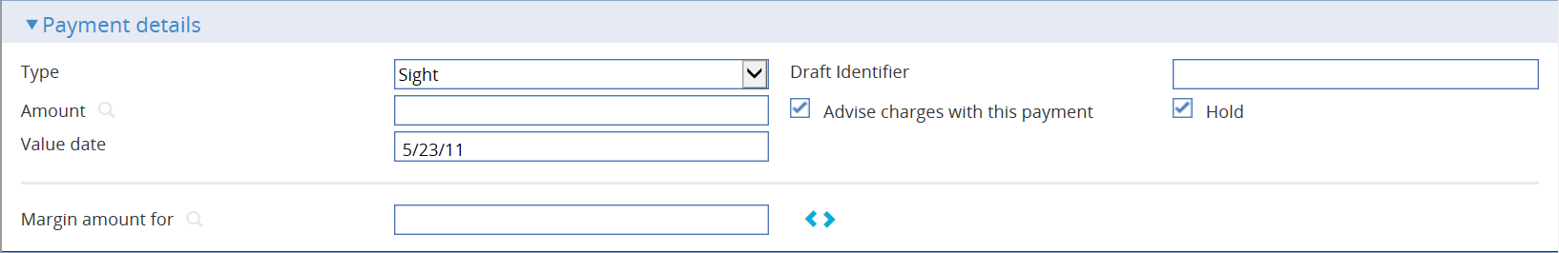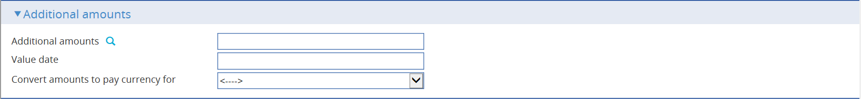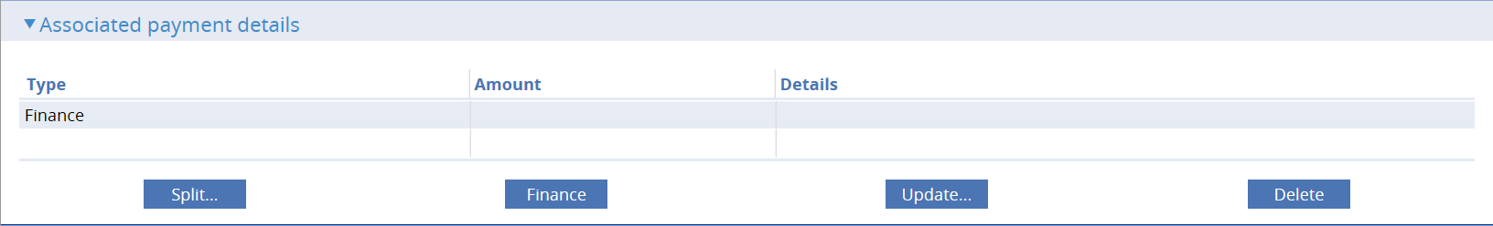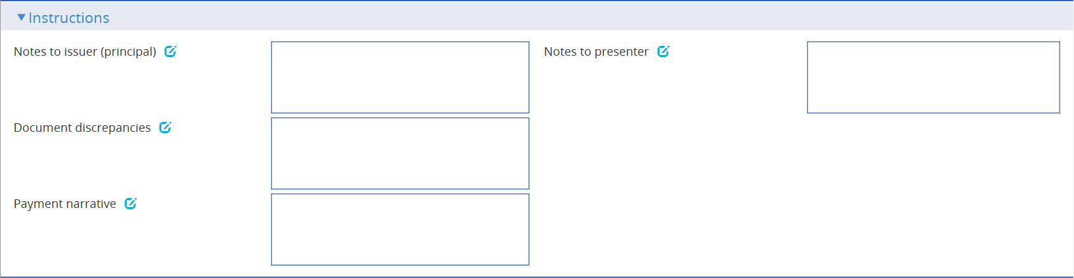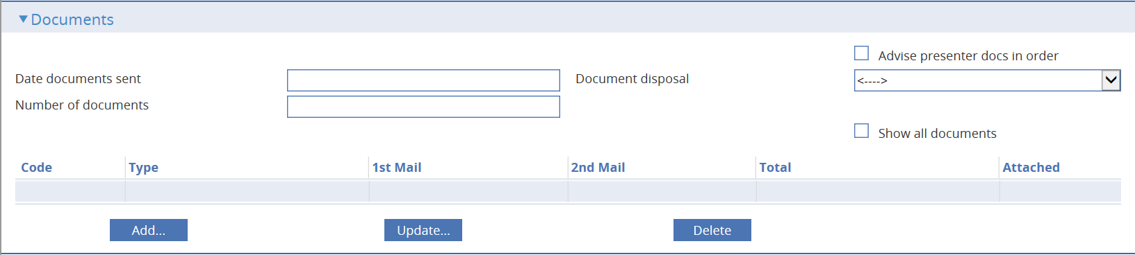 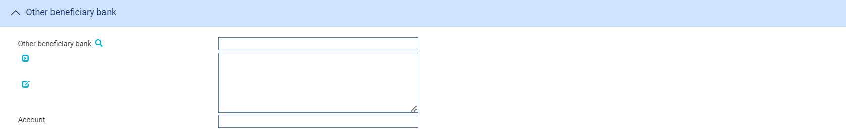 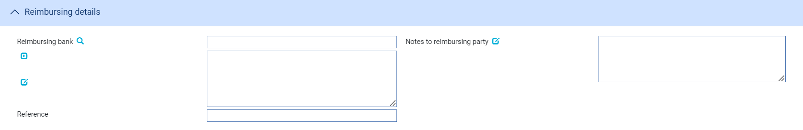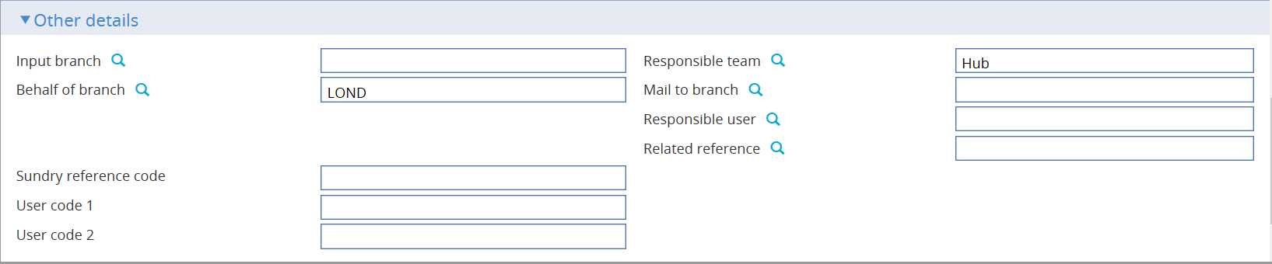

To enter details of a freely negotiable credit on your system, in the Masters window, select the Team and Behalf of branch and use the drop-down list in the New Masters pane to select 'Freely Negotiable LC', then press New. The system creates a Freely Negotiable LC event at either a Log step or Input step. Depending on how your system is configured, panes and fields available in log steps can be tailored for each data capture step. See the *SDK - Screen Tailoring User Guide* for details.

The following panes are used to enter details of the freely negotiable letter of credit:

* The Freely Negotiable LC Details Pane (see page 79)
* The Party Details Pane (see page 80)
* The Amount Details Pane (see page 80)
* The Special Payment Conditions pane (see page 80)
* The Claim Details Pane (see page 81)
* The Payment Action Pane (see page 82)
* The Payment Details Pane (see page 83)
* The Additional Amounts Pane
* The Associated Payment Details Pane
* The Instructions Pane (see page 84)
* The Documents Pane
* The Other Beneficiary Bank Pane (see page 85)
* The Reimbursing Details Pane (see page 85)
* The Other Details Pane (see page 86)

Instructions on using the Documents pane are given in the Common Facilities User Guide – Trade Innovation.

### The Freely Negotiable LC Details Pane

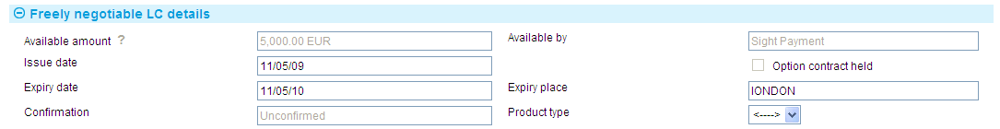

The following table explains what to enter into the Freely Negotiable LC Details pane:

|  |  |  |
| --- | --- | --- |
|  | Field | What to Enter |
|  | Available Amount | The system displays the amount available on the letter of credit. This is set to the amount of the letter of credit, taking into account the tolerance. |
|  | Available By | The system displays the payment method for the available amount. |
|  | Issue Date | The date the freely negotiable letter of credit was issued. |
|  | Option Contract Held | This field is checked if foreign exchange option contracts are entered against the letter of credit. Initially it is blank. |
|  | Expiry Date | The expiry date of the letter of credit. |
|  | Expiry Place | The location at which the expiry date applies. |
|  | Confirmation | Set to 'Unconfirmed'. |
|  | Product Type | If your bank has set up product types for freely negotiable letters of credit, select the appropriate one from the drop-down list on this field. Depending on how your system has been configured, this field may be mandatory. |

### The Party Details Pane

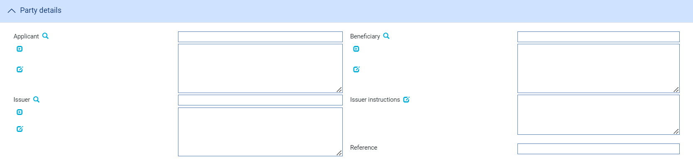

The following table explains what to enter into the fields in the Party Details pane:

|  |  |  |
| --- | --- | --- |
|  | Field | What to Enter |
|  | Applicant | The applicant. |
|  | Beneficiary | The beneficiary. |
|  | Issuer | The issuer of the letter of credit. |
|  | Issuer Instructions | Any instructions from the issuer. |
|  | Reference | The issuer's reference for the letter of credit. |

### The Amount Details Pane

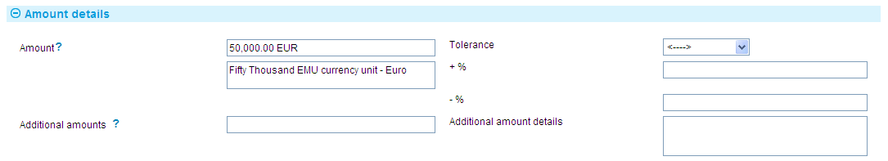

The following table explains what to enter into the fields in the Amount Details pane:

| Field | What to Enter | |
| --- | --- | --- |
| Amount | The amount and currency of the transaction. The system displays the amount and currency in the language of your system beneath these fields. You can edit this text, if necessary. | |
| Tolerance | Specify how the amount is being expressed. Select from one of the following: | |
|  | Exact | If the amount is the exact value of the letter of credit. |
|  | About | If the amount given in the Amount field is within 10% either way of the expected value of the letter of credit. |
|  | Other | If you select this option, use the -% and +% fields to specify as a percentage how much more or less than the final value of the letter of credit the amount entered is allowed to be. |
|  | Not Exceeding | If the final value of the letter of credit is expected to be no more than the amount entered, and not less than 95% of the amount entered. |
|  | Min/Max | If you select this option the system displays a + Amount and a - Amount field. Use them to specify as an amount how much more or less than the final value of the transaction the amount entered is allowed to be. |
| Additional Amounts | Any amounts payable to the beneficiary in addition to the principal amount of the transaction. These might include, for example, local freight charges.  If you enter an amount, it is added to the amount of liability under the transaction. If you use a different currency for the amount, then the amount is converted to the currency of the transaction using the current spot rate. | |
| Additional Amount Details | A text description of what any additional amounts are for. | |

### The Special Payment Conditions Pane

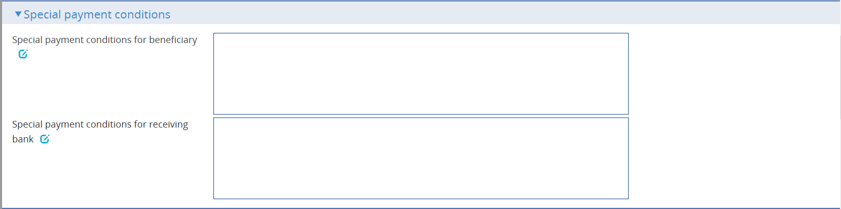

The following table explains what to enter into the fields in the Special Payment Conditions pane:

|  |  |
| --- | --- |
| Field | What to Enter |
| Special payment conditions for beneficiary | Specify special payment conditions applicable to the beneficiary of the credit. |
| Special payment conditions for receiving bank | Specify special payment conditions applicable to the receiving bank of the credit without disclosure to the beneficiary. |

### The Claim Details Pane

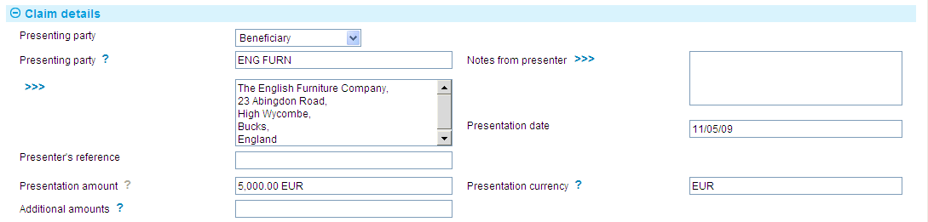

The following table explains what to enter into the Claim Details pane:

|  | Field | What to Enter |
| --- | --- | --- |
|  | Presenting Party | The presenting party. You can use the first field to select a party already identified in the event using their party role, in which case their details are retrieved and displayed in the remaining fields in this pane.  Alternatively, if the presenting party has not been assigned a party role within the transaction, select 'Other presenting party' in the first field, then use the remaining fields to enter their details in the usual way. If you identify a party in this way, they are assigned the role of 'Presenting party'.  The system uses the advising bank as the default, or the beneficiary, if the letter of credit was advised direct. |
|  | Notes from Presenter | Any notes or instructions received from the presenting party. |
|  | Presentation Date | The date of the presentation. The system uses today's date as the default. |
|  | Presenter's Reference | The presenter's reference for the letter of credit. |
|  | Presentation Amount | The system displays either the available amount of the letter of credit (less any outstanding claims) or the presentation amount, if entered during the Log step. |
|  | Presentation Currency | The currency of the presentation amount, if different from the currency of the letter of credit. |
|  | Additional Amounts | Any additional amounts being claimed. |

### The Payment Action Pane



The Payment Action pane allows you to process the claim by selecting a payment action and then entering details of the payment.

The actions included in the Payment Option drop-down list vary, depending on the presenter's actions, for example whether they are requesting authorisation to pay or whether instead they have paid and are requesting reimbursement.

For a single payment, details of the actual payment are entered into the Payment Details pane. If payment is mixed, to involve two or more part payments, check the Mixed Payment field. The system displays a Payments pane, which you can use to enter details of each of the part payments in turn.

Check the With Recourse box if the payment is with recourse; and the Final Payment box if the payment includes the final payment under the reimbursement authority.

If your payment action is 'Reject and Claim Refund' then enter the date of the refund into the Refund Date field.

The payment action you select applies to all part payments. However, where the action is 'Pay' the individual status of a payment can be changed using the Pay Status field in the Payment Details window.

If the action involves a request for authorisation to pay, then the system displays an additional field - the Presenter's Discrepancies field - into which you can enter details of discrepancies.

If the claim involves more than one payment, check the Mixed Payment box. The Payments pane changes to allow you to enter details of part payments.

Check the With Recourse box if the payment is with recourse (normally used when paying with discrepancies); and the Final Payment box if the payment includes the final payment under the letter of credit.

The Licenses button is displayed only if a license has been attached. See the Licenses User Guide – Trade Innovation for more information.

### The Payment Details Pane

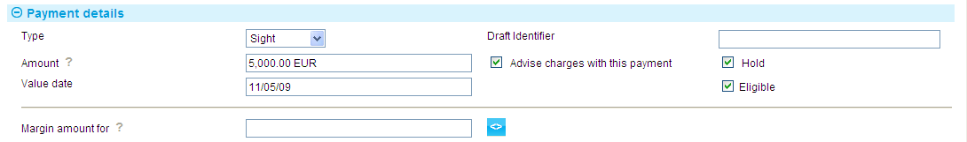

The Payment Details pane allows you to enter details of the payment you are making.

For mixed payment, check the Mixed Payment field in the Payment Action pane. A new pane - the Payments pane - is displayed.



Select the payment listed in this window and press the Update button. In the window that appears, define the first part payment.



The fields are the same as those used in the Payment Details pane to define a single payment. When you close the window, the details of the part payment are listed in the Payments pane, from where you can select them and amend or delete them. Use the Add button to reopen the window to enter details of the next part payment.

Once you have entered details of a payment, or part payment, it is listed in the Payments pane.



1. The system creates a first part payment for the full amount of the payment event. If you add more part payments, remember to amend the amount of this first part payment accordingly.

The following table explains what to enter to define a payment or part payment:

| Field | What to Enter |
| --- | --- |
| Payment Action | This field is displayed only for mixed payments, and it initially reflects the payment action selected for the claim in the main Input window. If the payment action involves refusal or leaves the claim outstanding, then you will not be able to alter the value in this field.  If the payment action involves paying the claim, then you can use this field to select a status for each individual part payment.  Select from the available options. |
| Type | Select the type of payment - Sight, Acceptance or Deferred - then press Refresh. The fields displayed in the rest of the window vary, depending on what you enter here. |
| Amount | The amount being claimed. |
| Advise Charge with This Payment | Check this box if charges taken or claimed are to be advised with this payment. |
| Value Date | For sight payments, enter the value date of the payment.  For acceptance and deferred payment the value date of the payment is calculated using the value in the Period field.  The system issues a warning if this date does not leave enough time for any pre-debit notification required. |
| Start Date/Period/From/ After | For acceptance and deferred payments, the start date of the payment period.  Use the Period field to define the period (as, for example, 1 month or 10 days), then use the From/After field to indicate whether the period will be calculated from or after the base date. |
| Draft Identifier | If you know the draft identifier, enter it here. |
| Hold | This field is displayed for sight and acceptance payments. Check it if drafts are being held, and uncheck it if they are being returned to the claimant.  You can discount a draft only if this and the Eligible box are checked. |
| Eligible | This box must be checked for you to be able to discount a part payment. For sight and acceptance payments, the Hold box must also be checked. |

### The Instructions Pane

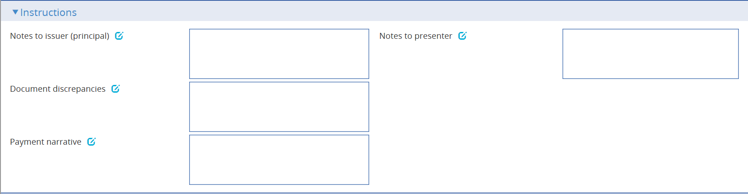

You can use the fields in the Instructions pane to enter any information or instructions for the issuer or for the presenting party.

Depending on the setting of the system option DiscrepancyFieldAlwaysVisible the Document Discrepancies field may be displayed here, even if the payment action would not normally require it to be populated. When the system option is switched on the field allows you to enter minor discrepancies for your bank's own audit purposes, where the payment action does not normally involve reporting discrepancies.

Payment Narrative field is displayed when payment action is set to Pay, Pay and claim reimbursement, Pay at maturity, Pay with discrepancies and Approve Authorisation Request.

### The Documents Pane

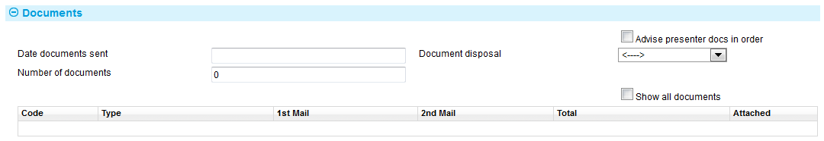

The following table explains what to enter into the fields in the Documents pane. See the Common Facilities User Guide – Trade Innovation for instructions on adding, amending, deleting and viewing details of the actual documents involved:

|  |  |  |
| --- | --- | --- |
|  | Field | What to Enter |
|  | Date Documents Sent | The date the documents were sent, as stated on the claim. |
|  | Number of Documents | The number of documents received here. Use the Add button to identify each of the documents received in turn. |
|  | Document Disposal | Use this dropdown to indicate the disposal action for the documents. Choose Hold  if you intend to hold documents received. Choose Notify if you intend to forward them to the applicant. If documents are refused and are to be returned to the sender you should choose Return. You can also choose Previous Instructions as an action. |
|  | Advise Presenter Documents In Order | Check this box if the presenter is to be advised that that any documents received are in order. |

If your bank has chosen to record an audit trail of all changes to attached documents then the Show All Documents check box allows you to see an audit trail of all changes for a document type.

### The Other Beneficiary Bank Pane

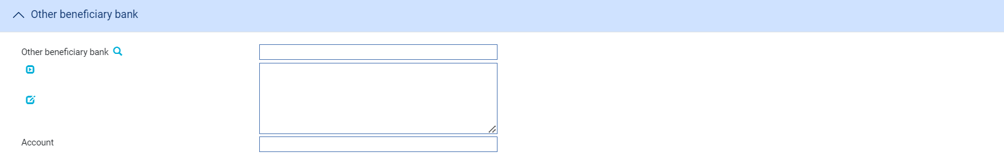

The Other Beneficiary Bank pane allows you to identify the party you want the issuing bank to pay, and the number of the account to be credited.

### The Reimbursing Details Pane

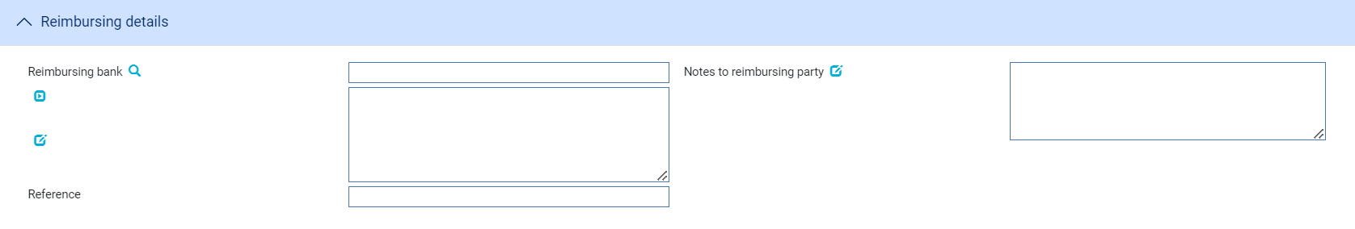

The Reimbursing Details pane allows you to identify, if relevant, the bank from whom reimbursement is to be requested and their reference for the claim; and to enter any notes for the reimbursing bank.

### The Other Details Pane

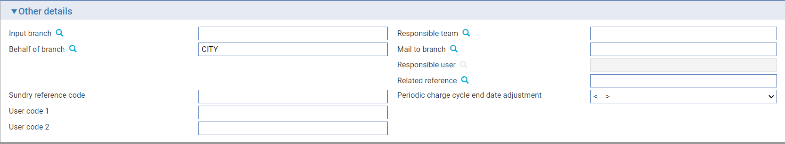

The following table explains what to enter into the fields in the Other Details pane. This pane may also include input fields defined by your bank:

|  |  |  |
| --- | --- | --- |
|  | Field | What to Enter |
|  | Input Branch | The input branch for the transaction. The input branch is set from the either:   * the accounting branch from the user’s team, or * the transaction branch for user if the user has a default transaction branch or is locked to a specific branch, or * a branch associated with the user where the user can enter transactions for several branches for a team |
|  | Behalf Of Branch | The behalf of branch for the transaction as entered by the user or set from the incoming SWIFT or gateway message. The behalf of branch determines the parameter sets that are to be used to generate charges, documents, postings, etc. during transaction processing. The branch can be changed to any other branch within the same main banking entity that shares the same parameter sets. |
|  | Sundry Ref Code /User Code 1/ User Code 2 | You may use these fields to enter values for analysis purposes. Your bank will have devised its own system for using these fields. |
|  | Responsible Team | The team that has overall responsibility for the master e.g. as the contact to resolve any queries or issues regarding the master and associated events. The system defaults the responsible team when creating the transaction as follows:   * Manual – set from team creating the transaction * Gateway – set from the team specified on the incoming message (if present and valid) otherwise to the team to which the transaction is assigned through workflow allocation based on the behalf of branch * SWIFT – set to the team to which the transaction is assigned through workflow allocation based on the behalf of branch   It can be changed, if required, to either the team associated with the primary customer, default team for the product or the user’s current team. |
|  | Mail To Branch | The mail to branch can be set to any branch within the main banking entity of the behalf of branch. |
|  | Responsible User | A user that has responsibility for the master e.g. as the contact to resolve any queries or issues regarding the master and associated events. This can be any user assigned to the responsible team. |
|  | Related Reference | You can specify any other transaction to which this letter of credit is related. This may already have been done when the master record was created. You can use the browser to select from possible references to include. |
|  | Periodic charge cycle end date adjustment | Provides the ability to configure the system to automatically set the date of a periodic charge cycle, where the end date falls on non-business/working day. Selection of one of the options enables the cycle date and due date to fall on the same or different dates as required. See the System Tailoring User Guide – Trade Innovation for more information. |

# Discounting Payments at a Later Date

1. The functionality described in this chapter is used by systems where the financing module is not implemented. If your system has the financing module implemented see the Financing User Guide – Trade Innovation for information on discounting payments.

The system permits you to discount acceptance and deferred payments that have not yet been paid as a separate event, for example payments with a status of 'Pay at Maturity' or 'Accept'.

To discount a payment, in the Master Summary window select 'Discount Payment' from the Create New Event drop-down list. The system opens the event at either a Log step or Input step. Depending on how your system is configured, panes and fields available in log steps can be tailored for each data capture step. See the *SDK - Screen Tailoring User Guide* – Trade Innovationfor details.

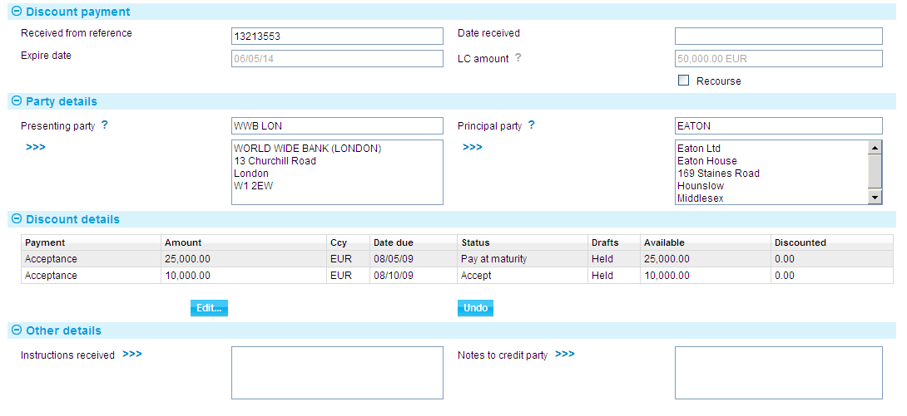

In the window displayed, the Discount Details pane lists all the payments associated with the letter of credit. Information for each payment is shown under the following headings:

|  |  |
| --- | --- |
| Heading | What it Shows |
| Payment | The type of payment - Sight, Acceptance or Deferred. |
| Amount/Ccy | The amount and currency of the payment. |
| Date Due | The date the payment is due to be made. |
| Status | The status of the payment. |
| Drafts | Indicates whether the drafts are being held by your bank or not. You can only discount a payment if drafts are being held. |
| Available | The amount of the payment available for discounting. |
| Discounted | The amount of the part payment that has been discounted, including any earlier discounting. |

The following table explains what to enter into the fields in this window:

| Field | What to Enter |
| --- | --- |
| Received From Reference | The reference used for the discount by the party from whom you received the request for discount. |
| Date Received | The date the request was received. |
| Expiry Date | The letter of credit's expiry date. |
| LC Amount | The amount and currency of the letter of credit. |
| Recourse | Indicate whether or not the discount is with recourse. This field is available for Bank use. By default, the box is unchecked and the discount is without recourse. |
| Presenting Party | The presenting party. |
| Principal Party | The principal party. The system will debit this party, where discount is not payable by the presenting party. |
| Defer | Any instructions received with the request. |
| Defer | Any notes for the presenting party. |

Select the payment to be discounted, then press **Edit**. The system displays a window which you can use to enter details of the discount.

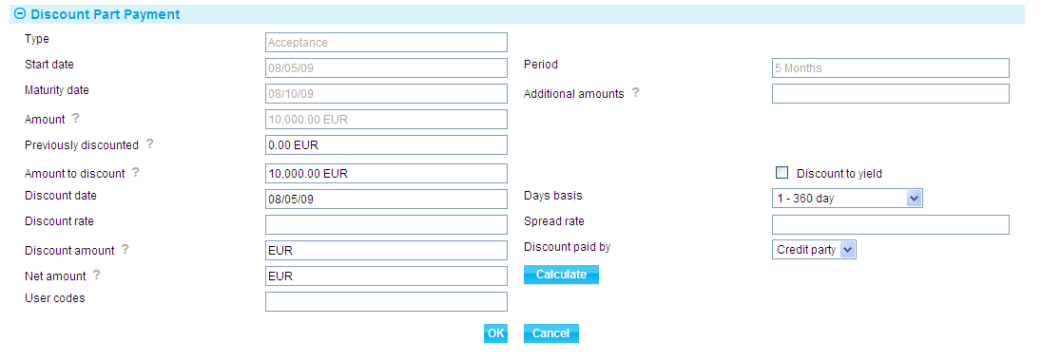

When you have completed input, the details shown for that payment in the main Input window reflect the discount entered.

The Undo button removes any discount details you have entered.

# Revolve Events and Notifications

Letters of credit are revolved and advised using the Revolve and Revolve Notice events.

## Revolving Credits in Trade Innovation

When you first enter details of a revolving credit onto your system it permits you to define how many times the credit will revolve, at what interval, and whether the revised amount is to be cumulative or non-cumulative. You can also specify whether a notification is to be sent in advance of the revolve date for an import letter of credit, and whether a credit is to revolve only when notification is received for an export letter of credit.

The system uses these details to create diary events for the letter of credit. It generates a diary entry for the Revolve event (see page 97), which will revolve the credit automatically on the next date, as specified in the letter of credit's schedule. As one Revolve event is completed, the system automatically generates a diary entry for the next.

For import letters of credit, if a notification advice is to be sent, a Revolve Notice event (see page 96) is added to the diary the required number of days in advance of the next revolve date.

For export letters of credit a Revolve Notice event is created manually following the receipt of a revolve notification from the issuing bank.

Both the Revolve Notice event and the Revolve event can be configured to be generated and released automatically, requiring no manual intervention. Alternatively, they can be configured to require manual intervention at the Input, Review or Authorise step before they can be released. If this is the case, the system will generate a Revolve event during overnight processing and list it, at the appropriate step, in the Work in Progress pane in the Summary window. You must manually intervene by opening the event and performing the required steps before it can complete and be released.

If your bank has implemented credit limit checking, the system will also generate a Revolve event in the Work in Progress pane for a Revolve event configured to be processed automatically, if credit checking during overnight batch processing results in an overline condition being reported. The event will be generated at the Approval step.

### Licenses

If there is a license attached to a revolving letter of credit, the license amount must be sufficient to cover the maximum amount available under the letter of credit - that is, the letter of credit amount plus the maximum tolerance - multiplied by the number of revolving cycles.

See the Licenses User Guide – Trade Innovation for details of licenses.

## Entering Details of Revolve Notifications

For export letters of credit the Revolve Notice event allows you to enter details of notifications received from the issuing bank. The Revolve event will typically be set up so that you are required to manually intervene to complete it, indicating as part of the event whether a notification has been received or not.

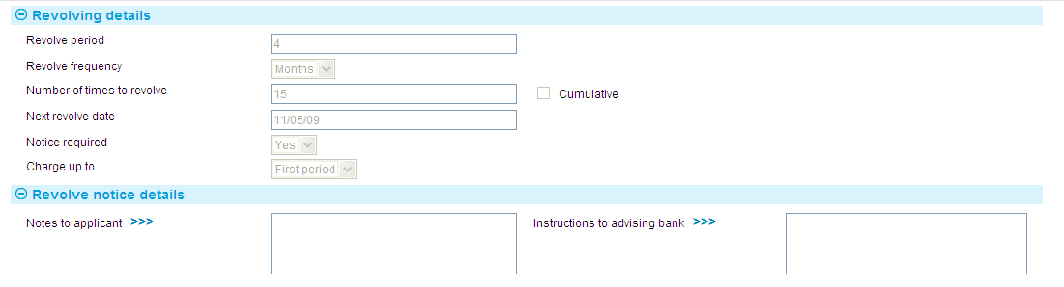

The fields in the Revolving Details pane display the terms under which the letter of credit revolves. Where the letter of credit has already revolved, the To Date field is present and shows how many times the letter of credit has revolved.

The fields in the Revolve Notice Details allow you to enter information for the applicant and for the advising bank.

## Revolving the Letter of Credit

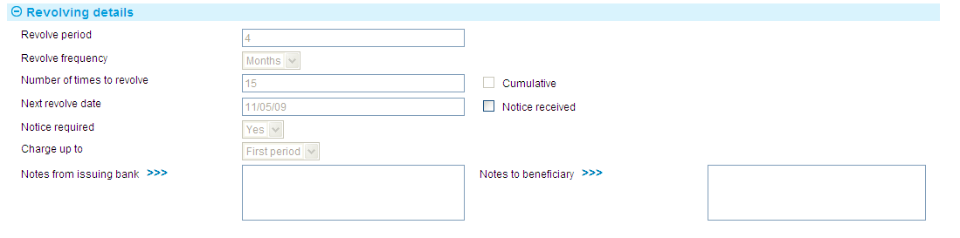

If the letter of credit requires notification before it can revolve, the Notice Received field is present. By default this is unchecked. Check it if a revolve notification has been received.

Once the Revolve event is released the system generates a diary entry for the next Revolve event.

# Amending an Export Letter of Credit

A letter of credit can be amended using an Amend event (see page 109) at any time between the release of the Issue, Advise or Transfer event that created it and book-off.

Typically, an amendment will be initiated by the issuing bank at the request of the applicant. The issuing bank then passes details of the amendment on to the next bank in the processing chain, which will record the details and then inform the next advising bank or the beneficiary, as appropriate.

There are two types of amendments. Amendment requesting beneficiary approval and amendments which does not require any approval.

If beneficiary approval is not required for the amendment, then accounting entries and changes to the master record as a result of the amendment are carried out as soon as the Amend event is released.

If the beneficiary's approval is required for the amendment, then we have further two ways of processing them.

1. Proactive amendments and
2. Non-proactive amendment.

Proactive amendment feature should be enabled through system option ‘**AllowLCProactiveAmendMaster**’ then all the amendments irrespective of seek beneficiary approval flag will be updated in the master record once the amendment is released.

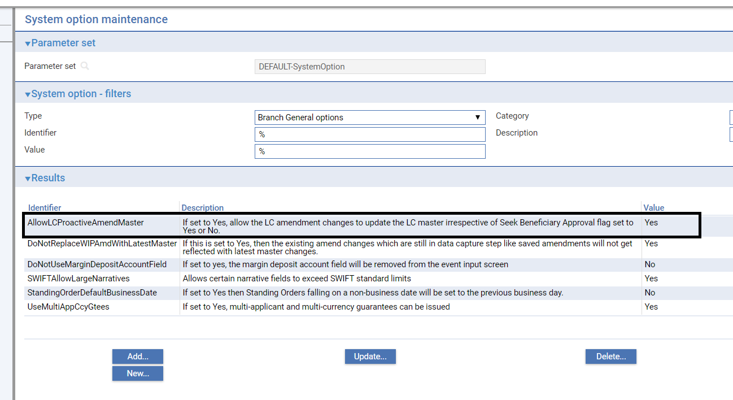

If beneficiary approval response is received, then the status of the amendment will be changed from Awaiting approval to Approved. In case beneficiary rejection response is received then the changes made will be reverted under beneficiary rejection response processing event.

Accounting entries updating will still depend on the bank’s posting rules setup. i.e. if they wish to proceed with updating accounting entries and charge collection

1. On amendment release and do the reversal booking if beneficiary rejects later or
2. They can do as and when the approval response received from beneficiary.

For non-proactive amendments the amendment changes do not take effect until the beneficiary's approval is obtained and recorded in the system. In this case, no accounting entries are produced for the Amend event, although any charges due can be paid, if required. Once beneficiary approval is recorded, then the appropriate accounting entries are made once the event recording beneficiary approval is released. If beneficiary approval is required, then the changes made during the amendment are not applied to the master record until beneficiary approval is obtained.

If the amendment increases the amount of a letter of credit that is already participated, a Drawdown/Revolve Commit Amt event may be created as a subsidiary event to decrease the commitment amount available on the participation deal. If the amendment decreases the amount of a letter of credit that is already participated, a Drawdown/Revolve Commit Amt event may be created as a subsidiary event to increase the commitment amount available on the participation deal, if the deal is revolving.

You can use an Amend event to change a letter of credit from inoperative to operative and to reinstate an expired or cancelled letter of credit's master record. However, you cannot reinstate a cancelled transfer letter of credit using an Amend event.

1. The Amend event should not be used to participate a transaction that was previously not participated. Use a Maintain Liability event instead.

## Reversal Postings

You can use the reversal posting facilities to set up the necessary postings to handle amendments which may have an effect on any previous liability accounting, such as changes to confirmation instructions or the tenor of a payment.

## Transfer Letters of Credit

Transfer letters of credit and their parent letter of credit can be amended independent of each other, although the system warns you if:

* An amendment to the value of the parent letter of credit means that its amount falls below that allocated to transfer letters of credit, back-to-back letters of credit and assignments
* An amendment to the value of a transfer letter of credit means that it exceeds the amount of the parent letter of credit available for allocation to the transfer

It also prevents you from making an amendment to the expiry date of either the parent letter of credit or the transfer letter of credit which would result in the transfer expiring after the parent letter of credit.

See the Transfer Letters of Credit User Guide – Trade Innovation for instructions on amending a transfer letter of credit.

## Assignments of Proceeds and Back-to-back Letters of Credit

Assignments of proceeds can be amended or removed from an import letter of credit at any time between the release of the Advise event and payment.

Back-to-back letters of credit are amended independent of their parent letter of credit, although the system issues warnings if amendments to amounts or expiry dates take the letter of credit outside the terms of the parent letter of credit.

## Licenses

If the master record is attached to a license, the License pane is available for you to view and amend any details of additional reservations or reinstatements when the amount or currency change.

There will also be some additional validation when you make an amendment to a master attached to a license. For example:

* If you make an amendment after the Valid To date on the license has passed, the system will either reject the amendment or allow a new license to be added, depending on how your system has been set up
* If you change the shipment date, the new shipment date must be between the Valid From and Valid To dates on the license
* If you change the amount or currency, the new value will be validated against those on the license. The license amount may be reserved or reinstated for the amended amount
* If you change either the name of the applicant or the beneficiary on an import letter of credit, the new name must be the same as the nominated party on the import license

Note that if you are increasing the amount of a master record, then a reservation is automatically made against the license. If you are decreasing the amount, then a reinstatement is automatically made. If you change the currency, you may reinstate in the old currency and make a reservation in the new currency (assuming that the license in question allows multiple currencies).

If the master record is amended so that its status changes from Cancelled or Expired, the reinstated letter of credit value will be validated against the available amount on the license.

If the amendment requires beneficiary approval then any reservations or drawdowns required occur in the Ben Response to Amend event instead, provided that the amendment is approved.

See the Licenses User Guide – Trade Innovation for details of licenses.

## Revolving Letters of Credit

For a revolving letter of credit, if you amend the details governing revolutions, then the new revolution details are then used to generate the next Revolve Notice and Revolve events upon completion of the Amend event. However, if the amendment requires beneficiary approval, any changes to the revolve details take effect once the Ben Response to Amend event recording the beneficiary's approval has been released.

## Maintaining Liability

You can change the way that liability on a transaction is shared by using the Maintain Liability event. Maintain Liability events can be used to:

* Participate a transaction
* Share customer liability on a transaction

When you press the OK button or the Pend button on the Input window of an Amend event for a participation deal, a Maintain Liability subsidiary event is automatically generated for each transaction affected by the amendment. You can use the Subsidiary Events link from the Master Summary window to view this event but it is processed and released via the participation deal Amend event.

See the Participated Deals User Guide – Trade Innovation for the Maintain Liability event.

## Handling More than One Amendment at a Time

The system permits you to have more than one Amend event in progress at the same time. If you attempt to open an Amend event for a master record that already has an Amend event in progress, or is awaiting the beneficiary's response to an amendment, the system will warn you of the fact, but will allow you to continue.

The saved amendments data can either be over ridden with the latest master data as an when the new changes updated in the master record or can be protected so that the changes saved will not be lost due to new master data changes. This depends on the system option ‘**DoNotReplaceWIPAmdWithLatestMaster**’. If you enable this system option, then the saved amendment data will be protected and will not be overridden with latest master changes but will show the comparison of current event data with the latest master data. Whereas if you disable the system option, then the system will show the current details held for the master when the Amend event is created or opened at an Input step.

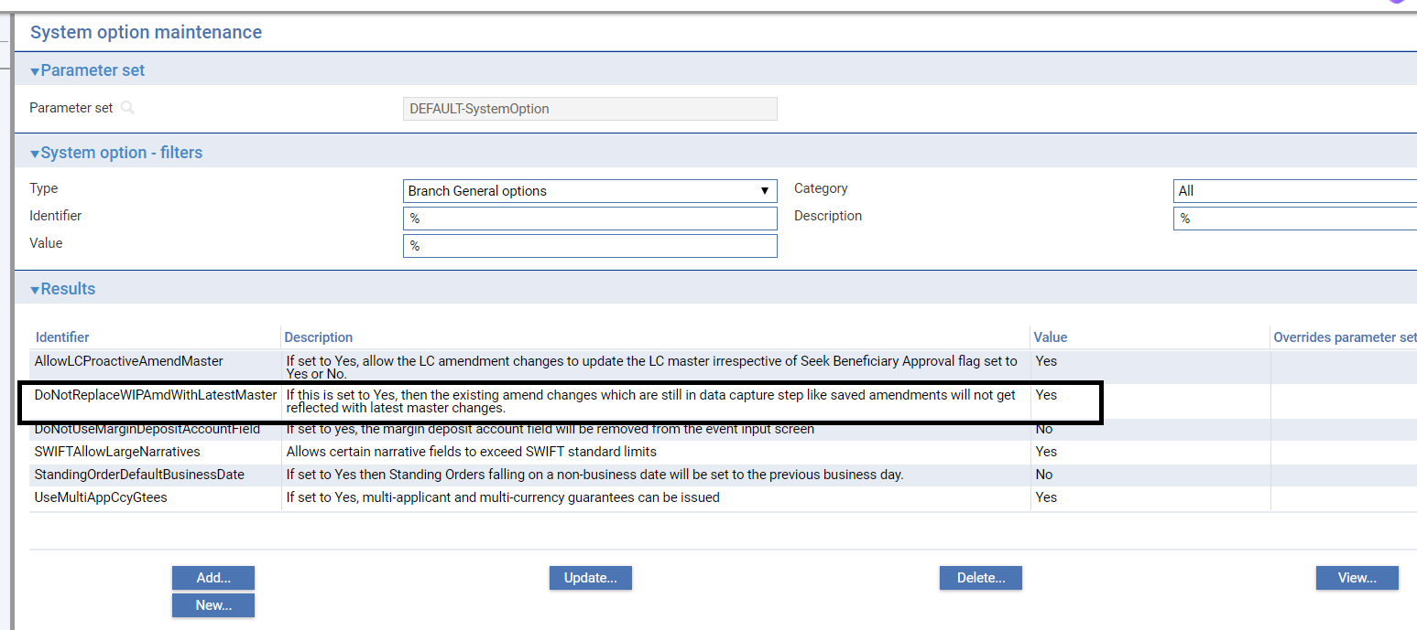

You can check whether any changes have been made to master record details between an Amend event requiring beneficiary approval being initiated and that approval being received. The Beneficiary Response to Amend event allows you to display a list of master record fields, and indicates in this list any fields where the information held on the master record differs from that held in the Beneficiary Response to Amend event. Should you discover a field that has been updated since the Amend event was initiated, you can choose whether or not to overwrite the value currently held in the master record with the value held in the Beneficiary Response to Amend event.

A field - the Use Previously Amended Amounts in Advise field - present during the Amend event when a previous amendment is still awaiting beneficiary approval permits you to decide whether or not the amount shown in tag 34b of the MT707 advice should take into account the amount of the earlier amendment.

If your system is configured so that Amend events need to be reviewed before release, then during these later steps the supervisor will be advised of the existence of another Amend event that has completed while the current event has been at the Review or Authorise step. They can then decide how each Amend event should be handled to ensure that the required changes are implemented.

## Displaying Changes

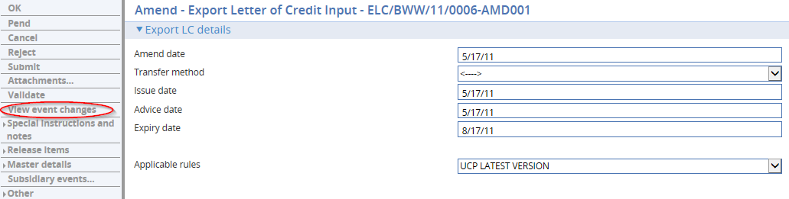

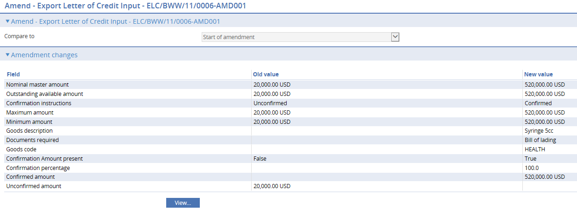

When making amendments or adjustments to a transaction the View Event Changes menu allows you - and reviewers and authorisers - to list those fields that have changed within the event. It opens a window that lists those fields whose value has changed and shows for each the value before the current event and the new value resulting from the event.

For free-format narrative fields, your bank can configure the system so that it shows either the entire content of the field in the New Value column, or just a certain number of lines (defined by the system option ViewChangesLineCount) followed by the text:

>>> plus n more lines. 'View' for details.

where n is the number of additional lines not displayed.

Selecting that entry in the list and pressing the View button displays the entire content of the field.

This window is displayed automatically when the event is opened for review or authorisation.

1. If you work with this window open, use the Refresh button to update the display to show any changes made since you opened the window.

Due to any other parallel amendment event or when entering the beneficiary's response to an Amend event or a to a Transfer LC Amend event for a letter of credit, the View Event Changes menu permits you to check whether any master record details have changed since the amendment event was initiated.

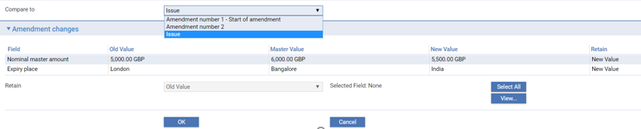It lists those fields whose value has changed and shows for each:

* The value before the event was initiated (Old Value)
* The new value resulting from the change made in the event (New Value)
* If another event has taken place since the amendment event was initiated which has changed the value of fields held on the master record, the current value of those fields (Master Value). If this field is blank, no intervening change in value has taken place
* You can see any changes made by clicking the View button.

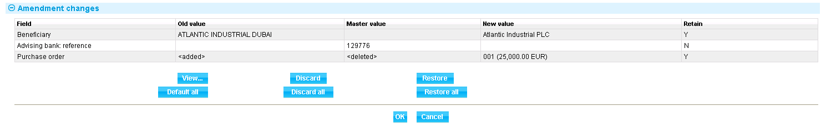

The window displayed allows you to see any intervening changes made by clicking the Intervening button.

By default, Retain column will display to retain New values. If you wish to replace the New value with either Old value or with Master value, then you can click any field and select retain with Old / Master / New value and then click OK to save the changes.

## Handling Delta Changes in Narrative Fields

Below 5 narrative fields can now hold 8*100*65 character of data compared to previous 1*100*65 characters. This is due to introduction of new MT708 amendment extension messages which can have maximum of 7 extinctions.

1. Description of Goods and/or Services.
2. Documents required.
3. Additional conditions.
4. Special Payment Conditions for Beneficiary
5. Special Payment Conditions for Receiving Bank.

Due to this change it will be inefficient to pass all the 8*100*65 character of data under every amendment for small change. Hence below new instructions codes are introduced to handle delta changes:

**ADD** : Must be followed by the text to be added (a sentence, paragraph or line item)

**DELETE :** Must be followed by the text to be deleted (a sentence, paragraph or line item)

**REPALL** : Must be followed by the text that replaces all text in same field. No other code may be used.

USAGE RULES  
The presence of this field implies that description of documents required is amended.

The user is able to enter one or more delta changes associated with, for an example, the Goods description field using Add or/and Delete instructions.

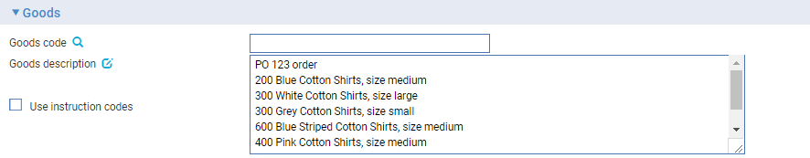

The ‘Use instruction codes’ flag controls the behavior of a given narrative field

* If the flag is off, the narrative field is editable so that the full text can be revised.
* If the flag is on, the narrative field is non-editable and enables its associated instructions to be added, deleted or updated.

### Replace all Instruction

To revise the full text click on the edit icon  at the end of the ‘Goods description’ field label and then click the **Edit** button, as shown on the following screenshot, to revise the existing text.

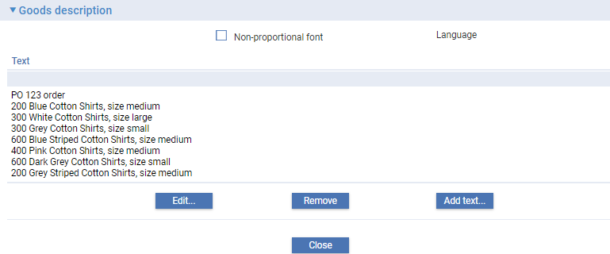

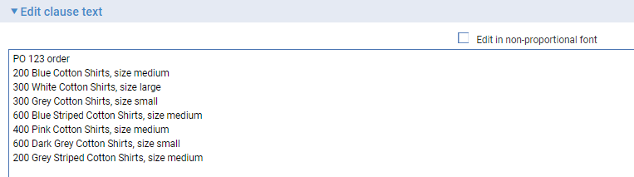

Amendment changes page allows you to compare the current amendment versus a selected baseline of master details that represent the scope of a given LC.

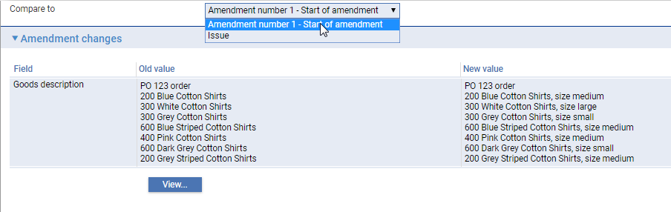

The list of possible baselines available for comparison can include the Start of the current amendment (master snapshot) and previous events such as Pre-advise, Issue/Advise, all Amendments (identified in the drop-down list with their respective amendment numbers), Adjustments (with their respective event reference numbers) and provisional events under the current Amendment.

The **View** button allows you to have a side by side compare view of the selected baseline (Old) versus the current amendment (New):

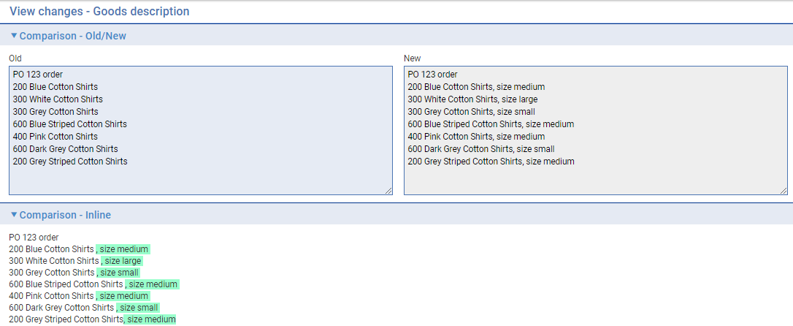

The ‘Comparison – Inline’ contents, results from the text compare that has been automatically performed to enable the user to distinguish changes.

**Outward MT707**

The Good description field is interpreted and mapped to the field 45B on MT707 as shown below:

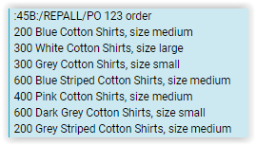

### Add or/and Delete Instructions

If the ‘Use instruction codes’ flag switched on, you can enter delta changes instructions.

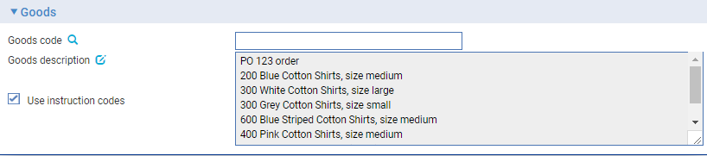

Click on edit icon  at the end of the ‘Goods description’ field label.

On the resulting page (shown below):

* Enter one or more delta changes qualified as 'add' or 'delete' instructions without leaving the page.
* Select an existing instruction and update without leaving the page, which results in the description being copied to the edit field so it can be overtyped. The user has the option to submit or cancel the update.
* Select an existing instruction and delete without leaving the page.

The following screenshots illustrate a delete instruction being defined:

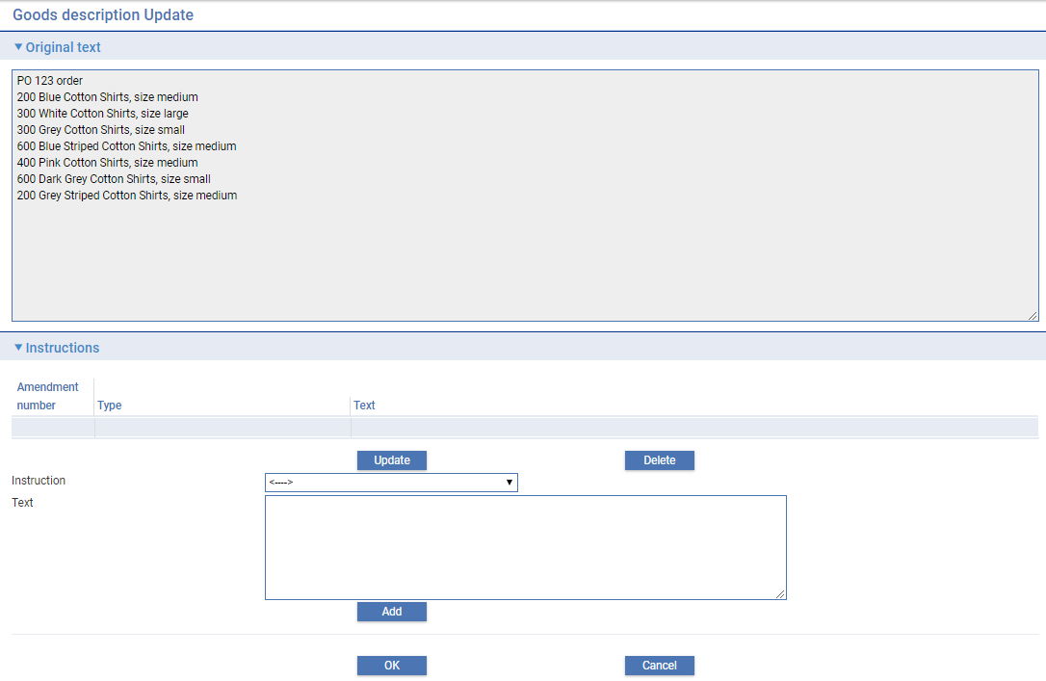

To delete a part of the existing text, select instruction type/qualification, click **Delete**

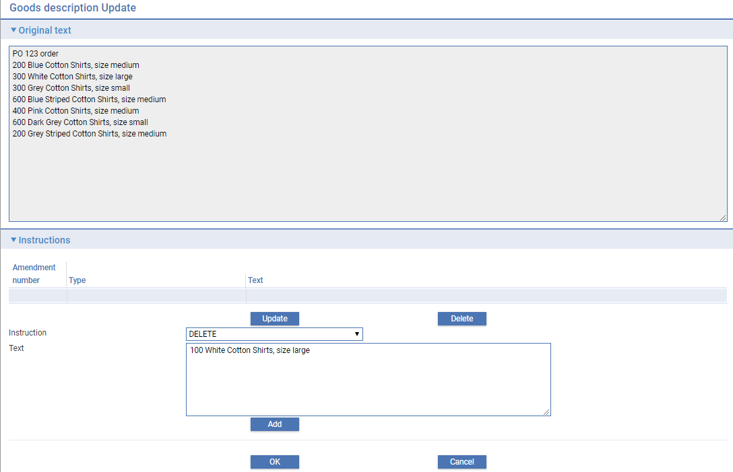

The instruction text field becomes editable and you can enter the required text directly or by copying and pasting from the original text field (displayed at the top of the page). Click the **Add** button to insert the instruction

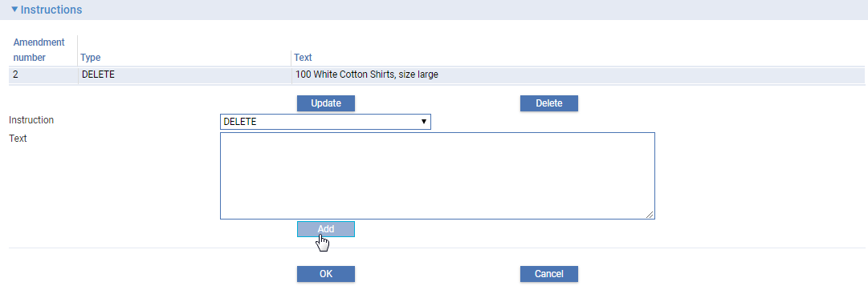

Similarly, to add new details, set the instruction type to ‘Add’ and enter the required text.

The delta changes are saved as discrete changes. But, when the details of a given narrative field are viewed on the Amendment change page, the delta instruction appear pended at the end of existing details.

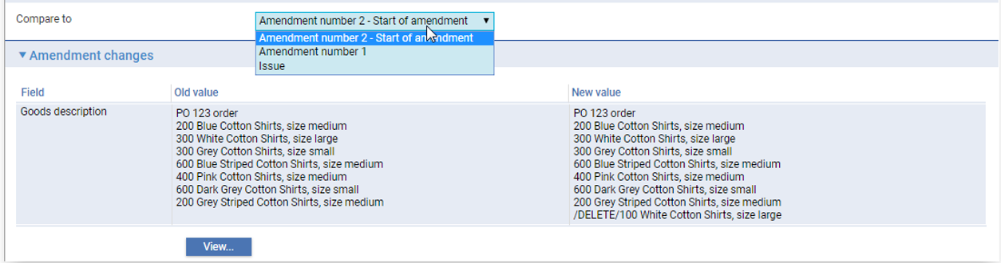

The **View** button enables the changes to be distinguished

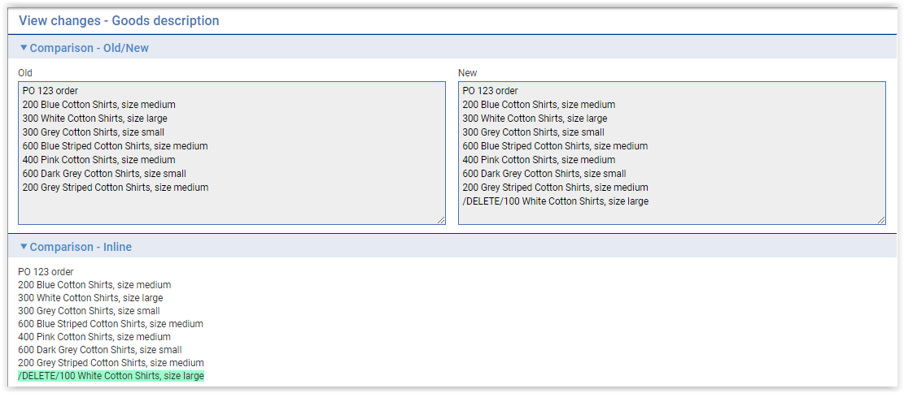

### Switching the ‘Use instruction codes’ flag on and off

The following behaviour is observed when switching between the Use instruction codes mode flag on (delta codes mode) and flag off (Replace all mode):

* Whenever a user switches mode, the system prompts with a message with a Yes/No option asking the user if they want to continue.
* If the user starts with Replace all mode and switches to Use instruction codes mode, the narrative field resets ignoring revisions made while in the editable mode.
* If the user starts with Use instruction codes and switches to Replace all mode, the previous-event delta instructions (including any added in the current event) remain available by appending in the editable narrative just in case the user needs to refer to them (especially if the flag is set off by mistake).

The system prompts an error message when code words are present in the narrative field when the event is validated. The user must remove these delta changes if they wish to proceed on a replace all basis.

### Visibility

The instruction code/text is shown for all previous amendments in the current amendment chain but the user can only change those entered in the current amendment chain.

Each instruction text is saved with the following additional details for reference purposes:

* Event ID
* Amendment number
* Narrative code
* Narrative description
* Instruction code
* Instruction text

The event fields associated with an amendment narrative field have been enhanced so that the lower level parts of event fields are available for use on documents and gateway messages.

## Amending an Export Letter of Credit

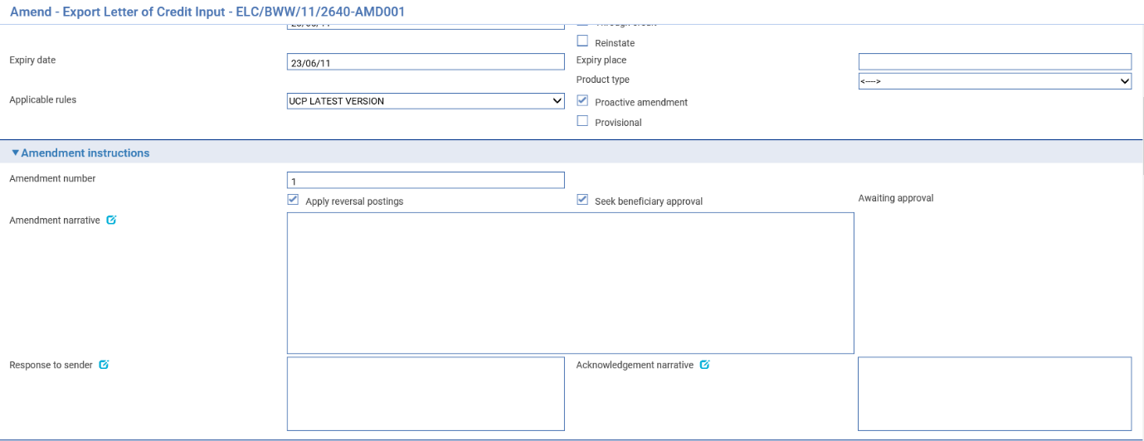 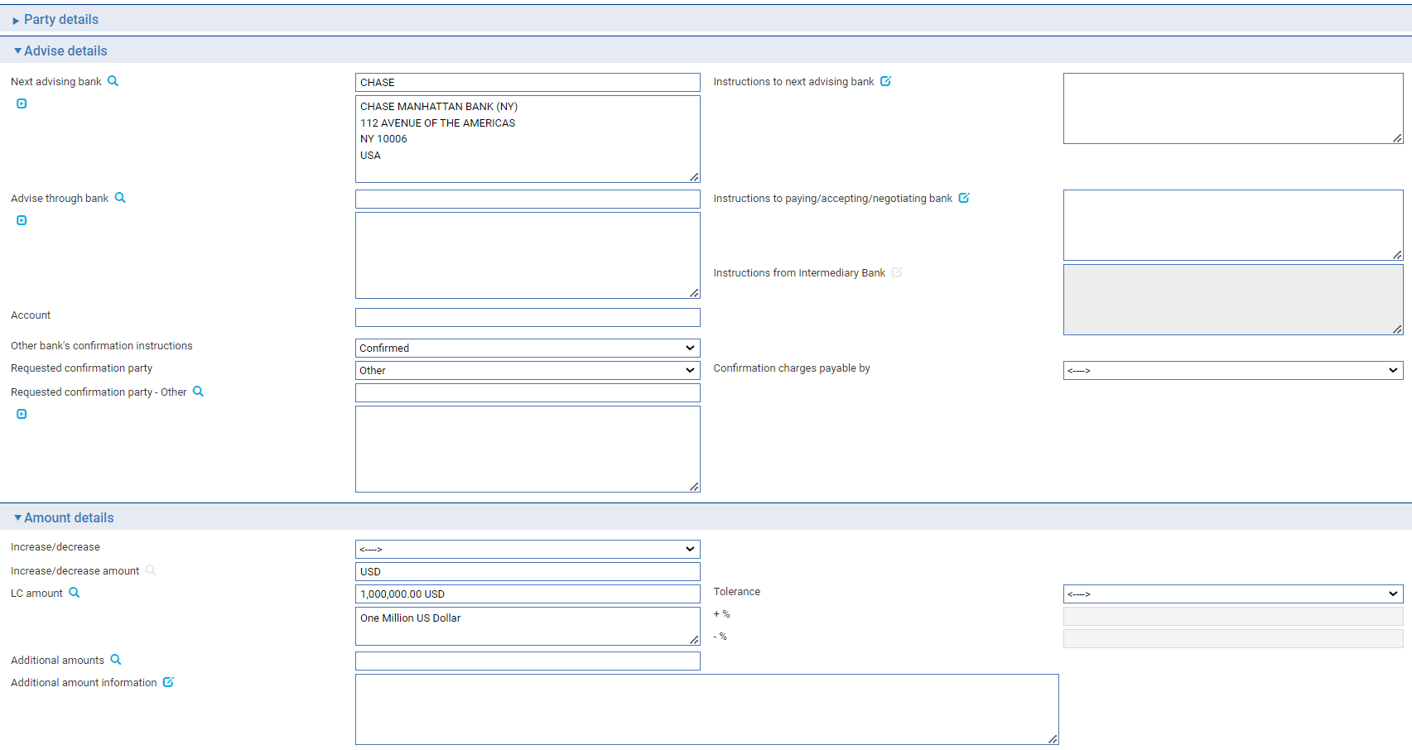

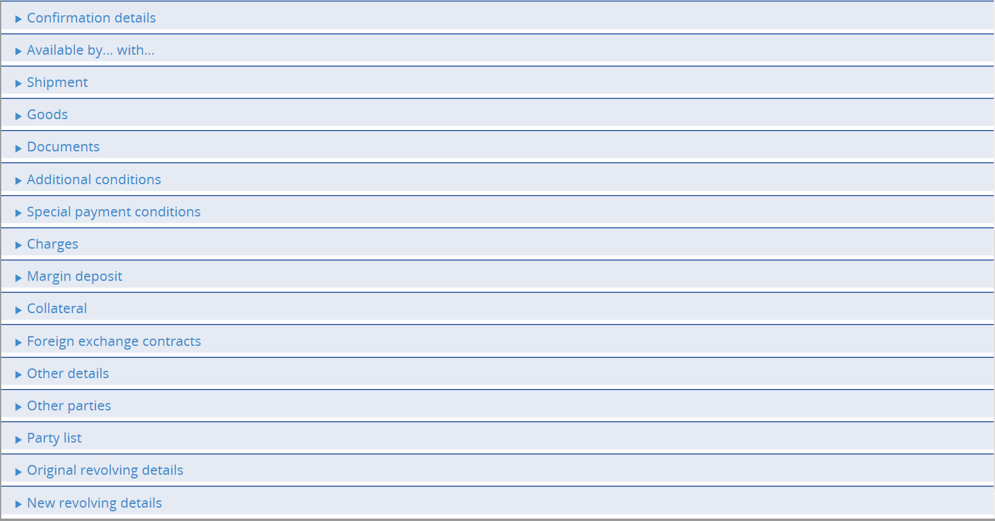

To amend an export letter of credit, in the Master Summary window select 'Amend' from the Create New Event drop-down list and press Create. The system opens the event at either a Log step or Input step. Depending on how your system is configured, panes and fields available in log steps can be tailored for each data capture step. See the *SDK - Screen Tailoring User Guide* – Trade Innovation for details.

The same window is also use for the Adjust event, but with additional panes (see page 117).

The View Event Changes menu (see page 100) allows you to display any changes made during the event.

Depending on how your system is configured, the Amendment Narrative file may be positioned on its own in an Amendment Narrative pane. (This is controlled by the AmendAdjustEventScreenlayout system option.)

The window displays a sub-set of the information already input for the transaction, which you can overtype. Your bank can configure the event so that you cannot amend the content of the Goods Description, Documents Required and Additional Conditions fields. (This is controlled by the ProtectFieldsGoodsCondDocsOnAmend system option.)

The following additional fields are present:

|  |  |
| --- | --- |
| Field | What to Enter |
| Amend Date | The date of the amendment. |
| Apply Reversal Postings | Shown only if the DoNotApplyReversalPostings system option is set to 'No'. Leave it checked if your bank has set up reversal postings for the letter of credit Amend event and wishes to apply them when the event is released. |
| Seek Beneficiary Approval | Check this box if beneficiary approval is required for the amendment.   1. **Seek Beneficiary Approval** flag is checked by default. Uncheck the field if beneficiary approval is not required.   Set Branch general system option ‘DoNotSeekBeneficiaryApproval’ to ‘Yes’ to change the default value of this field to unchecked. The system option only changes the default state of the field but the field can still be updated within the transaction. |
| Amendment Narrative | Information about the amendment. |
| Response to Sender | Any information for the party from which you received the amendment or amendment request. |
| Proactive amendment | This flag is available only if the system option ‘AllowLCProactiveAmendMaster’ is enabled. This will provide a control on current amendment transaction if it should be processed as proactive amendment or not. |

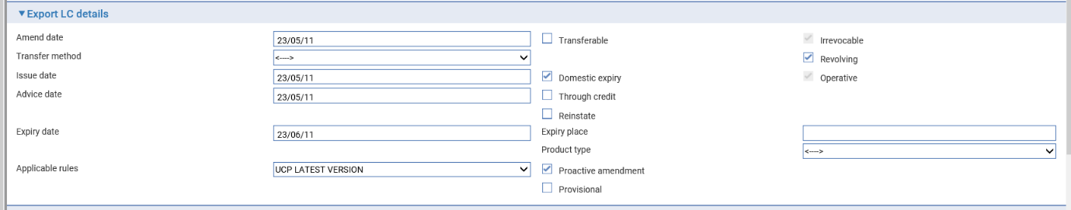

You can enter a new amount in one of two ways:

* Use the Increase/Decrease field to indicate whether the amendment involves an increase or a decrease, then enter the amount by which the letter of credit is to be increased or decreased into the Increase/Decrease Amount field
* Overtype the existing value in the LC Amount field

If the letter of credit is revolving, two panes are used to amend the revolving details. The first shows the original settings, the second allows you to enter new information for revolving the letter of credit.

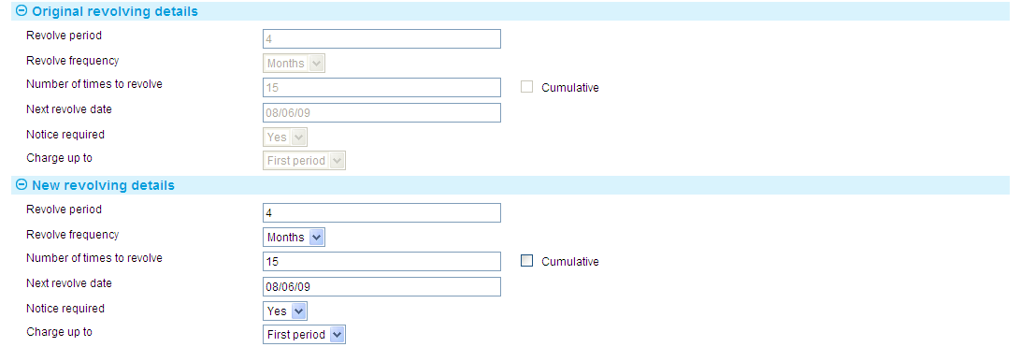

### Recording the Beneficiary's Response to an Amendment

If, when amending a letter of credit, you check the Seek Beneficiary Approval flag, based on proactive amendment system option settings (‘AllowLCProactiveAmendMaster’) either the amendment changes will be applied to master or will not take effect until the beneficiary's approval is obtained and recorded in the system. In either case the status of the transaction will still be awaiting approval.

1. **Seek Beneficiary Approval** flag is checked by default. Uncheck the field if beneficiary approval is not required. Set Branch general system option ‘DoNotSeekBeneficiaryApproval’ to change the default value of this field to unchecked.

To enter details of the beneficiary's response for an export letter of credit, in the Master Summary window select 'Beneficiary Response to Amend' from the Create New Event drop-down list and press Create. The system opens the event at either the Log step or an Input step, depending on how your system has been configured.

If your bank receives details of a beneficiary's response via SWIFT, then the system automatically creates beneficiary response event for the appropriate letter of credit at an Input step. When you open the event, the system displays details of the response.

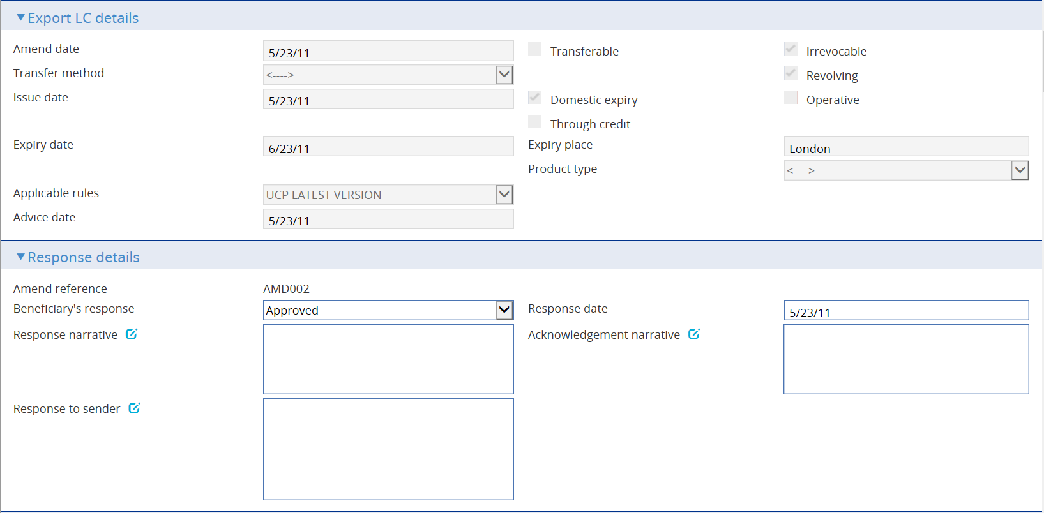 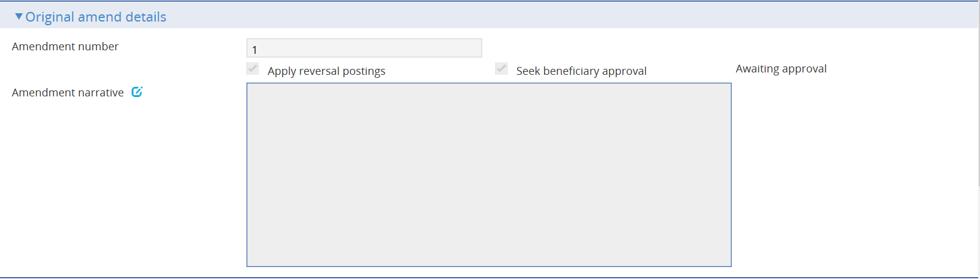 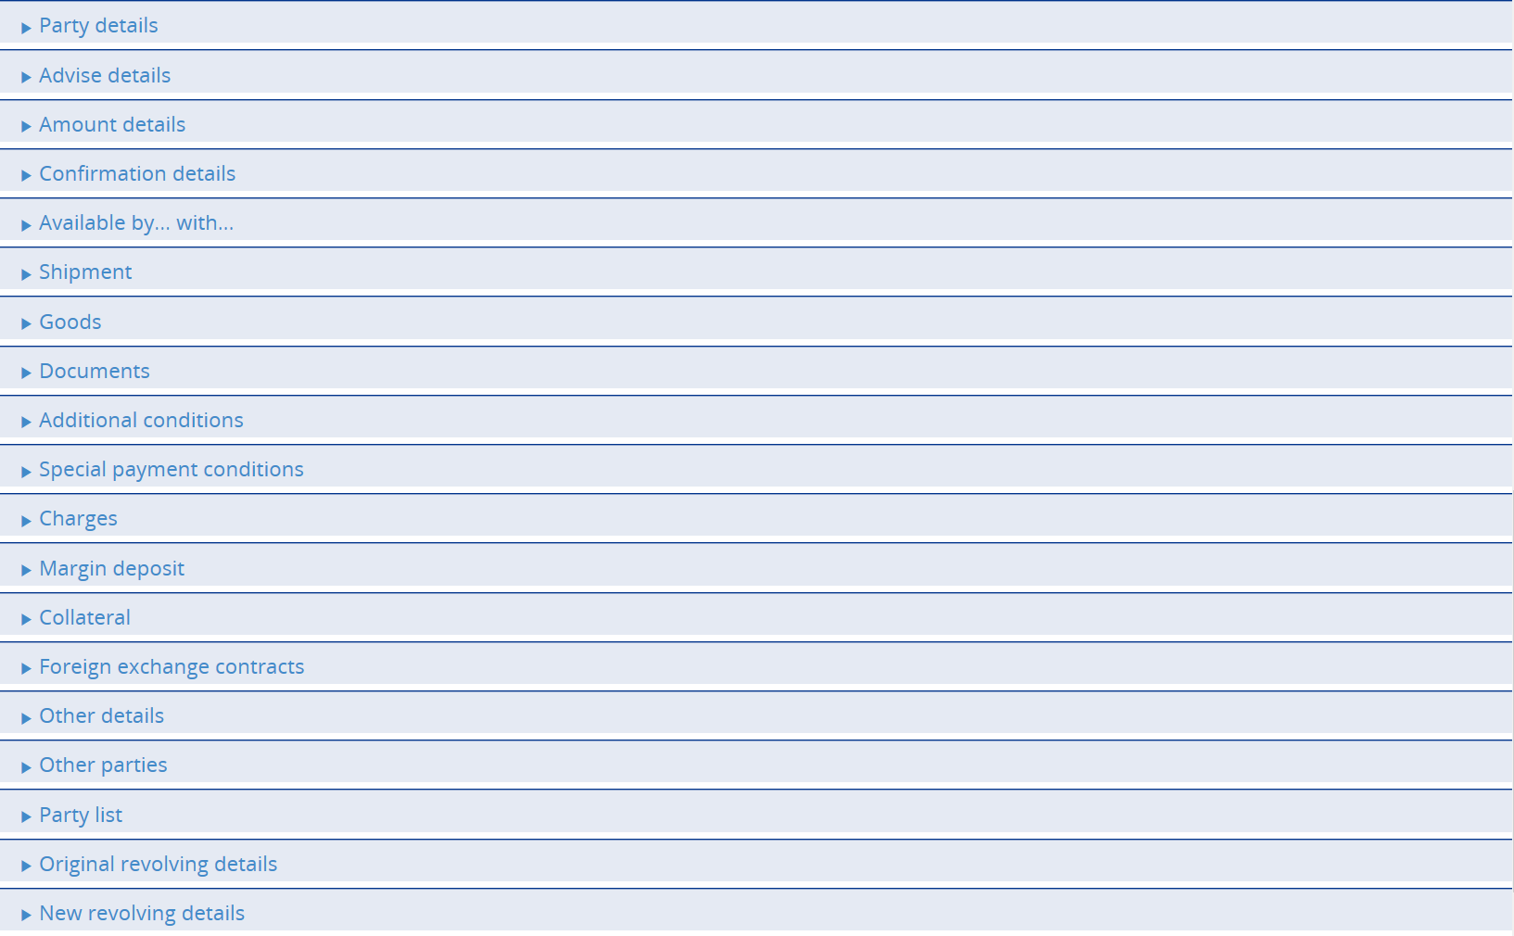

As with the Amend event your system may be configured so that the Amendment Narrative field is positioned on its own in an Amendment Narrative pane. (This is controlled by the AmendAdjustEventScreenLayout system option.)

Your bank can configure the event so that you cannot amend the content of the Goods Description, Documents Required and Additional Conditions fields. (This is controlled by the ProtectFieldsGoodsCondDocsOnAmend system option.)

If there is only one Amend event awaiting a beneficiary response, the system retrieves it and displays its reference. If the letter of credit has more than one Amend event awaiting beneficiary response, then the Select button permits you to select the one to which the beneficiary's response relates.

The View event changes menu (see page 100) allows you to display any changes made during the event.

In the Response Details pane select 'Approved' in the Beneficiary's Response field if the beneficiary has approved the amendment, or 'Rejection' if the beneficiary has not agreed to it. Use the Response Narrative field to enter any additional information included with response, such as the reasons for a rejection.

In case the amendment is processed as proactive amendment then on processing beneficiary rejection response the system will auto suggest the reverted values on the screen. All the fields on the screen will be allowed to edit if user is not satisfied with the reverted value suggested.

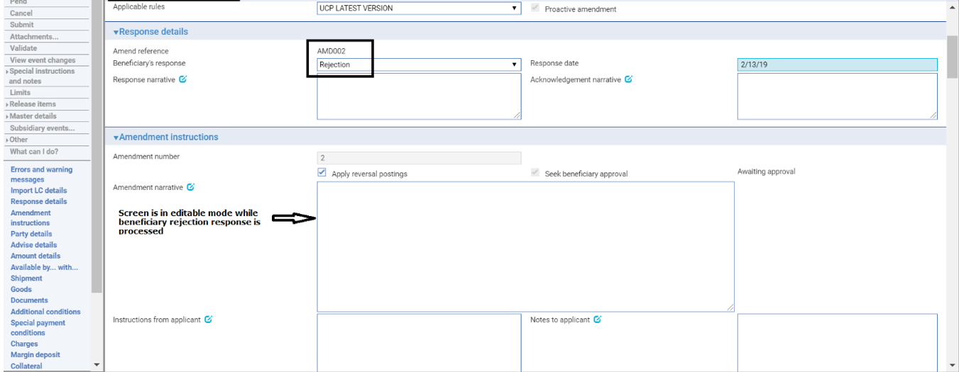

### Auto Revert Functionality

This is used to enable system to revert the amendment changes while processing beneficiary rejection response. This is applicable only for proactive amendments.

All the amendment fields can be categorized in to below 4 types of data and each type has a different logic to revert the changes.

Type 1: Values that can be replaced with another value. Example: Place of expiry

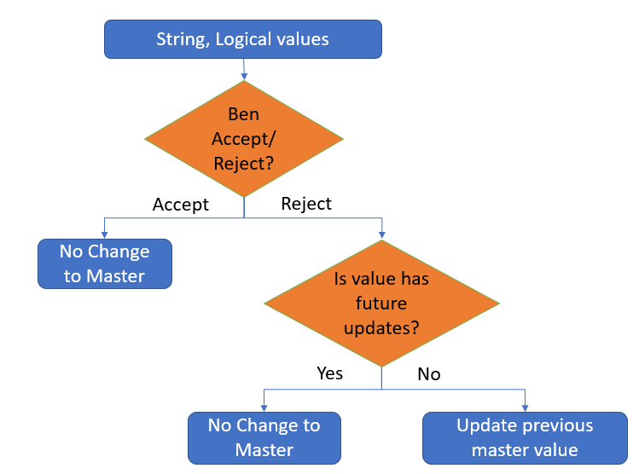

Type 2: Derived values. Example: Amount

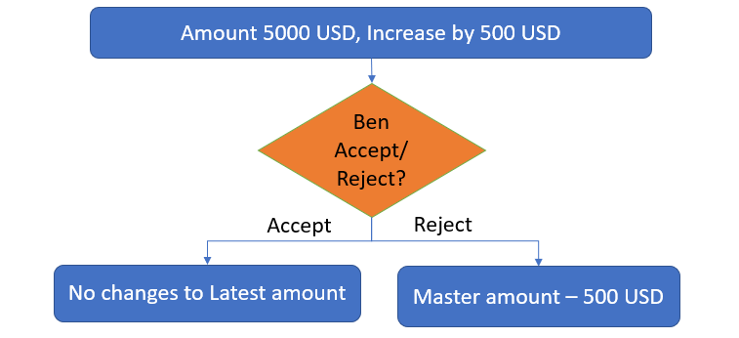

Type 3: Large narrative fields where delta changes are handled by ADD, DELETE, REPALL key words.

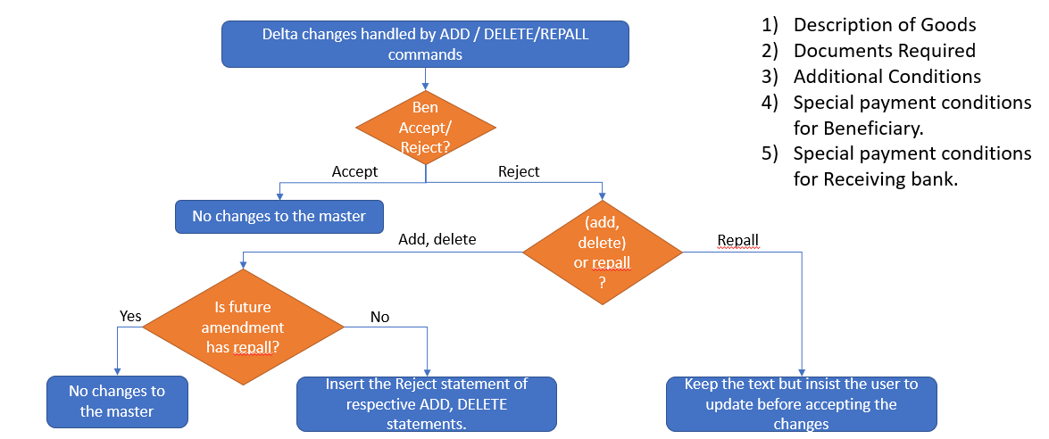

Type 4: Combination of multiple fields concatenating in to one field data. This is applicable only if the amendment is sent via SWIFT channel i.e. using MT707/708

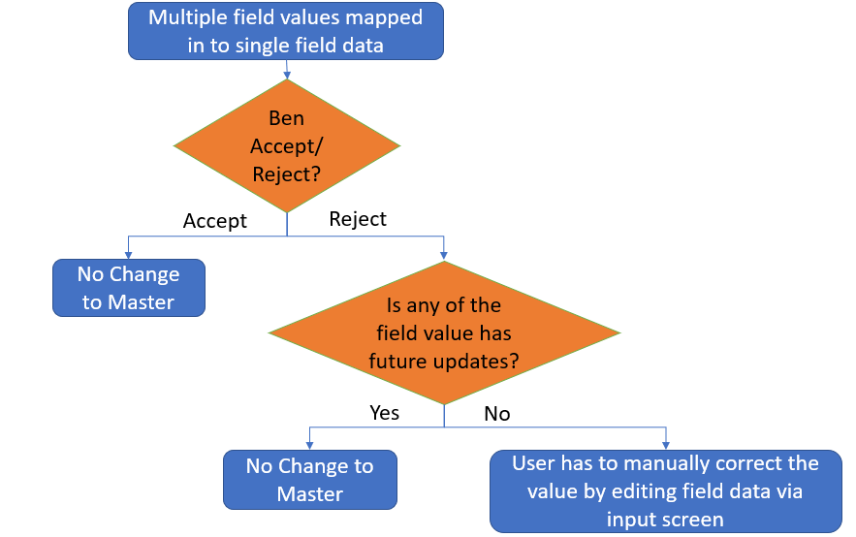

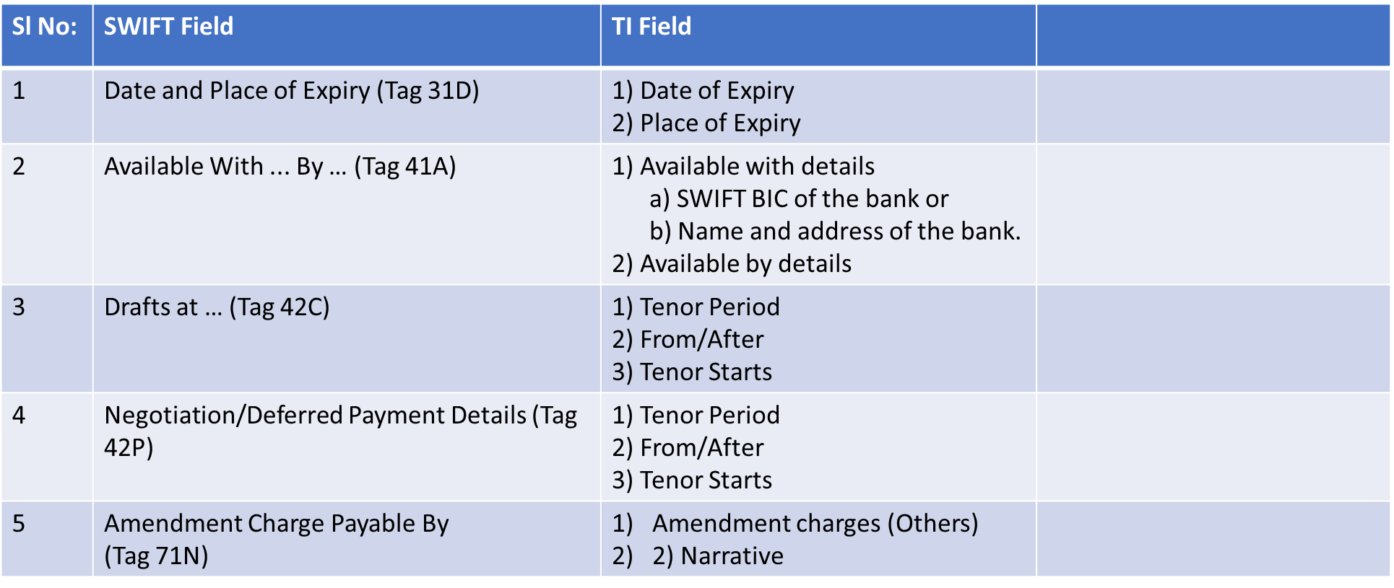



1. If user is making any additional changes apart from the original amendment changes while processing beneficiary rejection response then below warning message is shown on the screen:   
   "**Additional changes exist with is not part of the original amendment**”.

## Making Adjustments to the Master Record

The functionality of the Amend event allows you to make all the changes that are likely to be required in the normal course of business at the request of the applicant, and which may require beneficiary approval. The system includes an Adjust event, which contains additional functionality to allow you to make changes to all the information recorded for a transaction, with the exception of your bank's reference number for the transaction, and the status of a transaction's master record.

The Adjust event is designed to allow you to make changes where you need to alter details but do not need to notify other parties.

1. Once you have initiated an Adjust event, the system will prevent you from opening any other event for the transaction until the Adjust event has completed. If you attempt to open an Adjust event while another event for the master is in progress, the system will warn you of the fact and prompt you to abort the Adjust event. Unless you are attempting to make an adjustment to allow the pre-existing event to complete, you should abort the Adjust event and wait until the pre-existing event has completed before attempting the Adjust event again. If you continue with the Adjust event, then the system will prevent any further work on the pre-existing event until the Adjust event has completed.

This functionally is intended to allow you to correct mistakes and should be used cautiously. If you make any changes using this functionality, you should ensure that the proper reconciliations are carried out.

With the appropriate master record open, in the Master Summary window select 'Adjust' from the Create New Event drop-down list and press Create. The system opens the event at either the step or Input step. Depending on how your system is configured, panes and fields available in log steps can be tailored for each data capture step. See the *SDK - Screen Tailoring User Guide* – Trade Innovation for details.

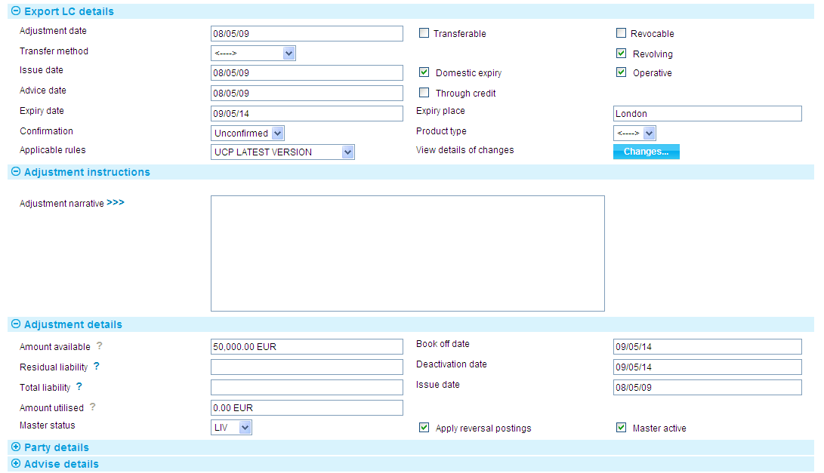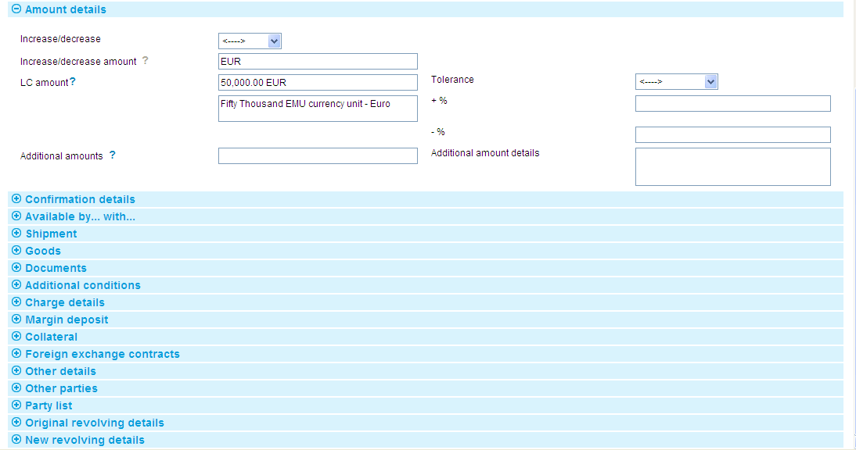

The View Event Changes menu (see page 100) allows you to display any changes made during the event.

The window displays a sub-set of the information already input for the transaction, which you can overtype.

Depending on how your system is configured, the Amendment Narrative field may be positioned on its own in an Amendment Narrative pane. (This is controlled by the AmendAdjustEventScreenlayout system option.)

During an Adjust event you can view charges and add optional charges, but cannot edit existing charges. To change charges, use a Maintain Charges event.

| Field | What to Enter |
| --- | --- |
| Adjustment Date | The date the adjustment was made. |
| Adjustment Narrative | A narrative identifying the nature of and reason for the adjustment. |
| Amount Available | The current available amount. |
| Residual Liability | The system displays the outstanding liability amount for the master record, excluding the amounts of any presentations. Use this field to overwrite those shown on the master summary if, for any reason, the master figures are incorrect. |
| Total Liability | The system displays the outstanding liability amount for the master record, including that of accepted drafts not yet paid. Use this field to overwrite those shown on the master summary if, for any reason, the master figures are incorrect. |
| Book Off Date | The system displays the letter of credit's book-off date, which you can amend. The system will then book off the letter of credit when the new book-off date is reached. |
| Deactivation Date | The system displays the date on which the letter of credit will become inactive (after its expiry date and any days grace period has elapsed). You can amend this date.  See the System Tailoring User Guide – Trade Innovation for the days grace period, which may be different for master records expiring locally and those expiring abroad. |
| Issue Date | The letter of credit's issue date. |
| Amount Utilised | The amount of the letter of credit utilised so far. |
| Apply Reversal Postings | Leave checked if your bank has set up reversal postings for the export letter of credit Adjust event and wishes to apply them when the event is released.   1. If the DoNotApplyReversalPostings system option in the system administration application is set to yes, then the Apply Reversal Postings check box is not available on this event. |

If the letter of credit is revolving, two panes are used to amend the revolving details. The first shows the original settings, the second allows you to enter new information for revolving the letter of credit.



# Cancelling a Letter of Credit

A letter of credit (parent or transfer) can be cancelled at any time after the release of the event that created it and book-off.

However, you cannot cancel a letter of credit on which there is work still in progress. For parent letters of credit, you must delete any associated transfer and assignments of proceeds before you can cancel the parent letter of credit itself.

Typically, cancellation will be initiated by the issuing bank at the request of the applicant. For transfer letters of credit, cancellations are carried out either to facilitate the cancellation of a parent letter of credit, or at the request of the first beneficiary. The issuing bank then passes details of the cancellation on to the next bank in the processing chain, which will record them and inform the next advising bank or the beneficiary, as appropriate.

If the letter of credit is participated, cancelling it may result in a Drawdown/Revolve Commit Amt event being created as a subsidiary event to increase the commitment amount available on the participation deal, if the deal is revolving.

If a license is attached to the letter of credit, and the letter of credit expires or is cancelled before the license Valid To date, then the reservation on the license amount can be reinstated (assuming a reservation had previously been made). The license amount that has already been utilised cannot be reinstated.

The system provides:

* A Cancel event (see page 122) which allows you to cancel a letter of credit
* A Beneficiary Response to Cancel event (see page 123), which allow you to enter details of a beneficiary's response to a cancellation notification

If beneficiary approval is not required for the cancellation, then as soon as the Cancel event has been released, accounting entries can be produced to reduce the liability and liability outstanding to nil and the master record is given the status 'CAN', although it is not removed from the system.

If a margin deposit was made to cover the letter of credit then accounting entries can be generated by the Cancel event to repay unutilised funds back to the customer's account.

If the beneficiary's approval is required for the cancellation, then the cancellation does not take effect until the beneficiary's approval has been obtained and recorded using the system. If this is the case, then no liability accounting entries are produced for the cancellation, although any charges due can be paid, if required. Once beneficiary approval has been recorded, the appropriate accounting entries can be made once the event used has been released. If beneficiary approval is required, and is not given, then the cancellation does not take effect.

If a letter of credit that has a license attached is cancelled, any unutilised amount reserved can be reinstated, assuming the Reinstate parameter has been set on your system and a reservation had previously been made.

1. Once you cancel a transfer letter of credit, then it is no longer included as an item in the table displayed when you press the Splits button from the Master Summary window or within a payment event.

For instructions on cancelling a transfer letter of credit see the Transfer Letters of Credit User Guide – Trade Innovation.

## Cancelling an Export Letter of Credit

To cancel an export letter of credit, in the Master Summary window select ‘Cancel’ from the Create New Event drop-down list and press Create. The system opens the event at either a Log step or Input step. Depending on how your system is configured, panes and fields available in log steps can be tailored for each data capture step. See the *SDK - Screen Tailoring User Guide* – Trade Innovation for details.

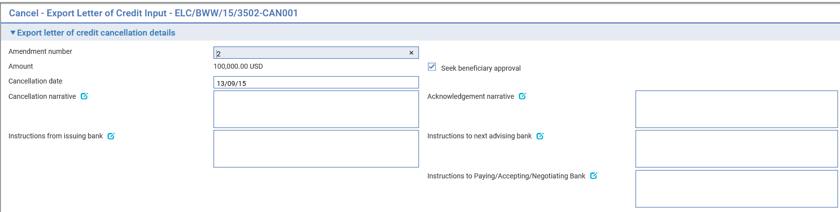

The following table explains what to enter into the fields during a Log or Input step to cancel the letter of credit:

|  |  |
| --- | --- |
| Field | What to Enter |
| Amendment Number | Cancellation request is part of amendment request hence requires the amendment number. |
| Seek Beneficiary Approval | Check this box if beneficiary approval is required for the cancellation.   1. **Seek Beneficiary Approval** flag is checked by default. Uncheck the field if beneficiary approval is not required.   Set Branch general system option ‘DoNotSeekBeneficiaryApproval’ to ‘Yes’ to change the default value of this field to unchecked. The system option only changes the default state of the field but the field can still be updated within the transaction. |
| Cancellation Date | The date when the cancellation takes effect. This defaults to today's date, but you can change it.  Any refunds to the customer are calculated with effect from the cancellation date. |
| Cancellation Narrative | Reasons for the cancellation. |
| Acknowledgement Narrative | Any additional information about the acknowledgement to sender. |
| Instructions from Issuing Bank | Any instructions received from the issuing bank regarding the cancellation. |
| Instructions to Next Advising Bank | Any instructions to the next advising bank regarding the cancellation. |
| Instructions to Paying/Accepting/Negotiating Bank | Any instructions to Paying/Accepting/Negotiating Bank. |

## Recording the Beneficiary's Response to a Cancellation Request

If, when cancelling a letter of credit you check the Seek Beneficiary Approval flag, then the cancellation does not take effect until the beneficiary's approval has been obtained and recorded in the system.

1. **Seek Beneficiary Approval** flag is checked by default. Uncheck the field if beneficiary approval is not required. Set Branch general system option ‘DoNotSeekBeneficiaryApproval’ to change the default value of this field to unchecked.

To enter details of the beneficiary's response for an export letter of credit, with the appropriate master record open, select 'Beneficiary Response to Cancel' from the Create New Event drop-down list and press Create. The system opens the event at either a Log step or Input step, depending on how your system has been configured.

### Logging the Response

The window used at a Log step has a sub-set of the fields used at an Input step.

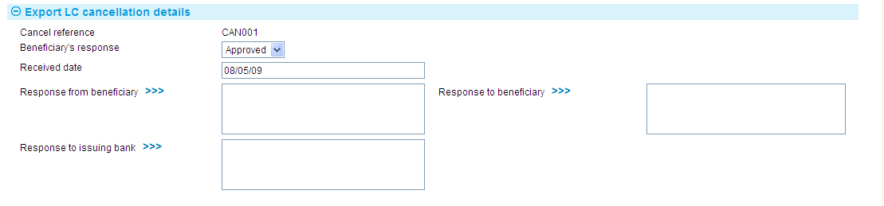

### Entering Full Details of the Response

The window used at an Input step has an additional pane showing details of the original cancellation request.

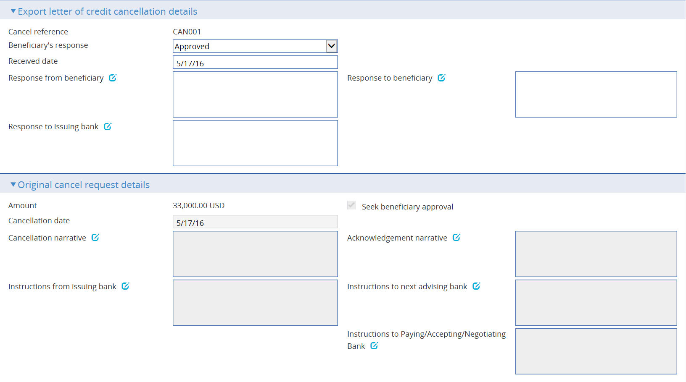

Use the Beneficiary's Response field to indicate whether the beneficiary has approved or rejected the cancellation. Use the Response Narrative field to enter any additional information included with the response, such as the reasons for a rejection, for the various parties to the transaction.

The Licenses button appears if the beneficiary approves the cancellation. It allows you to reinstate the unutilised reservation amount against the license.

# Appendix - Payment Actions and Charges

This appendix explains how the system handles the processing of charges during a payment event for letters of credit.

This appendix covers only the special processing for letters of credit. For a full account of how the system handles charges see the Common Facilities User Guide – Trade Innovation.

## Charges

When requesting payment, or asking for authorisation to pay, for an export letter of credit it is sometimes necessary for the bank to advise the issuing bank of charges that will be due from the applicant. Similarly, when documents are received on an import letter of credit, the issuing bank may need to advise the applicant of charges due, as a request for approval is sent to the applicant. The system handles this by allowing you to claim the charges.

If you select the Release Items|Charges link during a payment event, then when you have For Master selected, the system will display an additional button - the Claim All button.

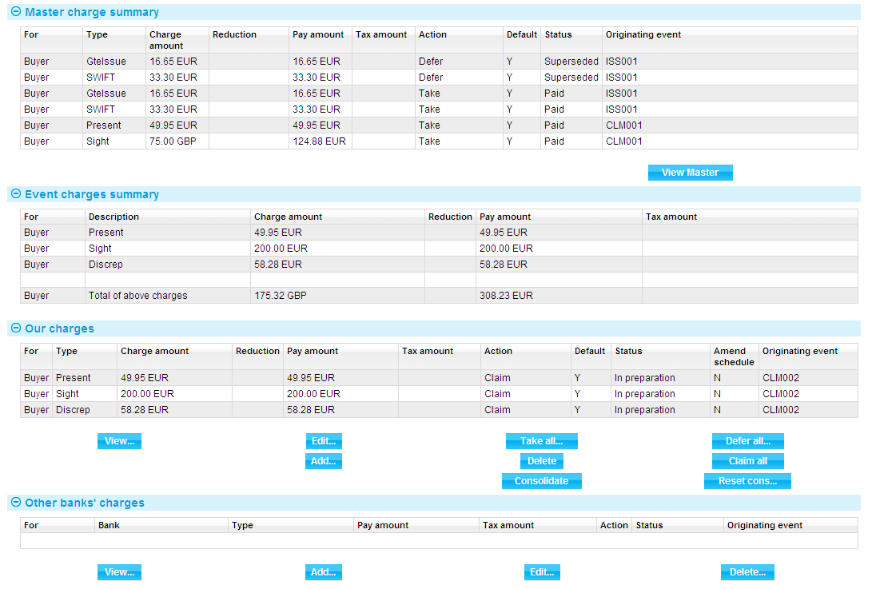

For more on the Charges Summary window see the Common Facilities User Guide – Trade Innovation.

If you press the Claim All button, the system changes the value in the Action column to 'Claim' for all charges with a status of 'Outstanding' or 'In Preparation'. When the event is completed, the status of these charges changes to 'Claimed'. This indicates that the charges have been claimed by the bank, but payment has not yet been authorised or paid. No postings are generated by the claim, since no payment has yet been made.

If the response does not authorise payment of the claim, you will need to manually take all previously-claimed charges. The system will issue a warning that these charges relate to an outstanding payment event and are being superseded. Once taken, these previously-claimed charges can be waived or edited in the usual way.

## Presenter's Actions

The following table lists all the presenter's actions supported by the system and explains when they might be used:

|  |  |
| --- | --- |
| Presenter's Action | What it Signifies |
| Request Authorisation to Pay | Discrepancies have been advised by the presenter and authorisation to pay is being requested. If this option is selected, an extra field is displayed, allowing you to enter details of discrepancies. |
| Pay and Claim Reimbursement | The sender has paid the beneficiary and has sent a claim to the reimbursing bank. |
| Request Payment | The presenter is requesting payment. |
| Request Acceptance | The presenter is requesting payment and or acceptance of drafts. |
| Sender has Debited our Account | The presenter has paid the beneficiary and has debited the receiver's account. |
| Documents Sent On Approval | Documents with discrepancies have been sent on approval. |
| Other | Used when the payment action involves more complex instructions, for example where discounting of acceptances is being requested. The Notes fields should be used to provide details. |

## Payment Actions

The Payment Action field allows you to select the appropriate action for the claim. Actions are of three types.

Payment actions, which indicate that the bank is paying or will pay the claim in the future:

* Accept
* Approve Authorisation Request
* Pay
* Pay at Maturity
* Pay with Discrepancies
* Pay from Suspense (for transfer letters of credit)
* Repay Finance

Actions that involve refusal:

* Refuse Documents
* Reject
* Reject Authorisation Request
* Reject and Claim Refund

Actions that leave the claim outstanding:

* Request Payment
* Request Acceptance
* Request Authorisation to Pay
* Await Documents
* Claim Reimbursement
* Pay and Claim Reimbursement
* Send Documents on Approval
* Await Replacement Invoices (for transfer letters of credit)
* Issue a General Request to Issuing Bank or Presenter
* Finance offer

The actions included in the drop-down list on the Payment Action field vary, depending on whether the letter of credit was presented by a bank, on the presenter's actions, and on the type of payment (sight, acceptance or deferred).

Note that in addition to the standard the system actions mentioned above, your bank may define other actions (which are based upon the standard actions) in order to satisfy your internal processes. These additional actions will also be available in the drop-down list.

See the *System Tailoring Guide* – Trade Innovation for instructions on defining additional payment actions.

If the claim involves more than one payment, check the Mixed Payment box. The Payments pane display changes to allow you to enter details of part payments. Check the With Recourse box if the payment is with recourse (normally used when paying with discrepancies); and the Final Payment box if the payment includes the final payment under the letter of credit.

If you have a license attached, the drawdown leaves part of the reservation unutilised, and this is the final payment, then a reinstatement of the unutilised portion will automatically be created (if reinstatement is allowed).

1. If partial shipments are not allowed and the presentation amount is less than the full amount available, the system issues a warning to that effect and prompts you to check the Final Payment box.

The Notes to Issuing Bank and Notes for Presenter fields allow you to enter any narrative for the issuer or presenter respectively. Depending on what payment action you select, further notes fields may be displayed, for example to allow you to enter details of discrepancies or reasons for refusal.

If your payment action is 'Reject and Claim Refund', the system displays an additional field, into which you can enter the date of the refund.

### The Effect of Different Payment Actions on Charges

The following table indicates the effect of different payment action behaviours on charges for export letters of credit:

| Payment Action Behaviour | What it Does | Our Charges for Buyer | Our Charges for Seller | Other Party Charges | Other Bank's Charges for Buyer | Other Bank's Charges for Seller |
| --- | --- | --- | --- | --- | --- | --- |
| Accept | The main purpose of acceptance is to confirm the maturity date of an acceptance payment and to allow the drafts to be returned or discounted. The payment is then treated as a pay at maturity, allowing the payment to be paid as the due date is reached.  This is available for acceptance payments only. | Claim | Defer | Claim | Claim | Claim |
| Approve Authorisation Request | Only available if discrepancies advised by another bank. In this case a further drop down list appears allowing the user to enter the appropriate additional authorisation details:   * See details * Accept * Remitted - note value date field is then shown * Debit sender's account * Negotiate * Claim reimbursement   This is available only if the presenter's action is 'Request Authorisation to Pay'. | Take | Take | Take | Take | Take |
| Await Documents | Used where the presentation was made in advance of the documents being received.  This is available only where presentation is by a bank. |  |  |  |  |  |
| Await Replacement Invoices | Only available where a transfer export letter of credit requires invoice substitution. This allows replacement invoices to be requested from the first beneficiary before continuing the claim. | Defer | Defer | Defer | Defer | Defer |
| General Request to Issuer, Presenter or Transferee | This can be used to send correspondence about the claim to the issuing bank or presenter by entering details into the Notes for Presenter or Notes for Issuing Bank field, as appropriate. | Take | Take | Take | Take | Take |
| Pay | The presentation is being paid. If a single payment is being entered, then the payment will be made and an MT754 or equivalent will be sent to the principal party (issuing bank)  If the payment is mixed then this indicates the documents are payment is to be made. Each part payment is initially set to have a status of 'Pay' which can be overridden as required to one of the following pay statuses:   * Pay * Pay at maturity * Accept (if acceptance part payment only) | Take | Take | Take | Take | Take |
| Pay and Claim Reimbursement | The presentation is being paid and a reimbursement claim is to be sent to the reimbursing bank. The payment is left outstanding until funds are received from the reimbursing/issuing bank. | Take | Take | Take | Take | Take |
| Claim reimbursement | The payment action can be used to claim reimbursement from the reimbursing bank where a previous request for payment authorisation has been approved by the issuing bank. | Claim | Defer | Defer | Claim | Defer |
| Pay at Maturity | The payment will be made at maturity. The payment advices such as MT754 can be produced immediately and the payment will be automatically picked up as the maturity falls due so that it can be continued and paid. | Claim | Defer | Claim | Claim | Claim |
| Pay from Suspense | As for Await Replacement Invoices, but additionally would be used to pay the second beneficiary from suspense. | Defer | Defer | Defer | Defer | Defer |
| Pay with Discrepancies | As for Pay, but discrepancy details can be entered. | Take | Take | Take | Take | Take |
| Refuse Documents | Documents are refused. What happens to the documents depends on what is selected in the Document Disposal field. If 'Return' is selected, payment status is set to 'Reject', otherwise it is set to 'In Progress'. If a mixed payment this applies to all part payments. If a payment if refused but documents are held this allows the claim to be continued when the presenter re-presents the required documents. That is, the item will be available for further action in the process outstanding claim. | Take | Take | Take | Take | Take |
| Refuse Authorisation Request | Used to refuse a request for payment where discrepancies have been advised.  This is available only if the presenter's action is 'Request Authorisation to Pay'. | Take | Take | Take | Take | Take |
| Reject | Used where presentation is not in order.  This is available only where presentation is by a bank. | Take | Take | Take | Take | Take |
| Reject and Claim Refund | Used where the presenting bank has debited the receiver's account. In this case details of the refund value date are included.  This is available only where presentation is by a bank. | Take | Take | Take | Take | Take |
| Request Acceptance | The bank will not pay the beneficiary until funds have been received from the issuing bank. This covers both the request for payment and request for drafts to be accepted.  This is available for acceptance payments only. | Claim | Defer | Defer | Claim | Claim |
| Request Authorisation to Pay | Used when documents have discrepancies. The bank does not pay but seeks authorisation to pay from the issuing bank. | Claim | Defer | Defer | Claim | Defer |
| Repay Finance | Allows the user to create a Repay Finance event. | Take | Take | Take | Take | Take |
| Request Payment | The bank will not pay the beneficiary until funds have been received from the issuing bank. | Claim | Defer | Defer | Claim | Claim |
| Send Documents On Approval | This is essentially the same as request authorisation to pay. The documents are essentially being handled as a collection. | Claim | Defer | Defer | Claim | Claim |
| Reverse Payment | The bank reverses a part payment that has already been paid. | Take | Take | Take | Take | Take |